# FSE – Part 2 – sections wise

## Query Writing

Q) The employee ID, employee name and netpay for the month…

A)

Select employee_info.EMPID, employee_info.EMPNAME, emp_payroll.NETPAY

From employee_info, emp_payroll where employee_info.EMPID=emp_payroll.EMPID

AND employee_info.EMPID=’E001’ AND

Emp_payroll._MONTH=’04’;

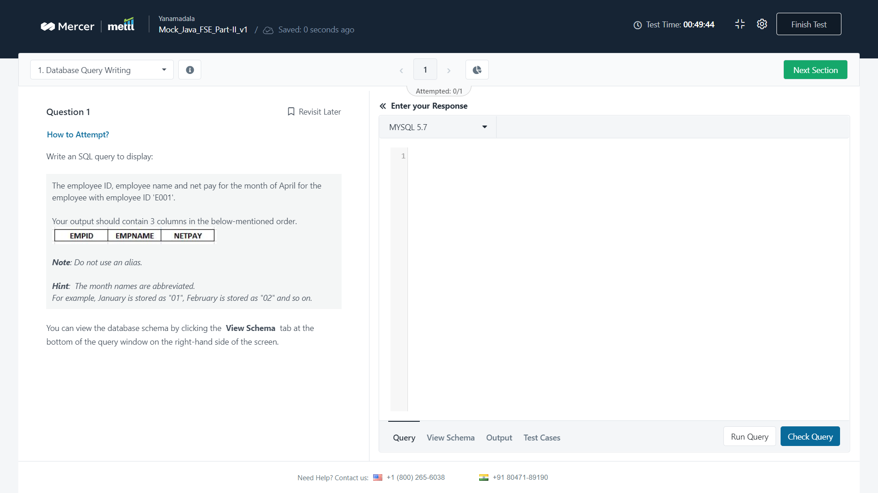

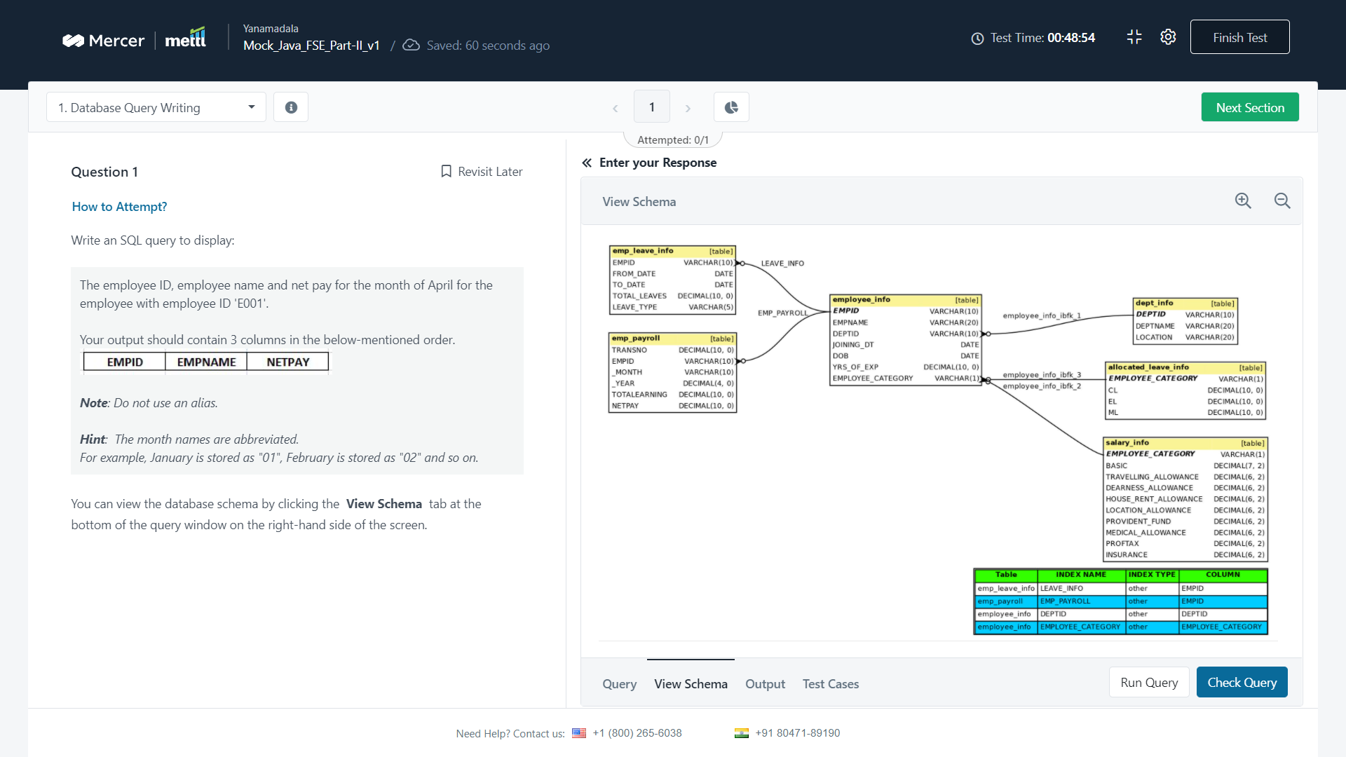

Q) The employee id , employee name and the total number of leaves taken..

A) see Venkat and nagaraju whatsapp for query typo mistakes…

Or below image answer

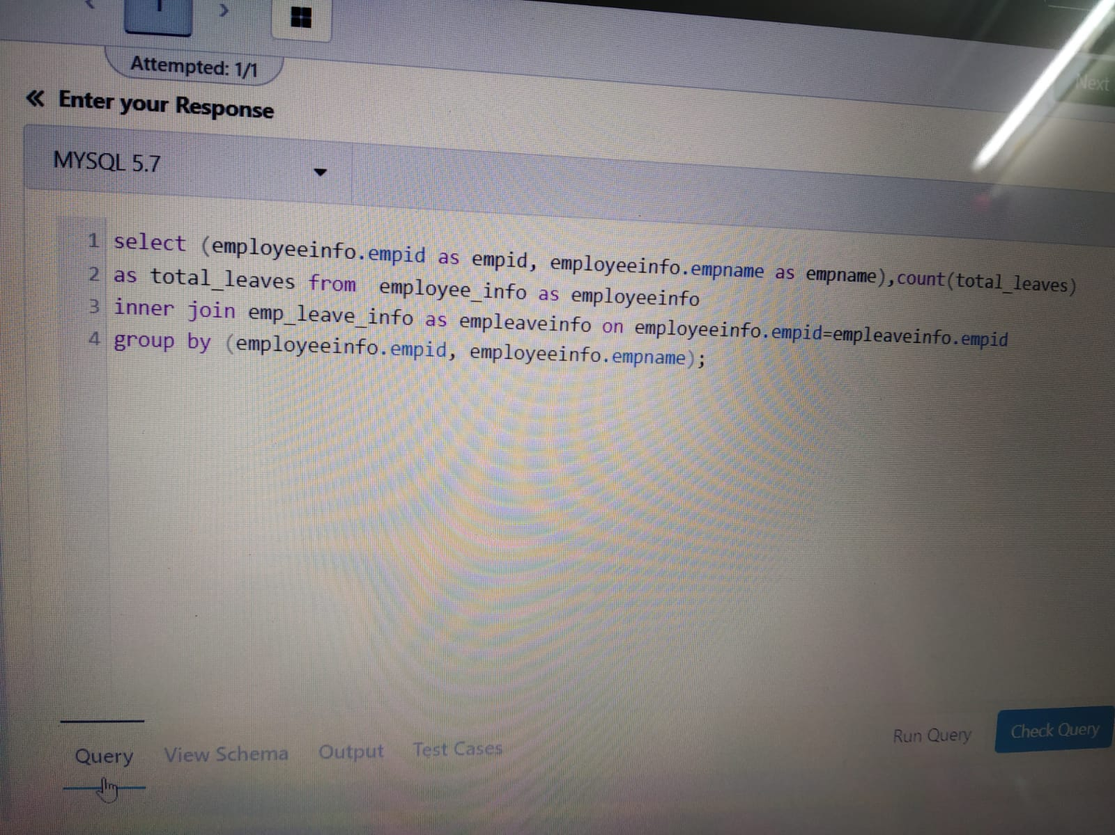

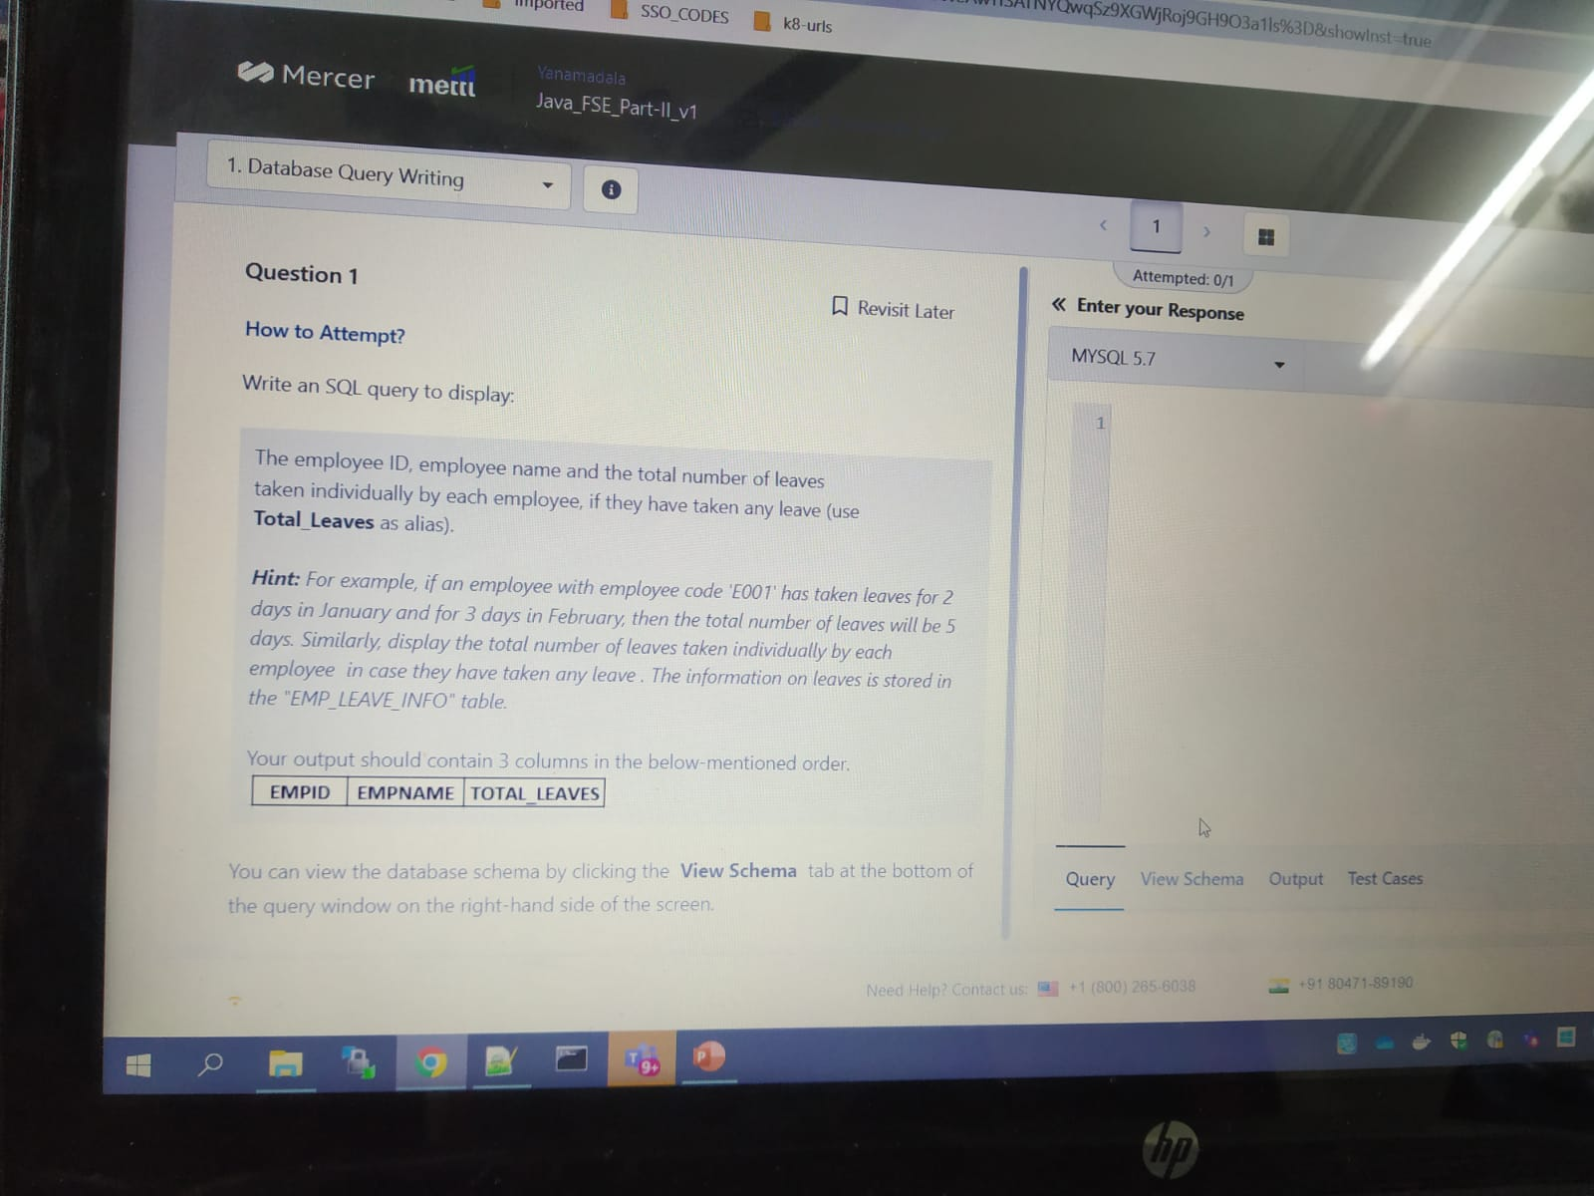

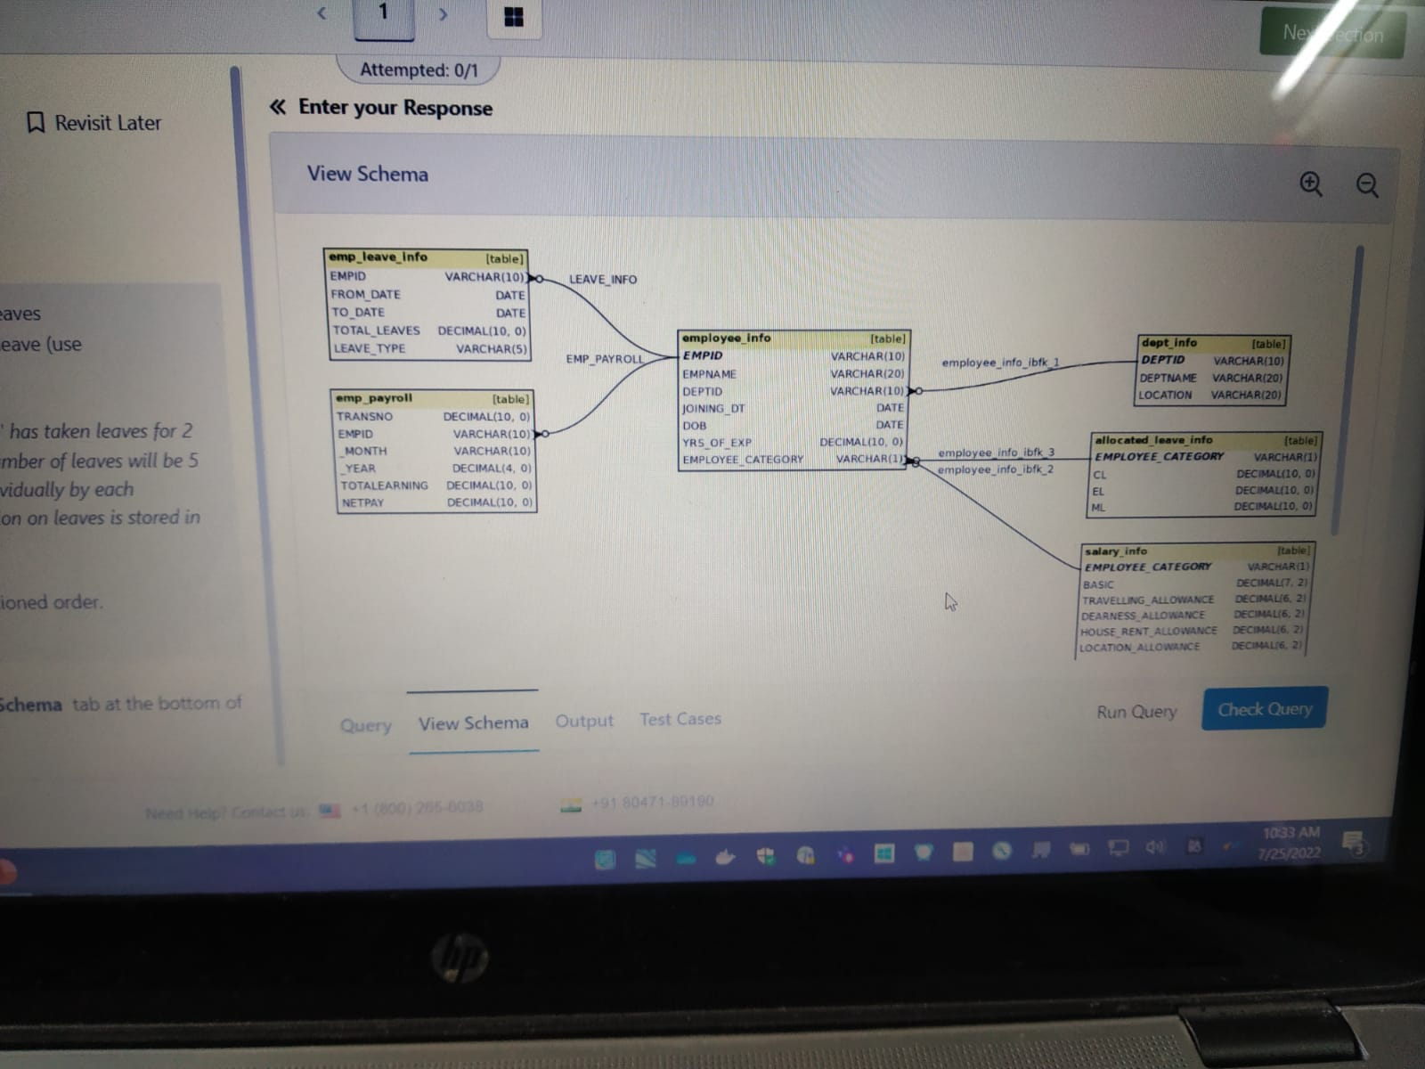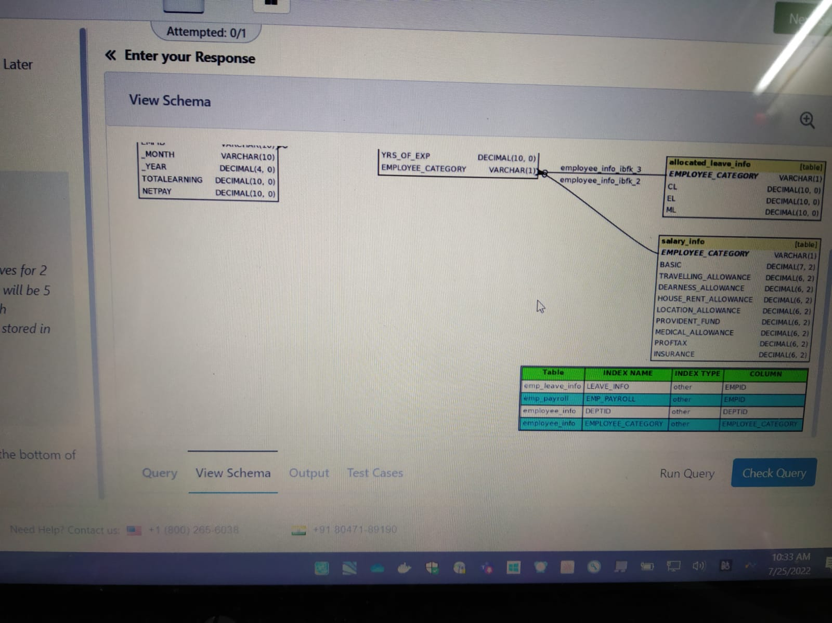

## Databases

3 . you need to design an application which will be used by different clients (e.g

Ans : 3 (3tier )

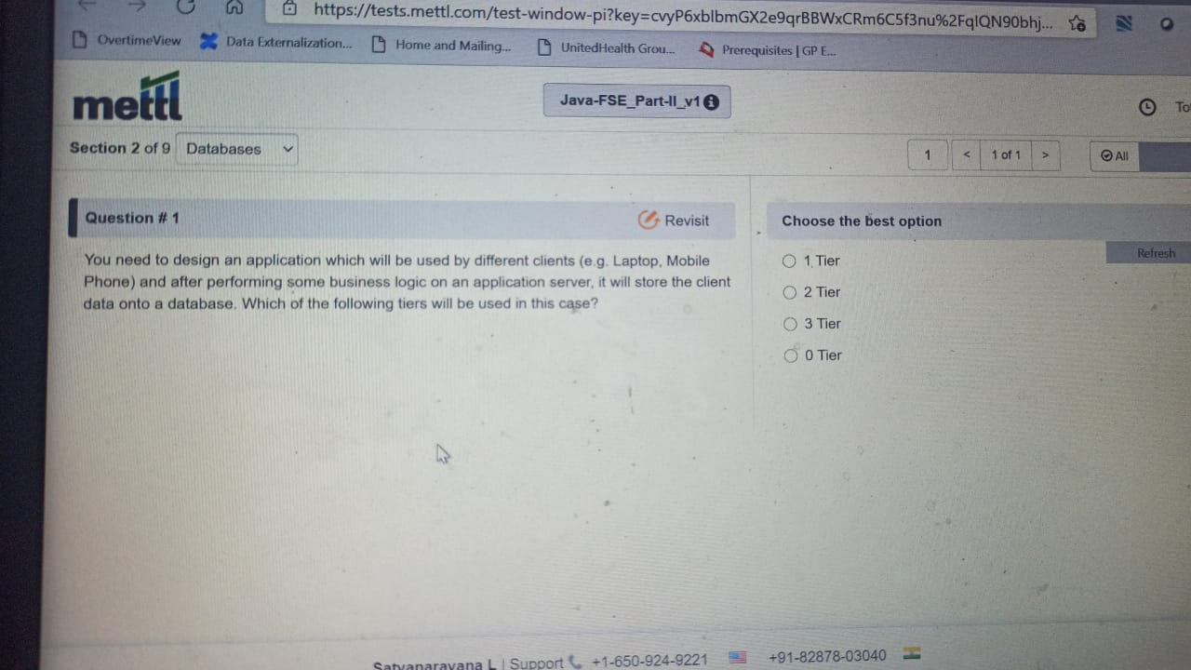

Q) A typical client-server system based application is hosted on a server. Which of the …

A) 2 (need to confirm)

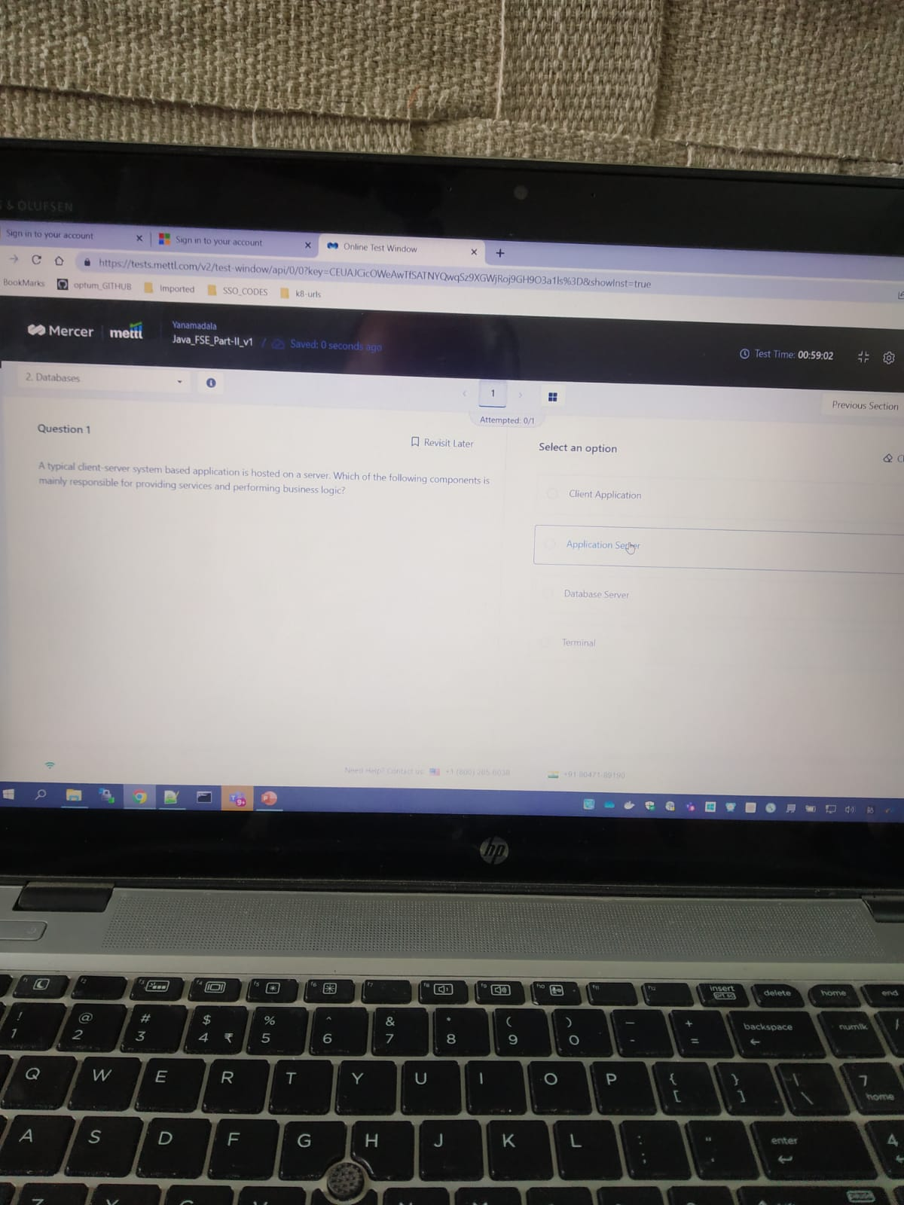

## Java

11 . what will be the output of the following code ?

A ) 1

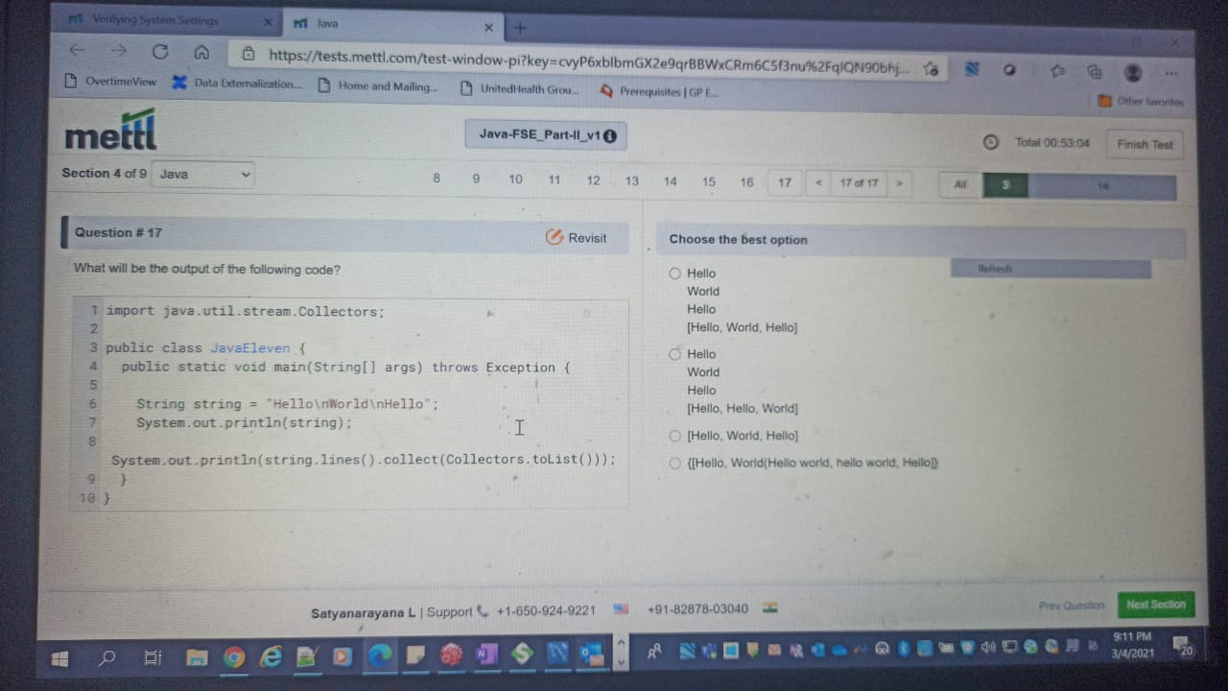

12 . which of the following methods is/are added in the collections package in java 8

1. 2 ( B and C )

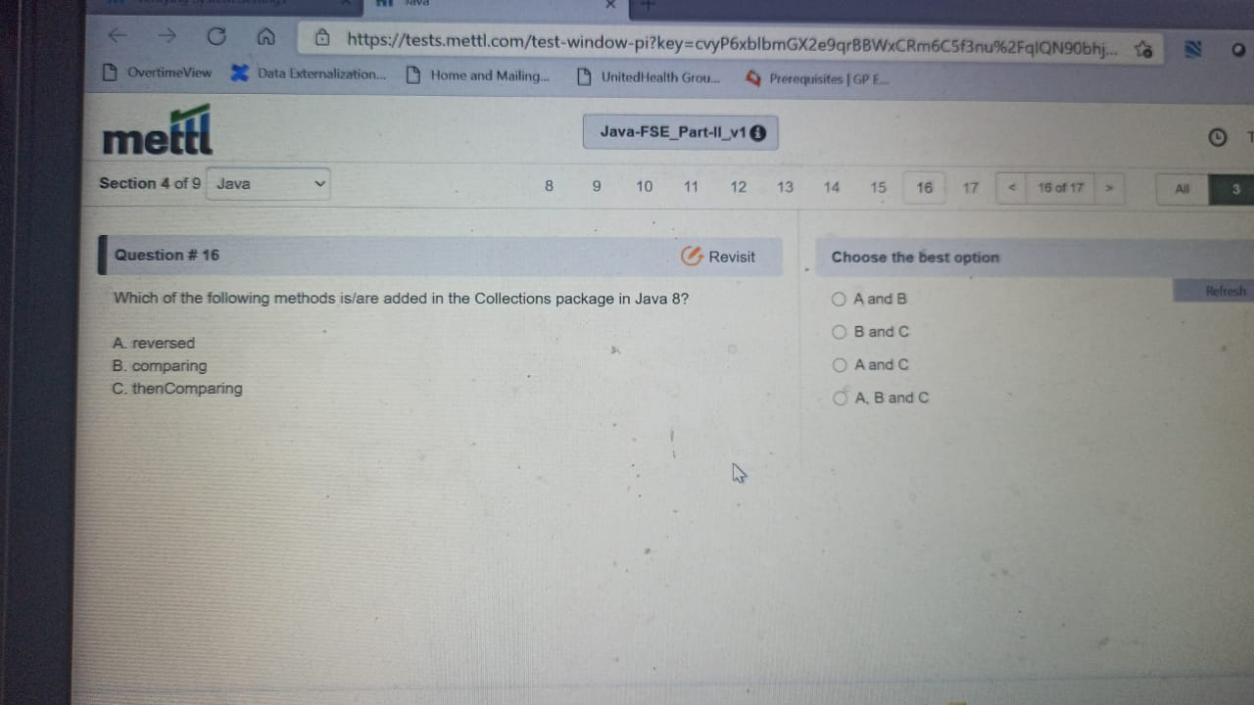

13. how do you support both get and post methods ..

A ) 2

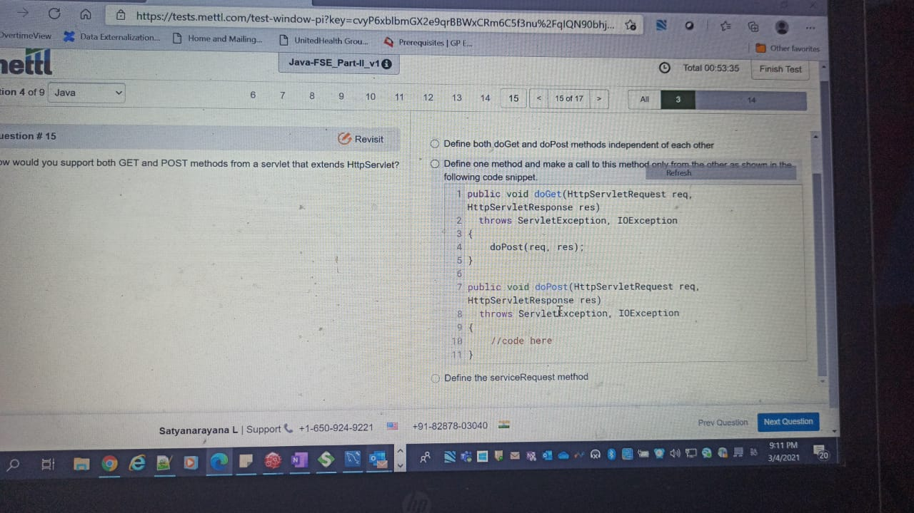

14 . what will be the output of the following program ?

A ) 4

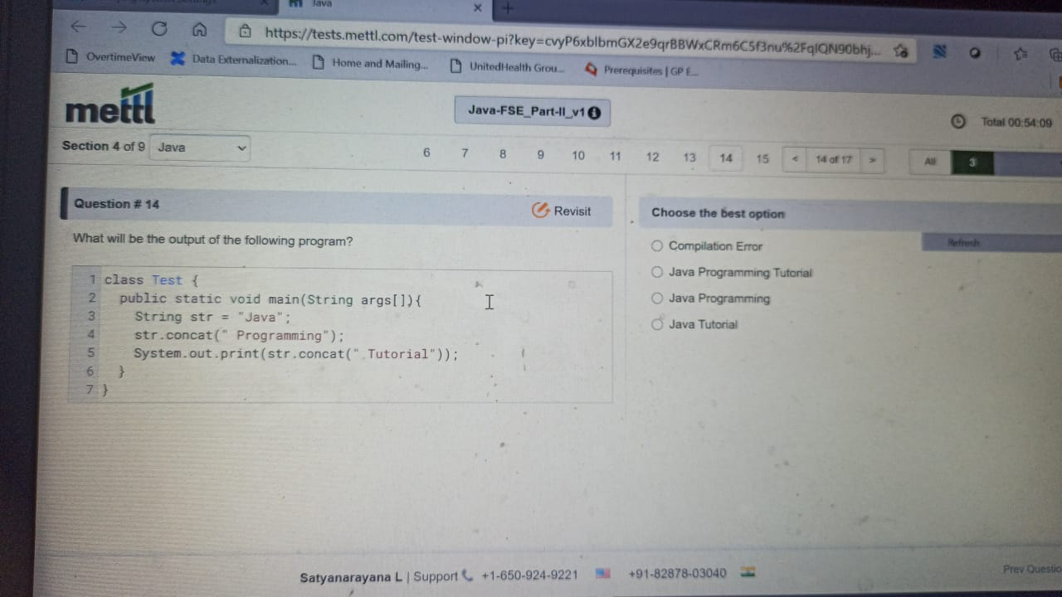

15 . what will be the output of the following program ?

A ) 1

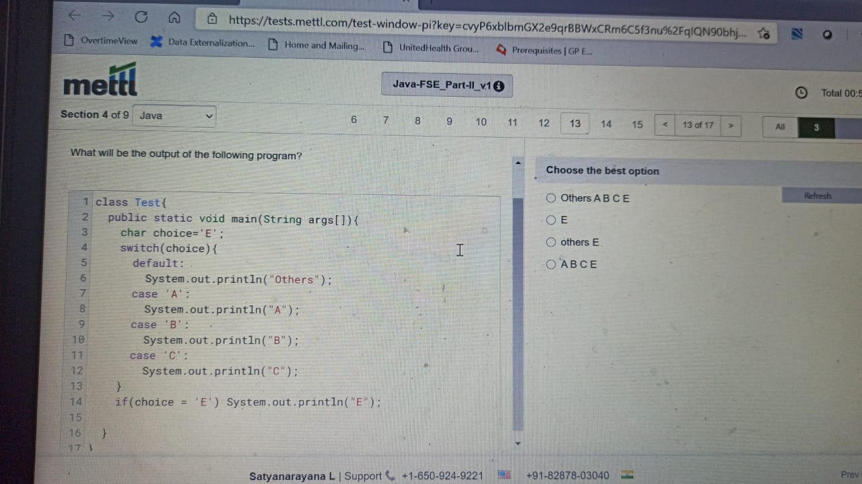

16 ) main class for mvc design pattern ..

1. 2

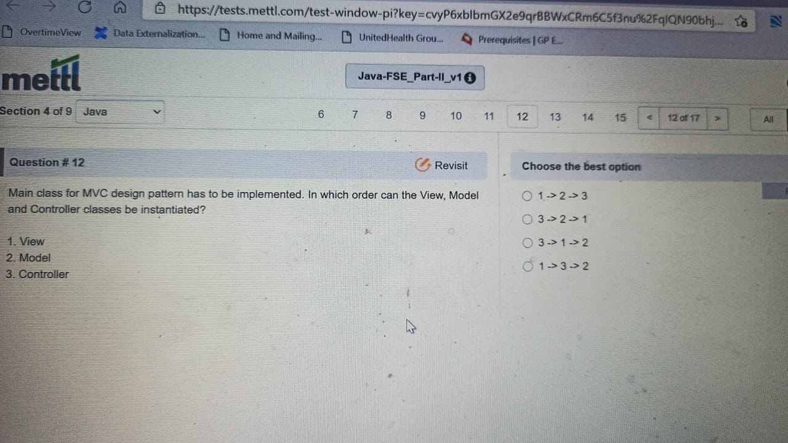

17. which of the following statements about ..

A) 3 (a b c)

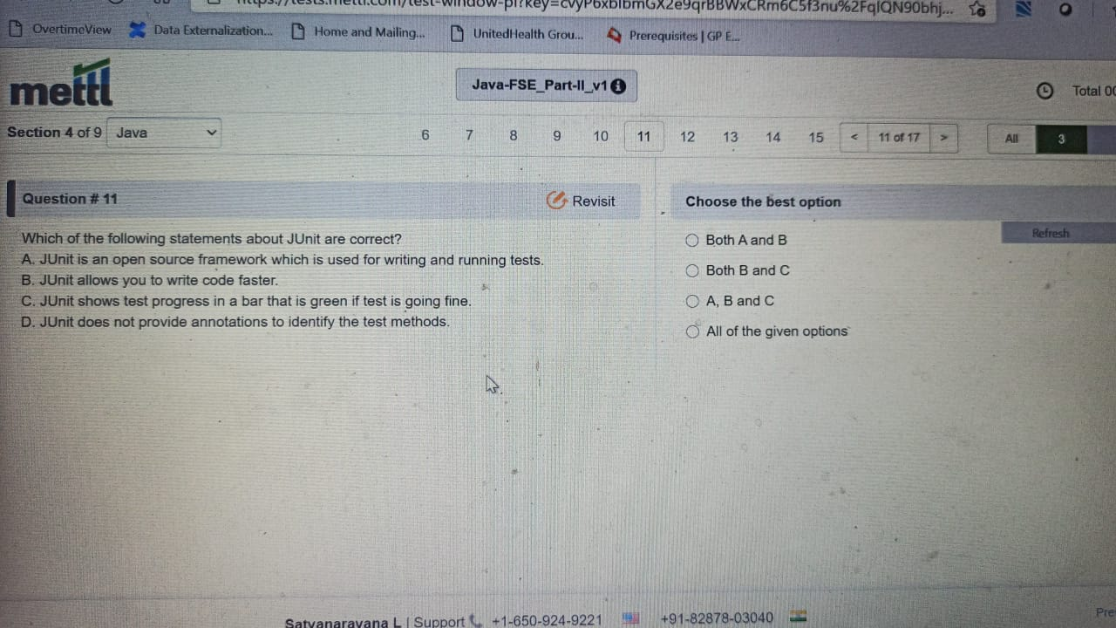

18. for which of the following JPA entity fields is data never stored in a database ?

A ) 2

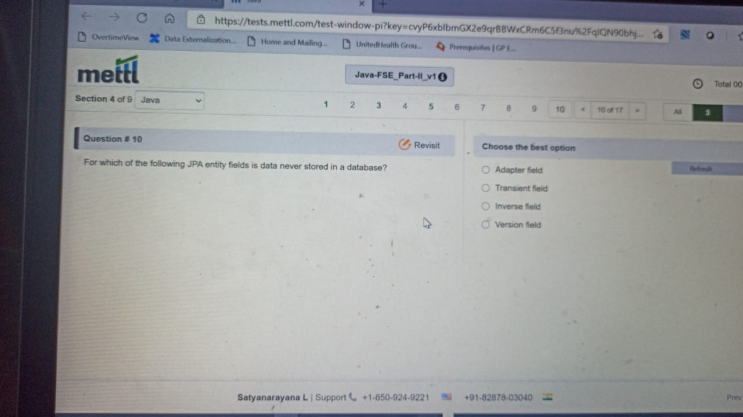

19. in a java SE environment..

A) 4

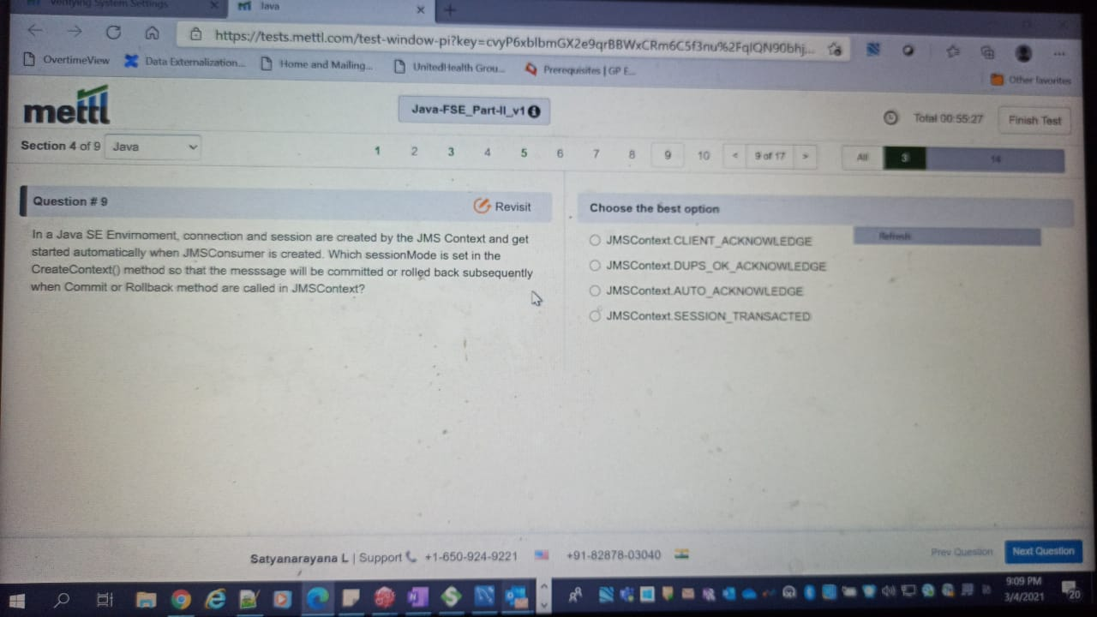

20. consider a table “computer”..

A ) 2

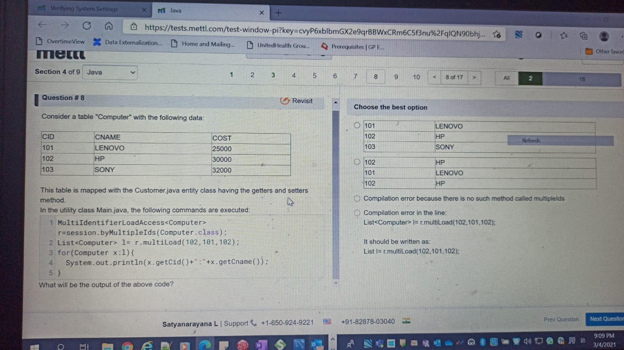

22. what will be the output …

A) 2

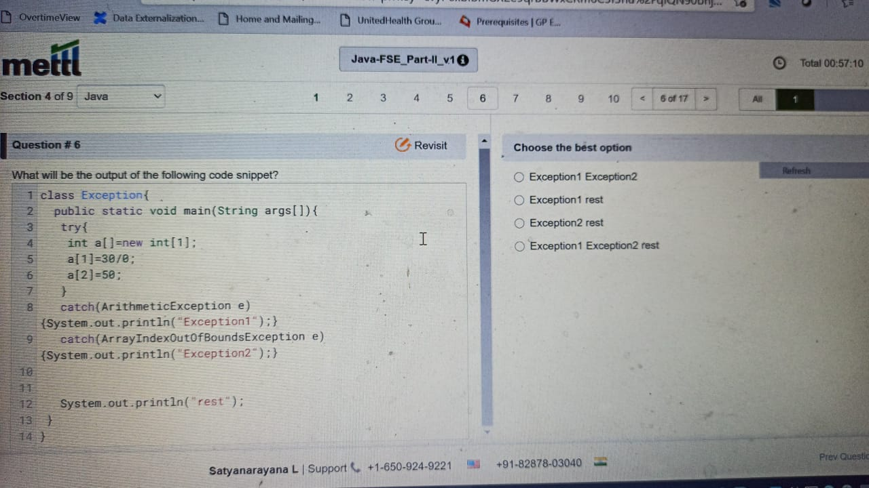

23. An application showing a JFrame ….

A) 1 adapter

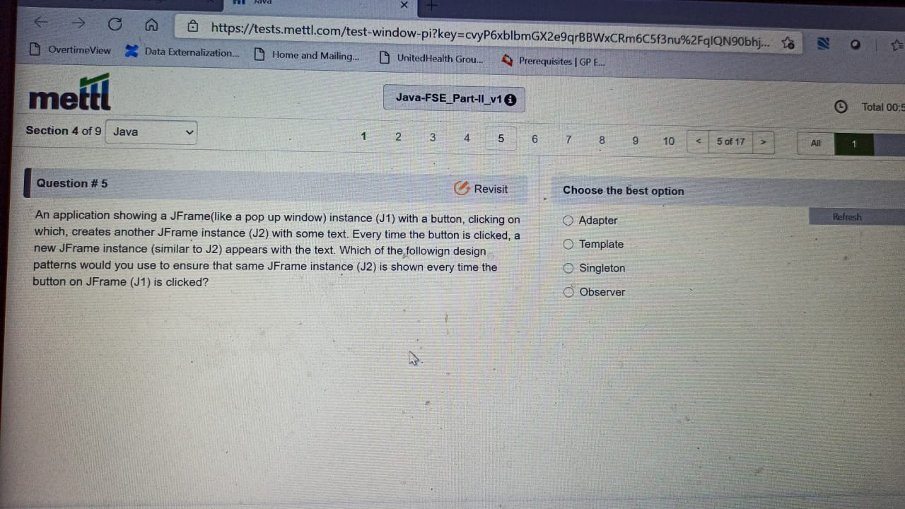

24. what will be the output of the following code snippet ?

A) 4

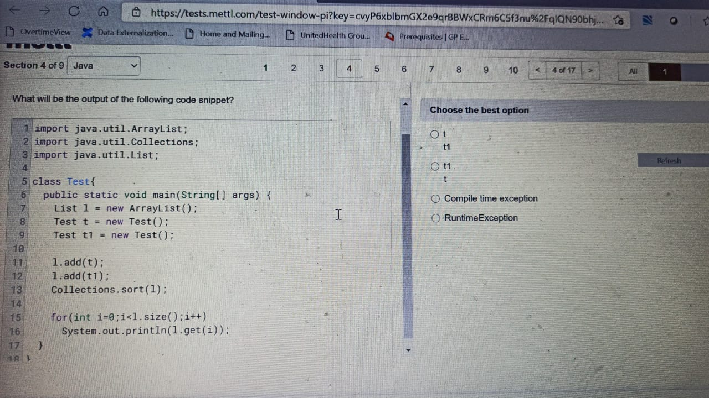

Q). you want the output in a sorted.

A) 1

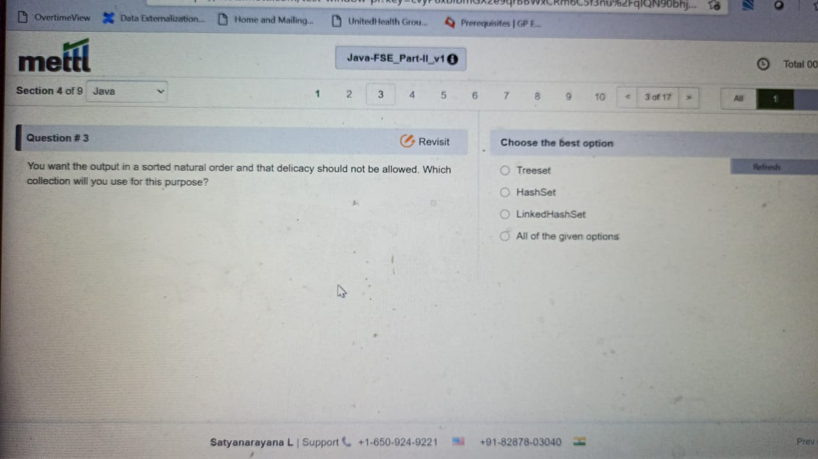

27. considering the following code ..

A)

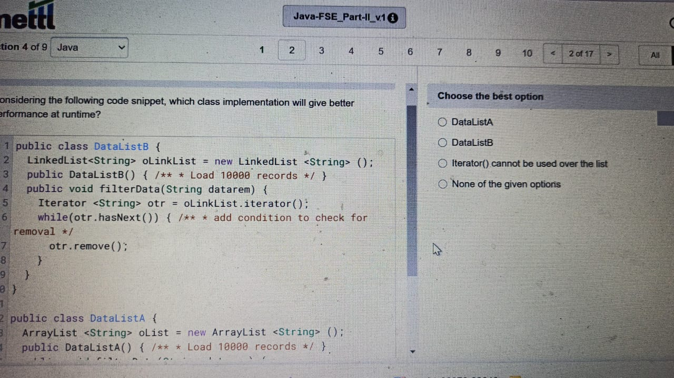

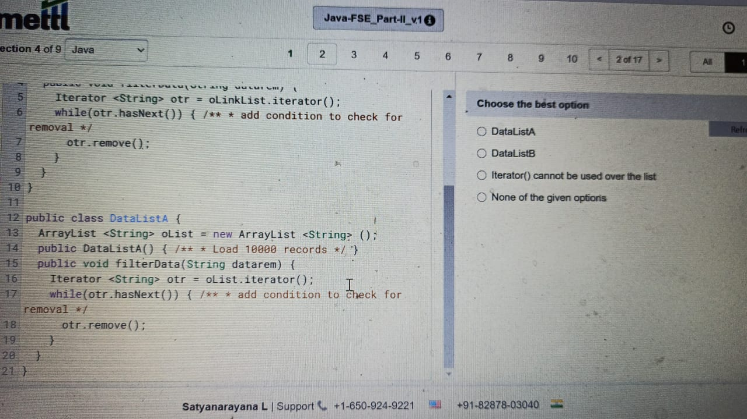

Q). two computers are conncted to the internet..

A) 1 and 2

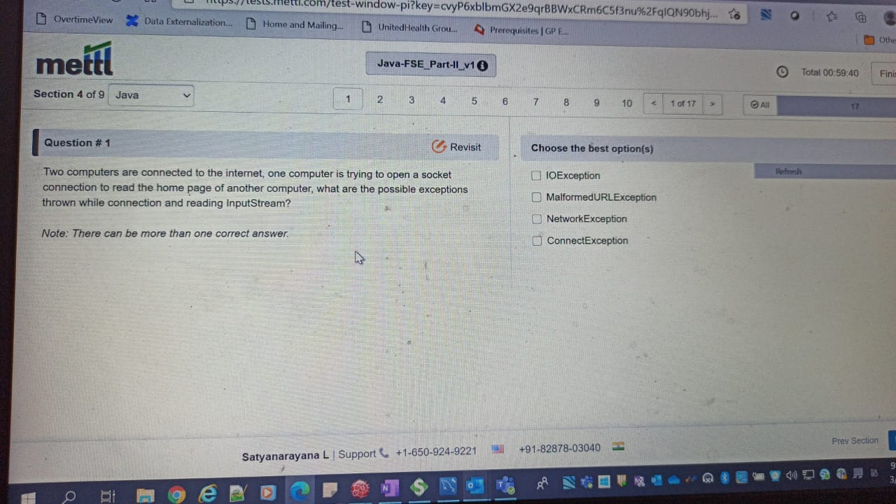

Q) which of the following statements is/are true ?

Ans : 1 , 2

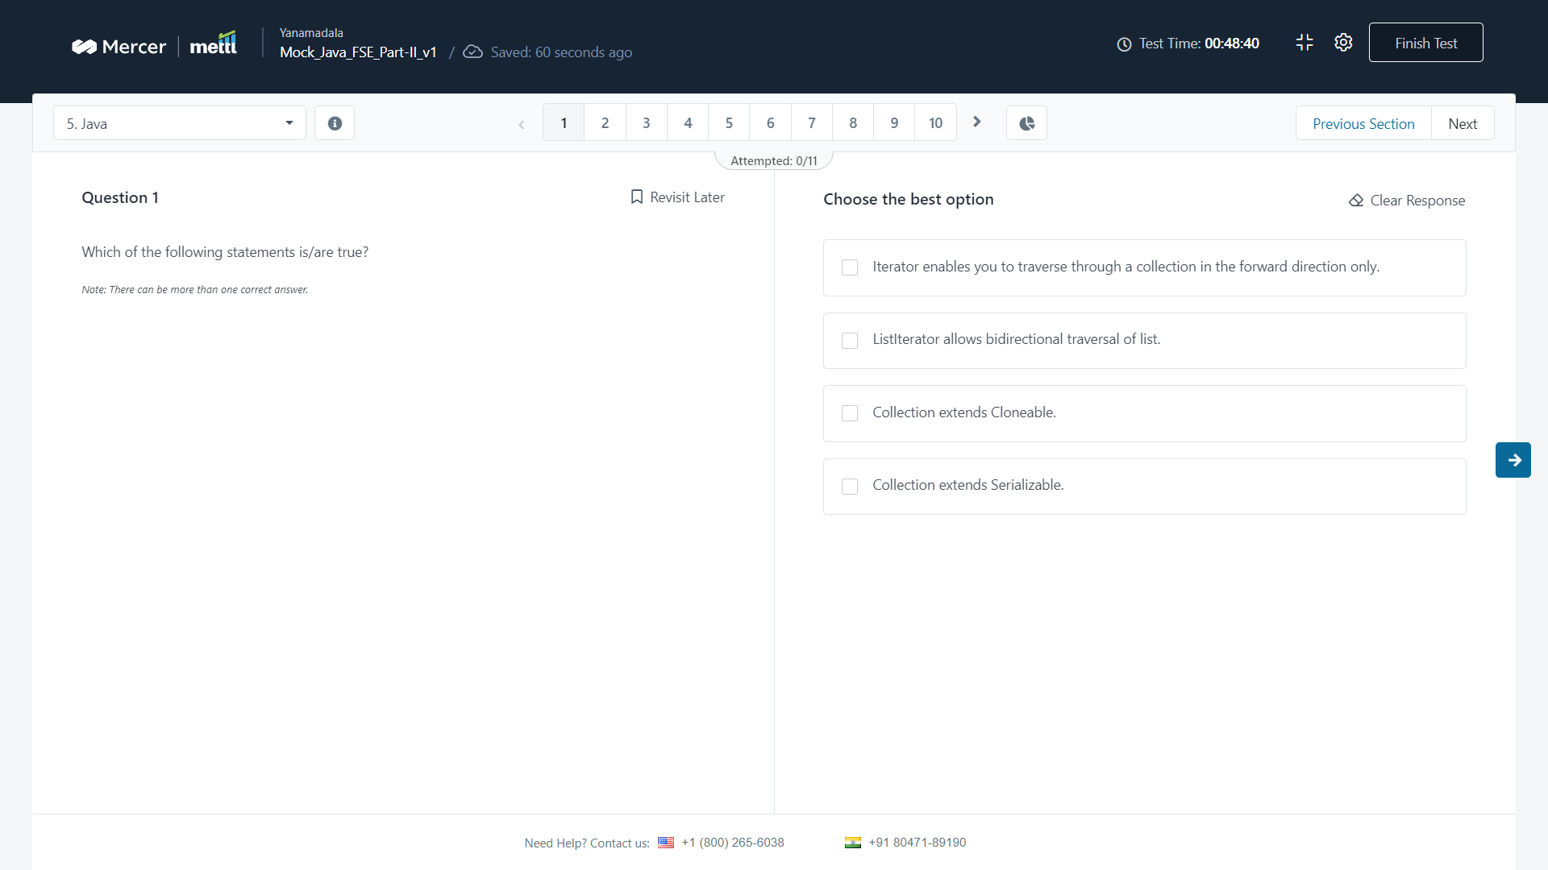

Q) which of the following options is a disadvantage of using a static factory..

Ans : 4

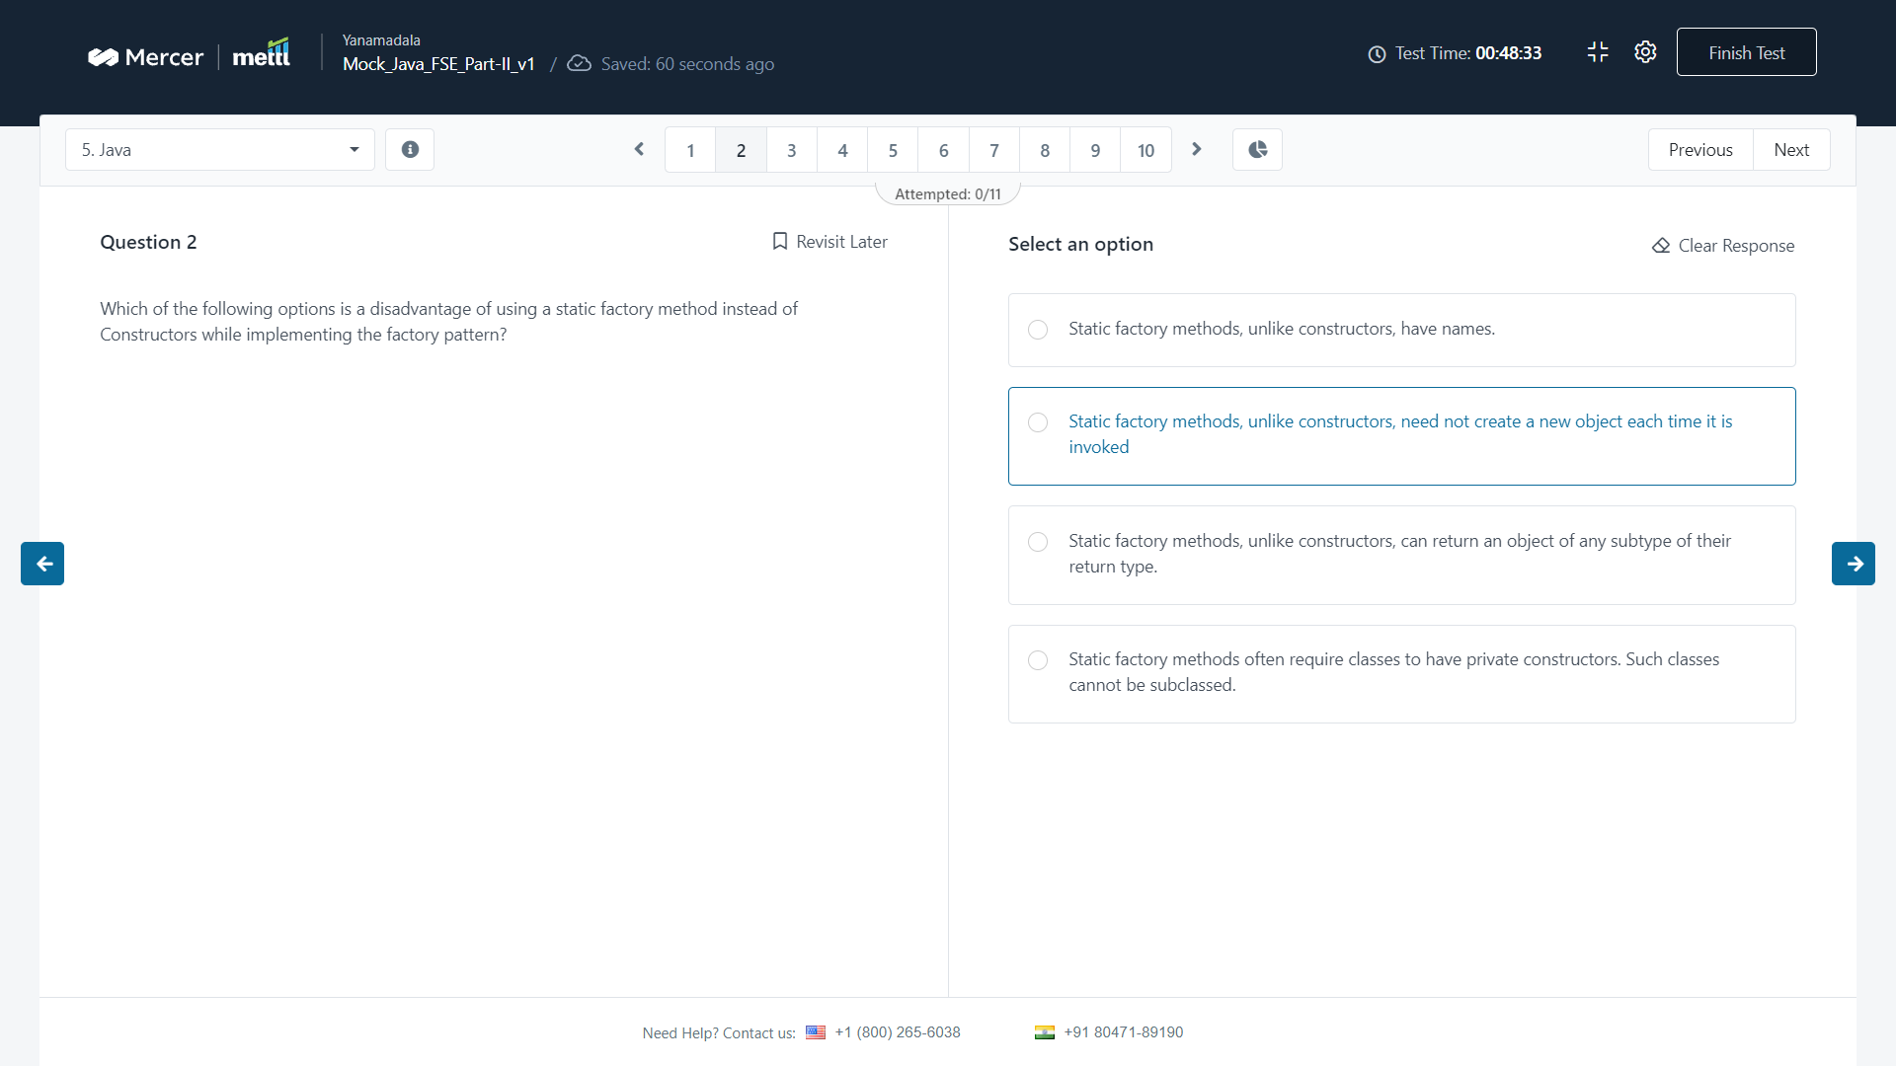

Q) what will be the output of the following code snippet ?

Ans : 3 compile time….

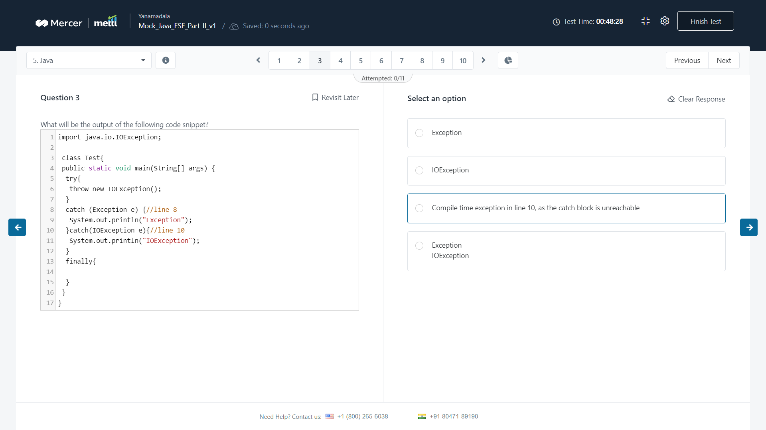

Q) which of the given codes when inserted independently …

Ans : 2

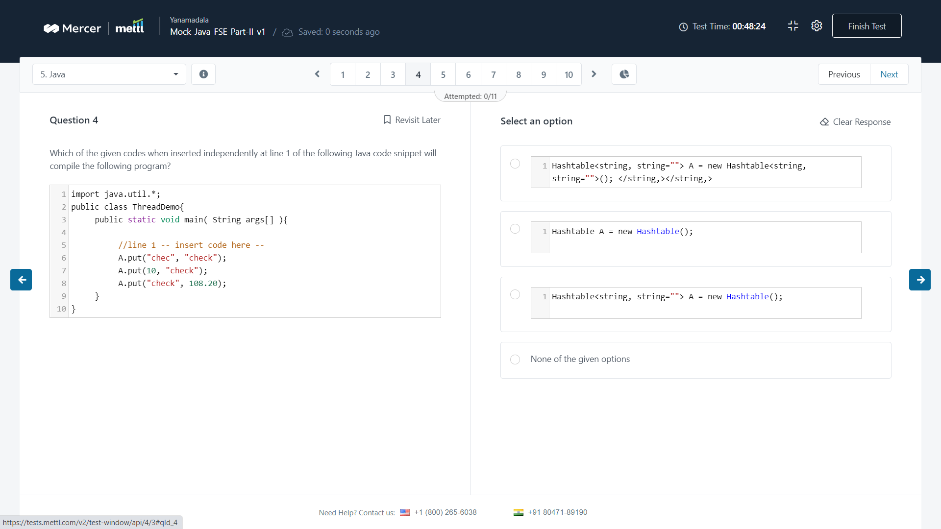

Q) which of the following session methods reload(s)…

Ans : session.refresh()

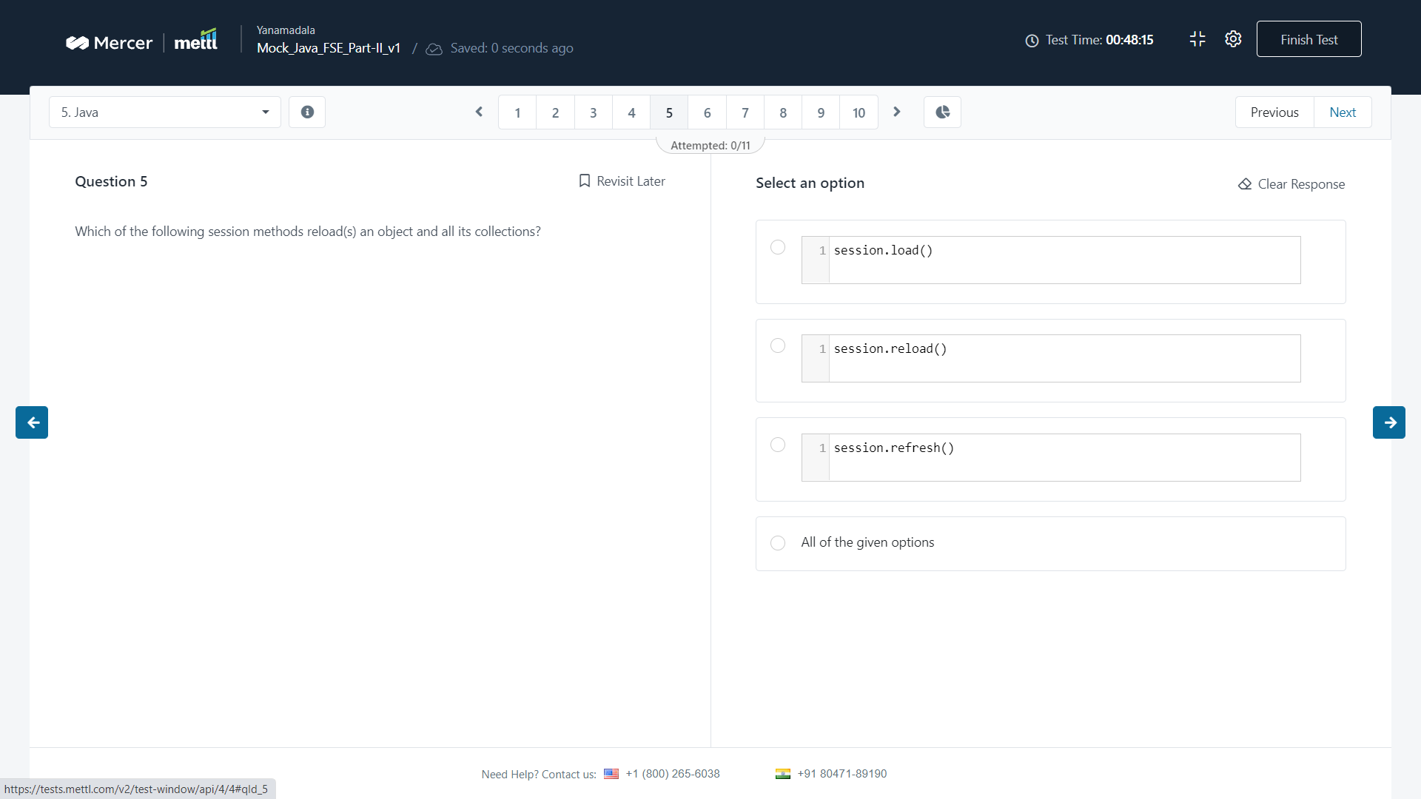

Q)which of the following options is a valid syntax to create a text message in JMS ?

Ans : 1 only A

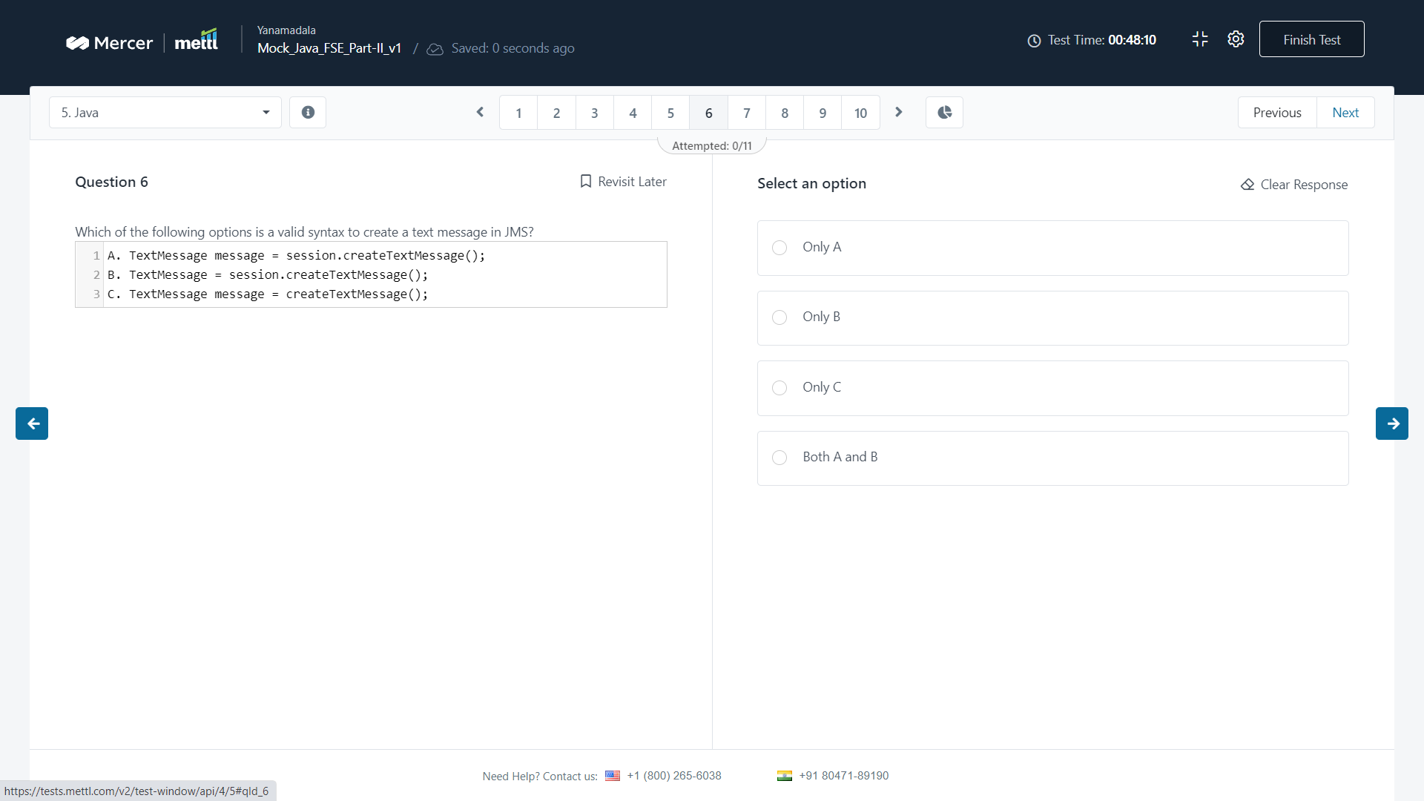

Q) The new assertEquals methods use autoboxing…  
Ans : assertEquals(object, object)

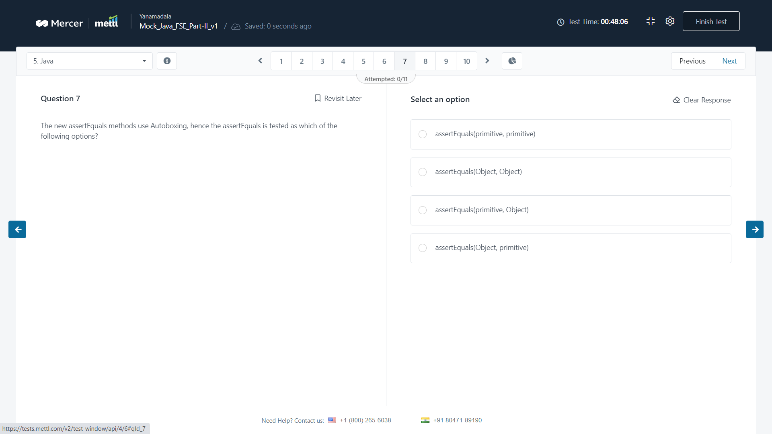

Q) Which of the following statements about methods in java is true ?

Ans : 2

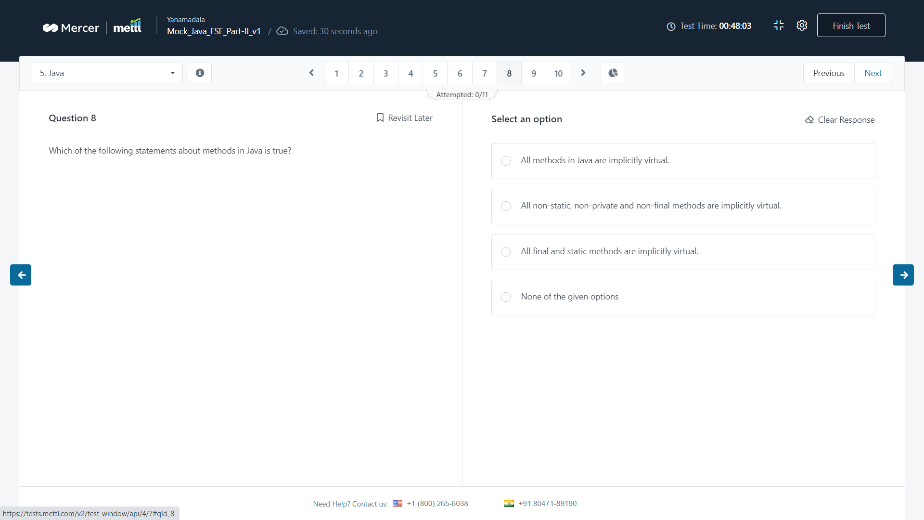

Q) As per java servlets concepts, assuming that..

Ans : 2

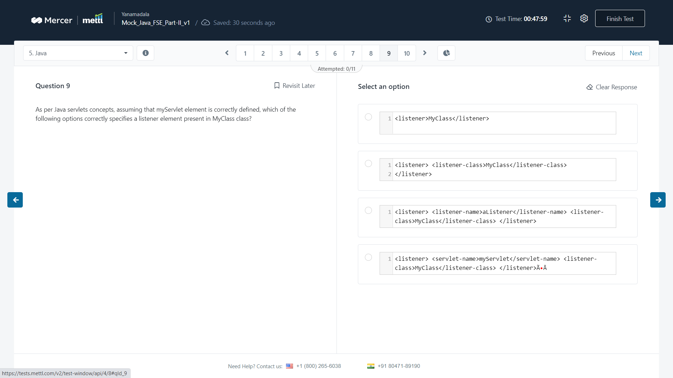

Q) which of the following methods has been included in java 8 ?

Ans : string.join()

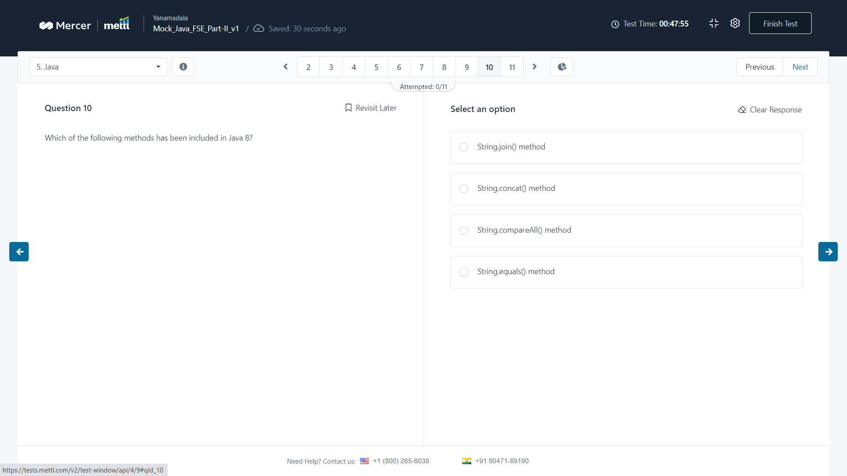

Q) what will be the output of the following code ?

Ans : compile time error

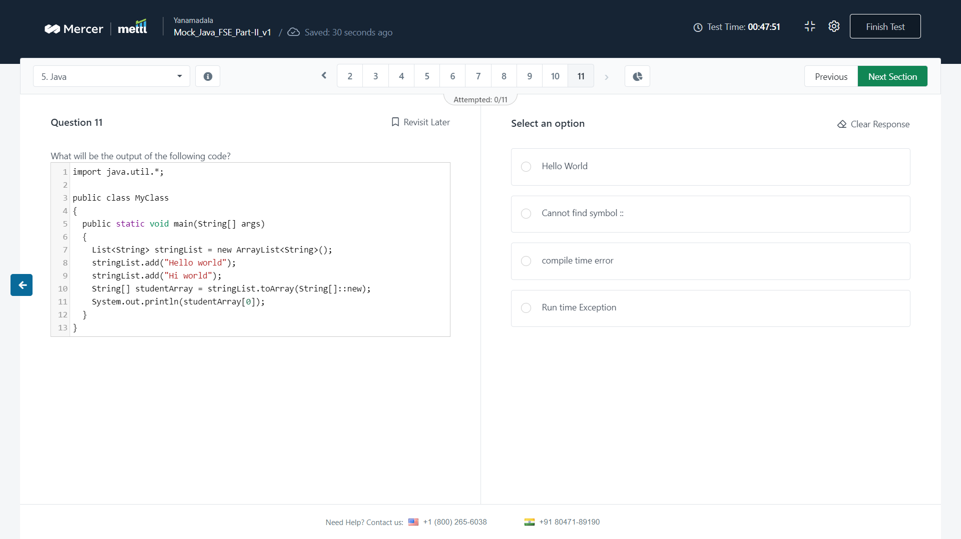

Q) you want to create an instance of a new map such that its iteration order is the same…

Ans : linkedhashmap

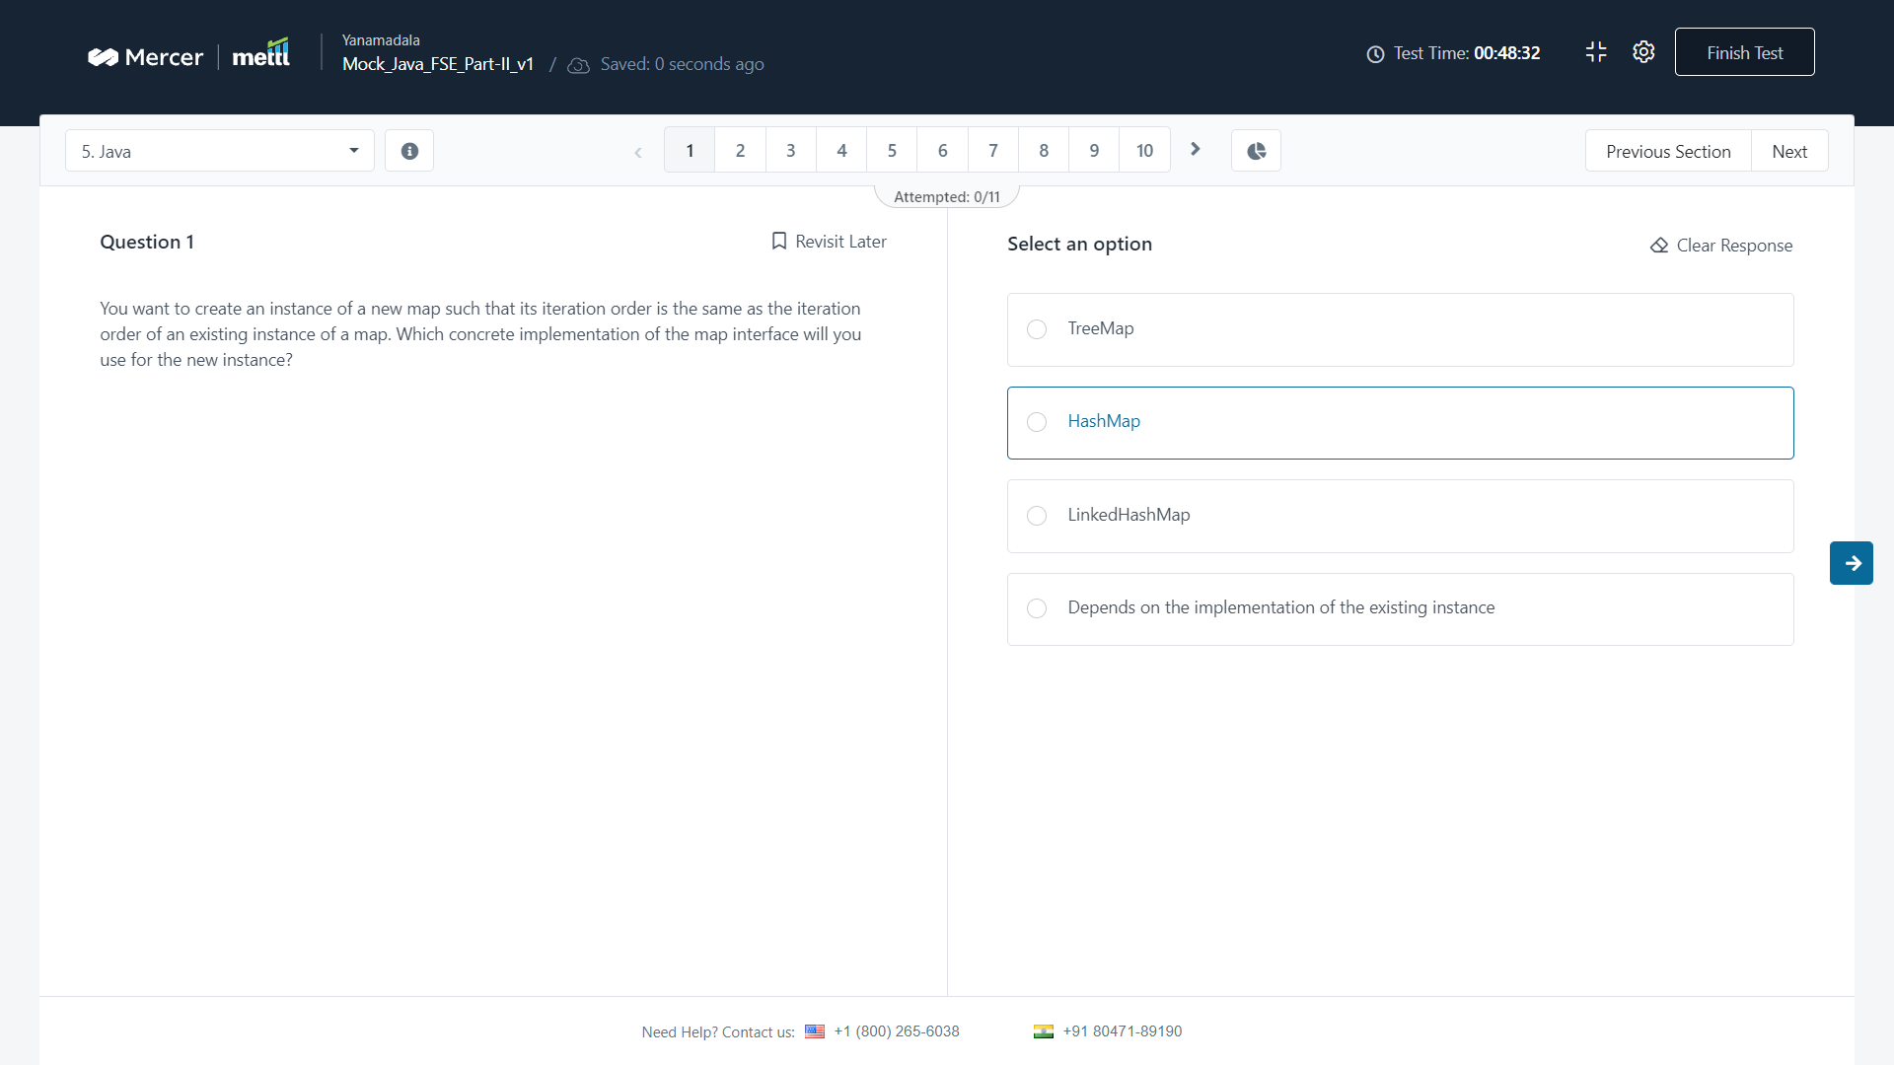

Q) which of the following options is disadvantage of using a static factory method instead of …

Ans : 4

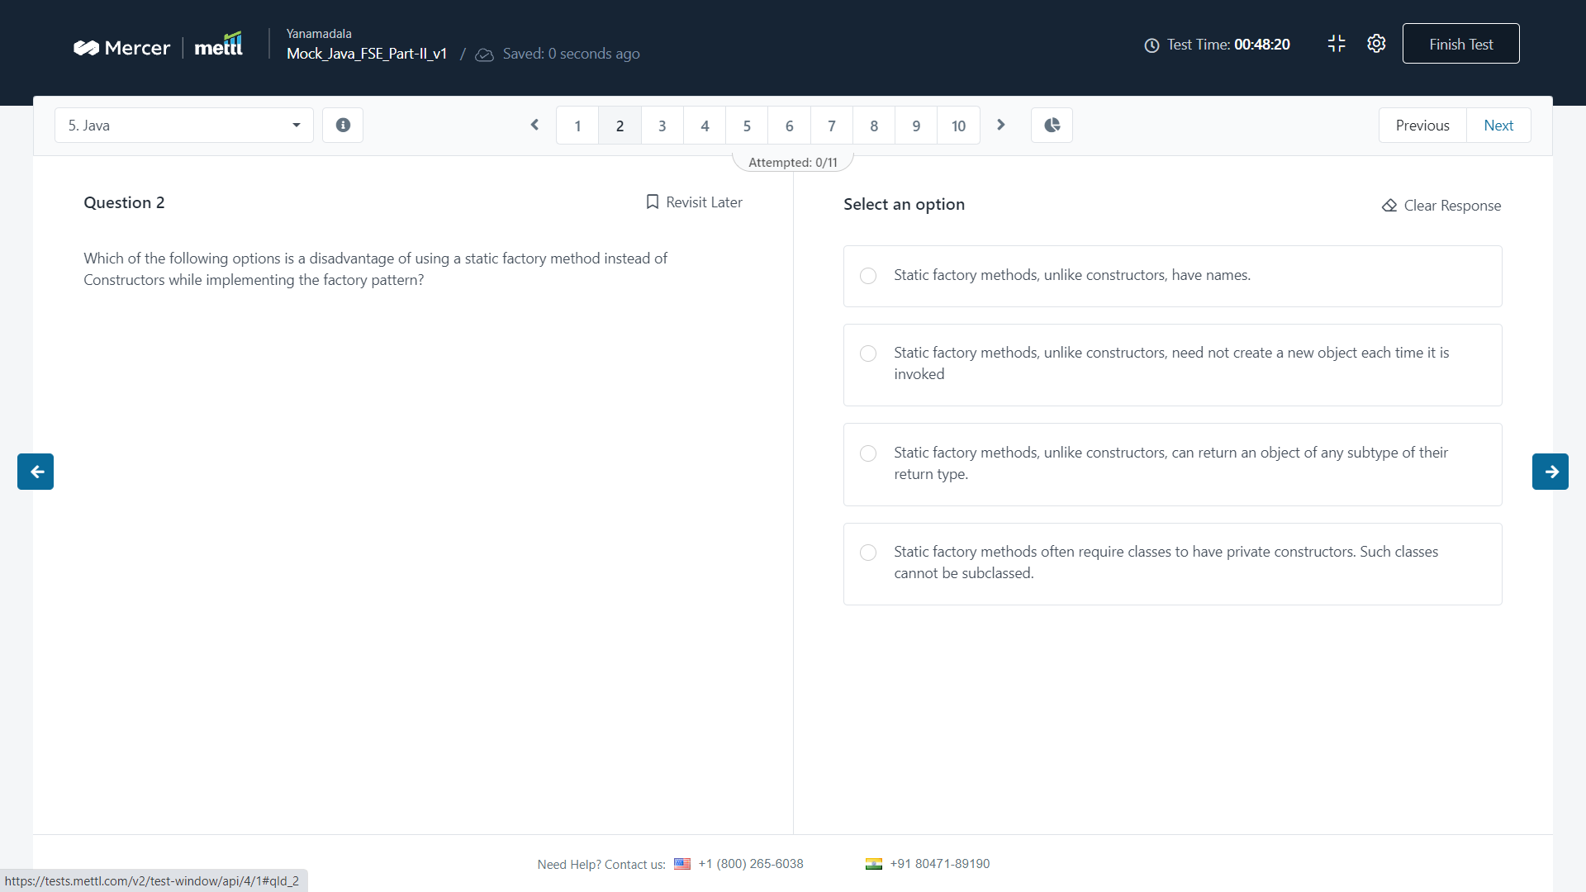

Q) What will be the output of the following code snippet ?

Ans : 3

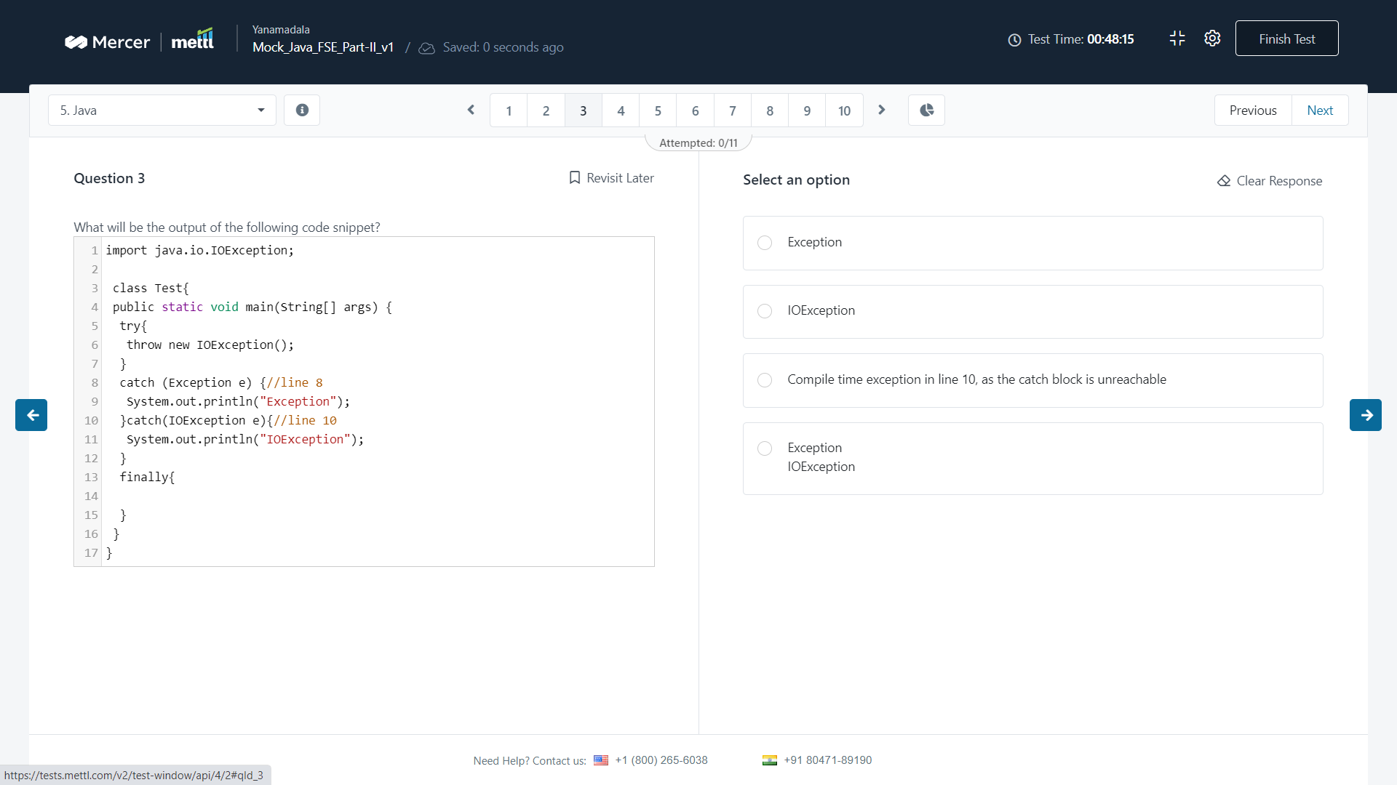

Q) which of the given codes when inserted independently at line 1 of the following java code…

Ans : b

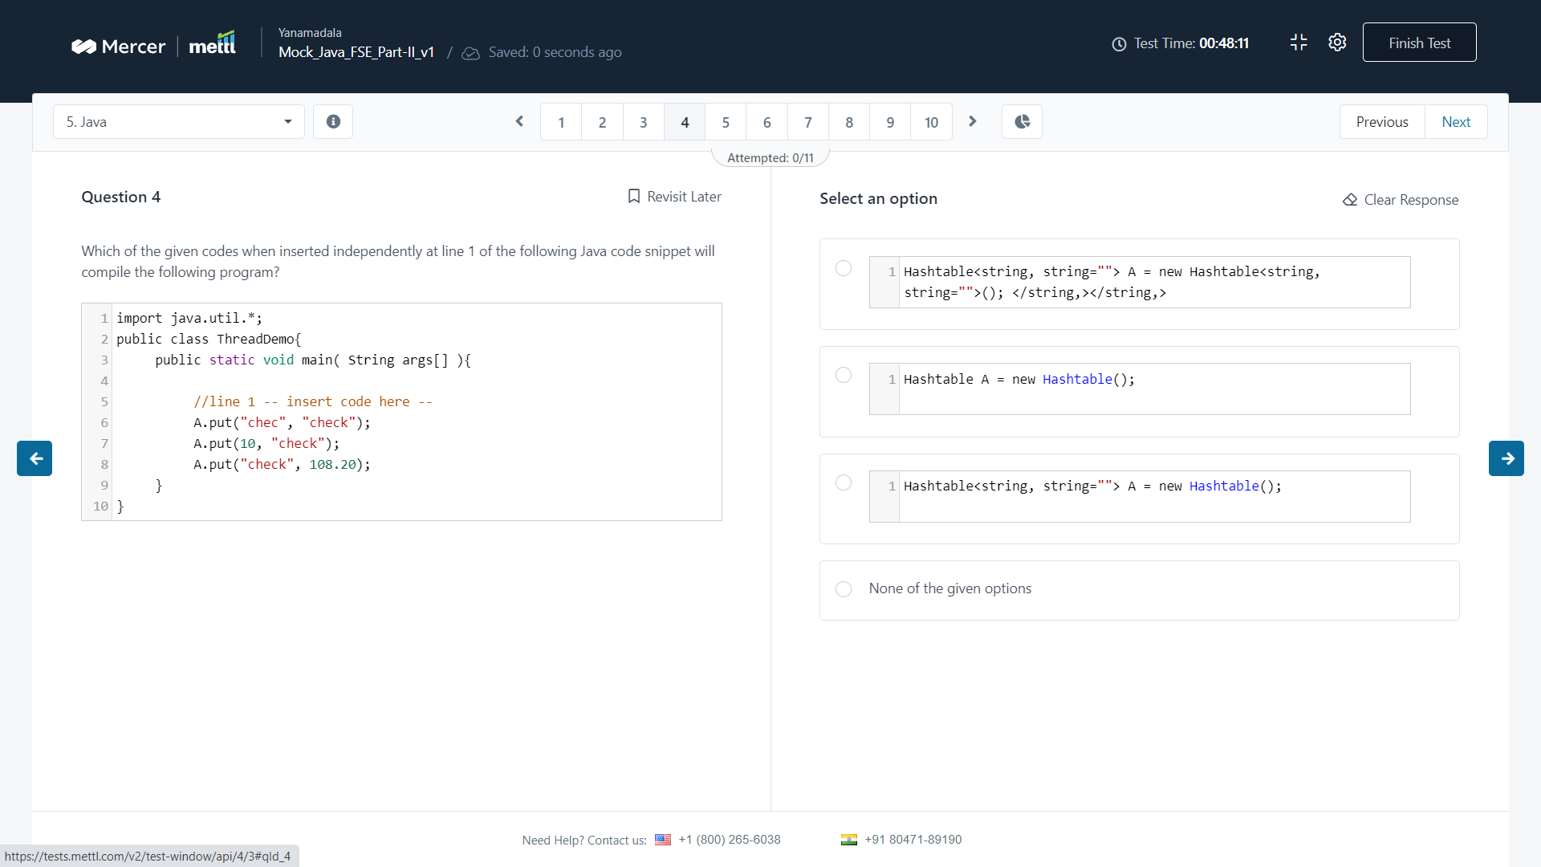

Q) which of the following session methods reload(s) an object and all its collections ?

Ans : 3

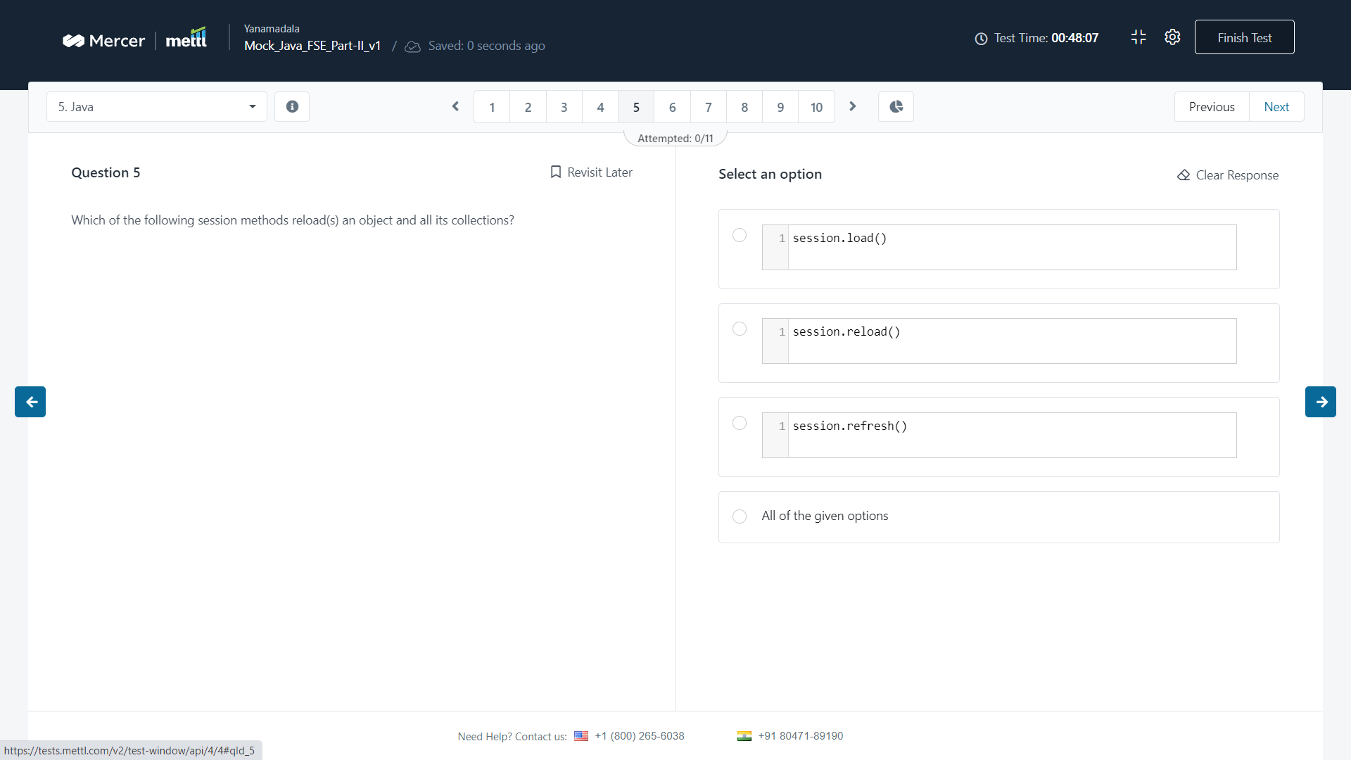

Q) which of the following options is a valid syntax to create a text message in JMS ?

Ans : 1

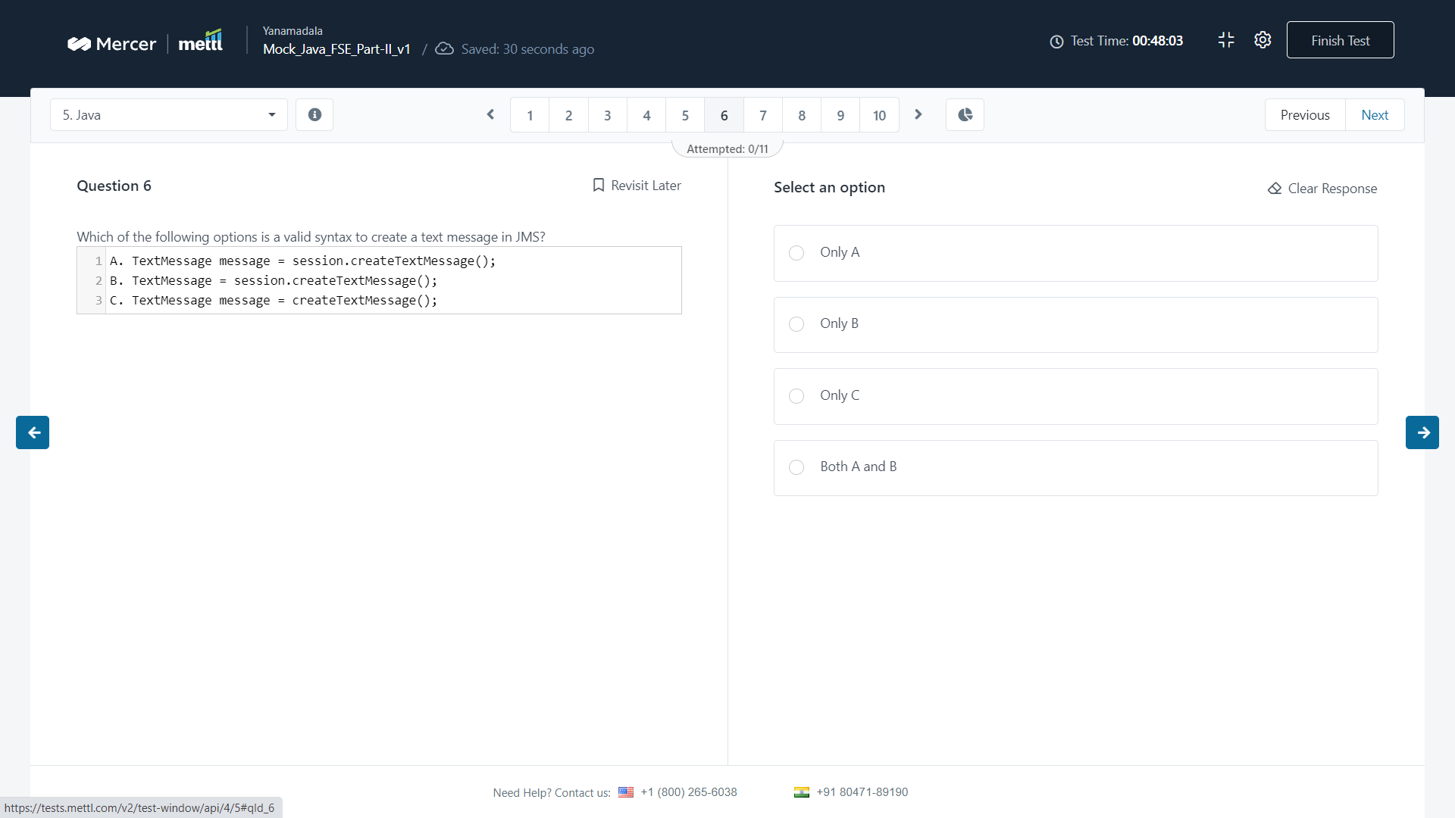

Q) the new assertEquals methods use autoboxing, hence the assertEquals is tested..

Ans : 2

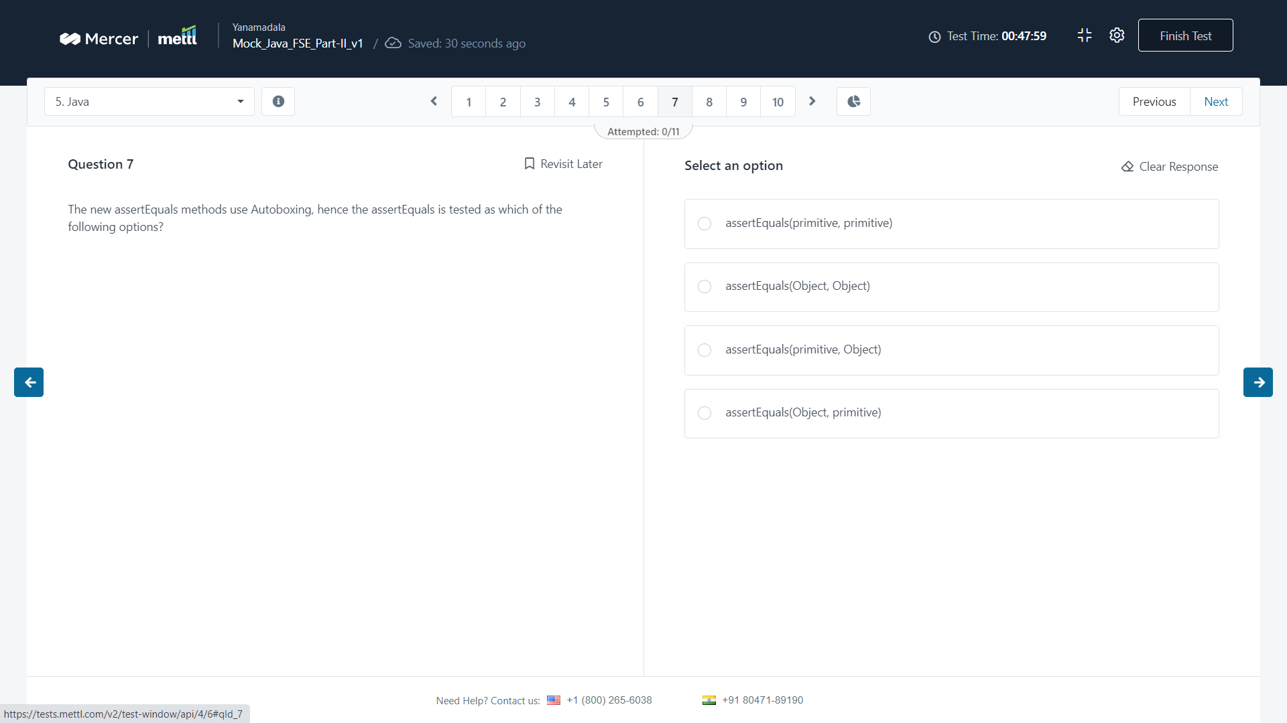

Q) what will be the output of the following snippet ?

Ans :c

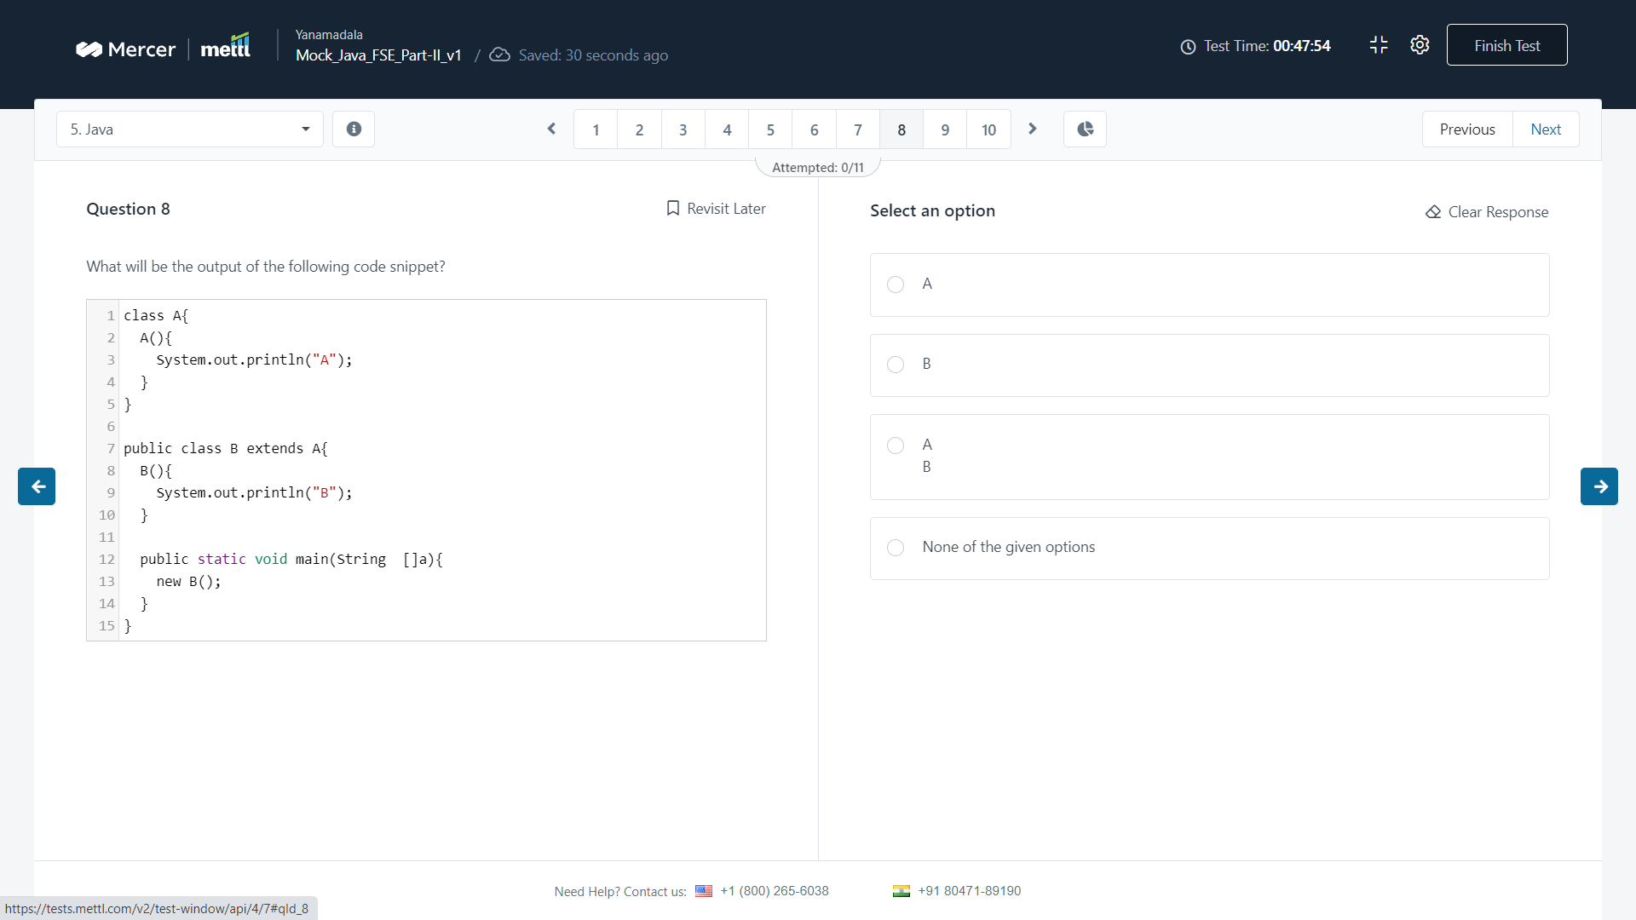

Q) As per java servlets concepts, assuming that myServlet element is correctly defined, which..

Ans : 2

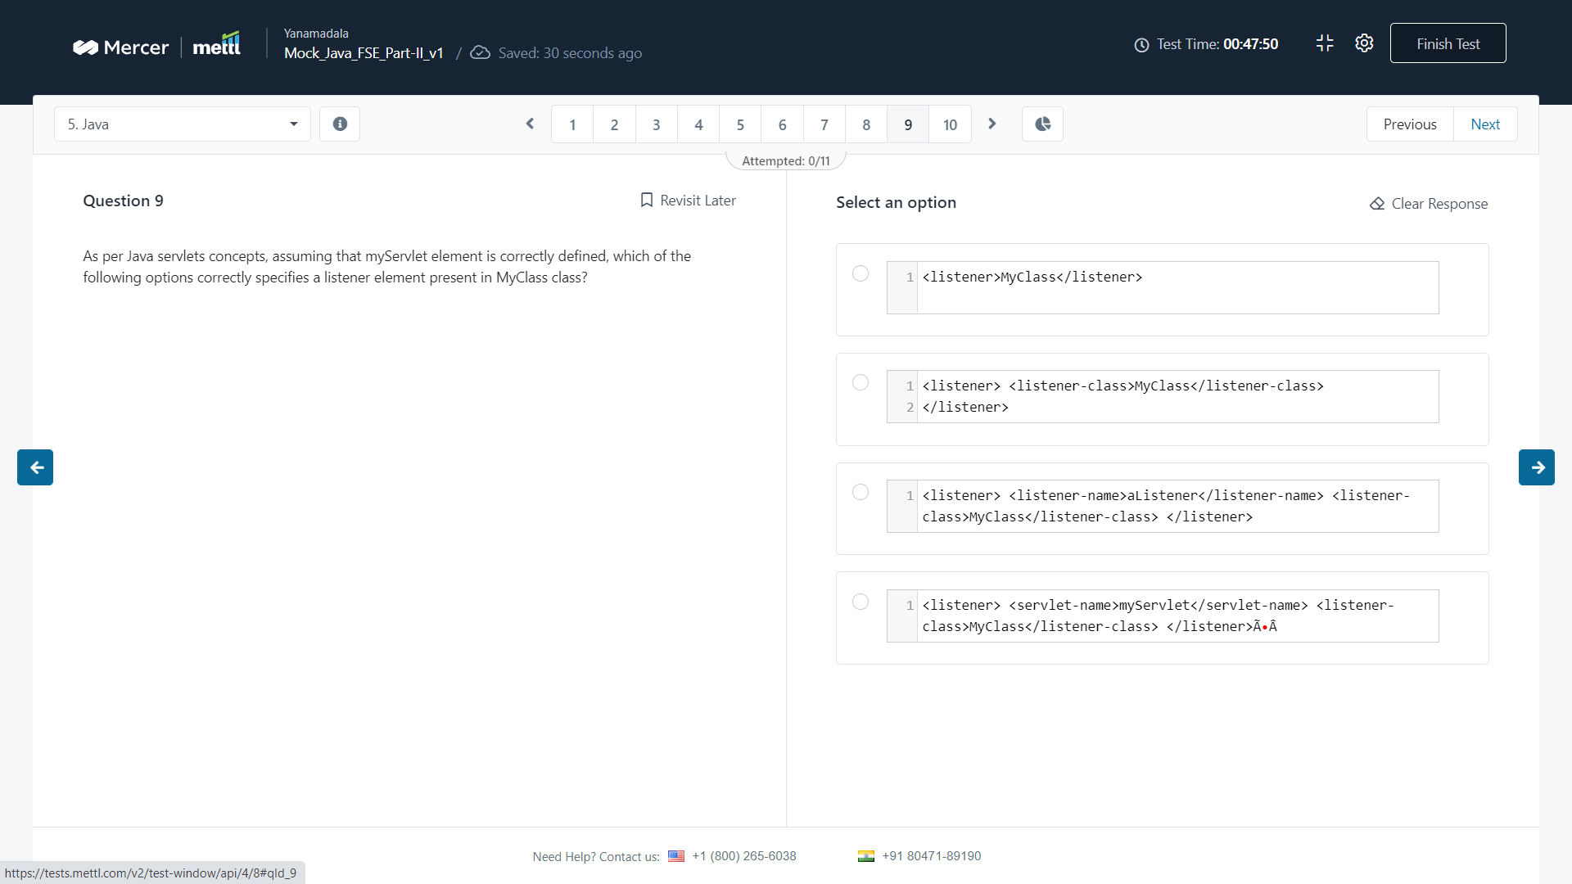

Q) how would you implement the following code in java 8?

Ans : 2

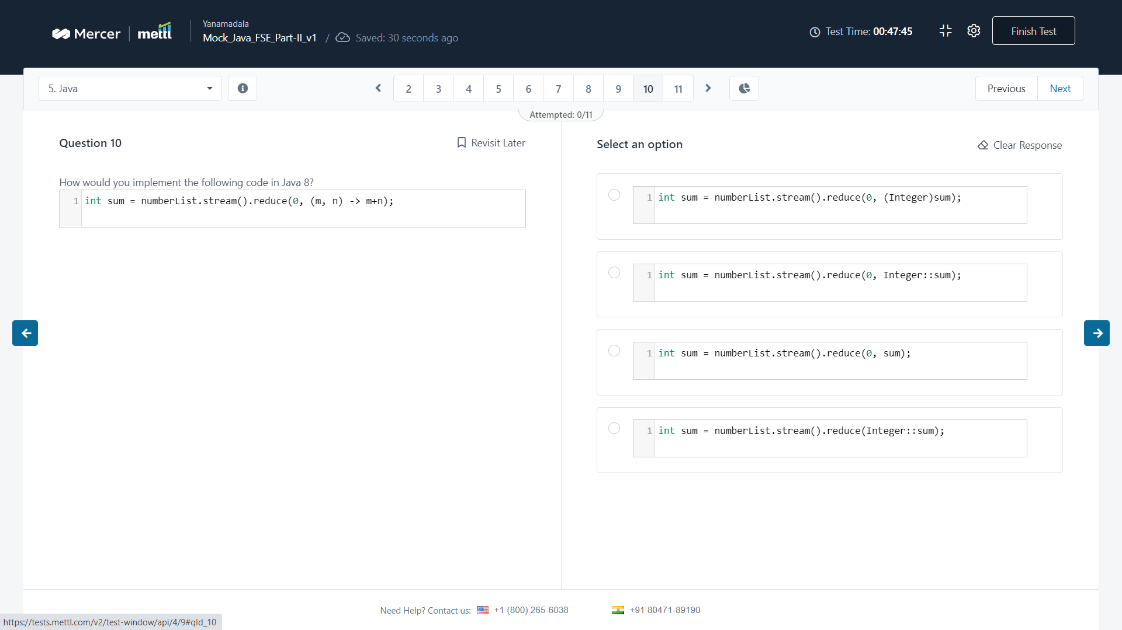

Q) what will be the output of the following code ?

Ans : 3

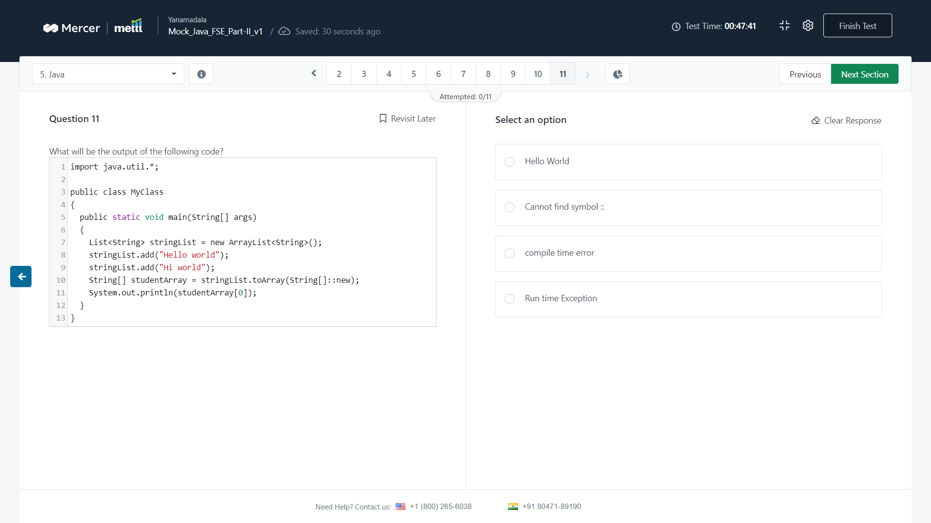

Q) what will be the output of the following code ?

A) 1

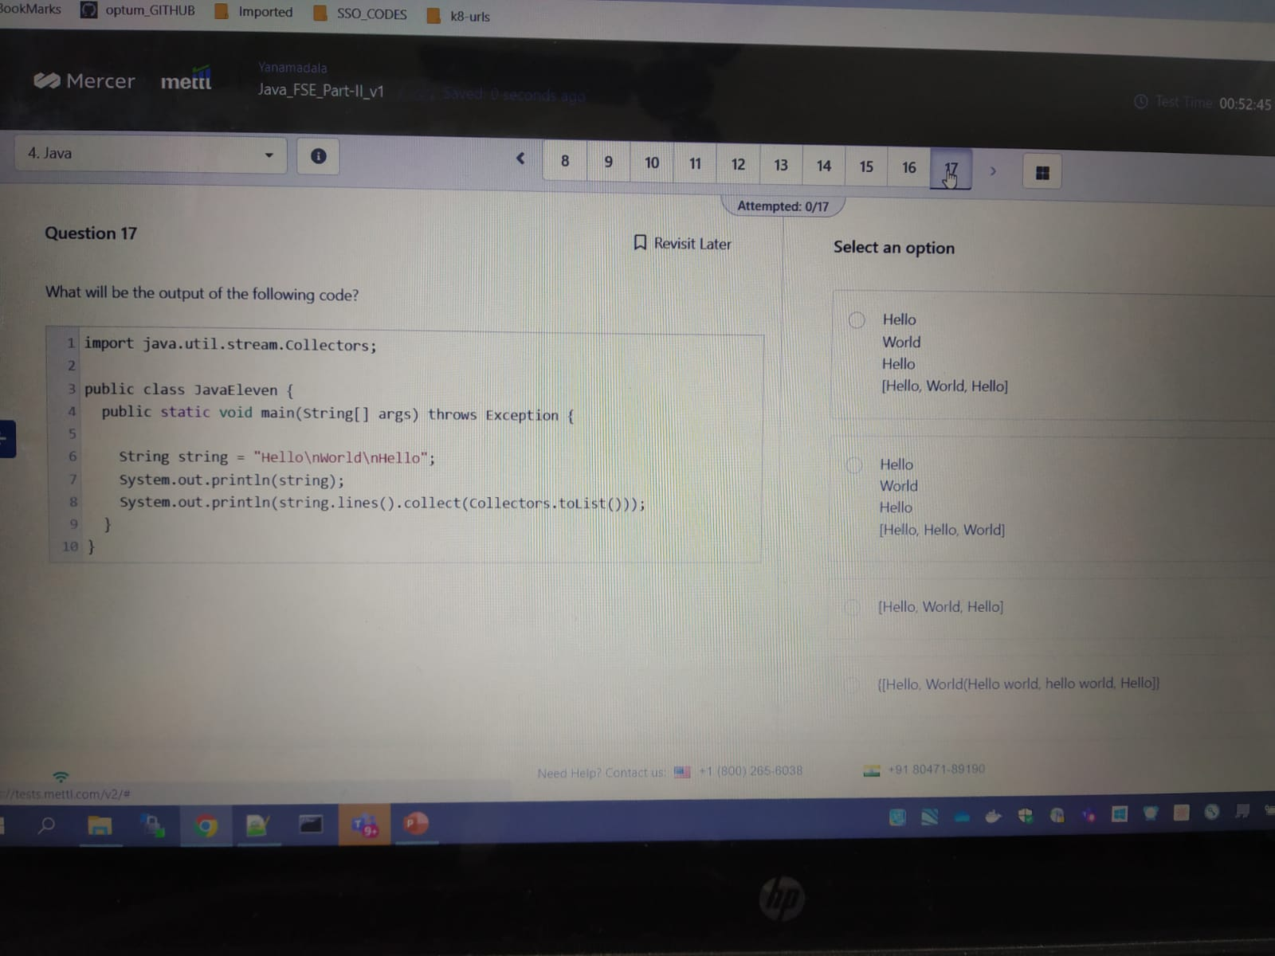

Q) what does the following line of code do ?

A)

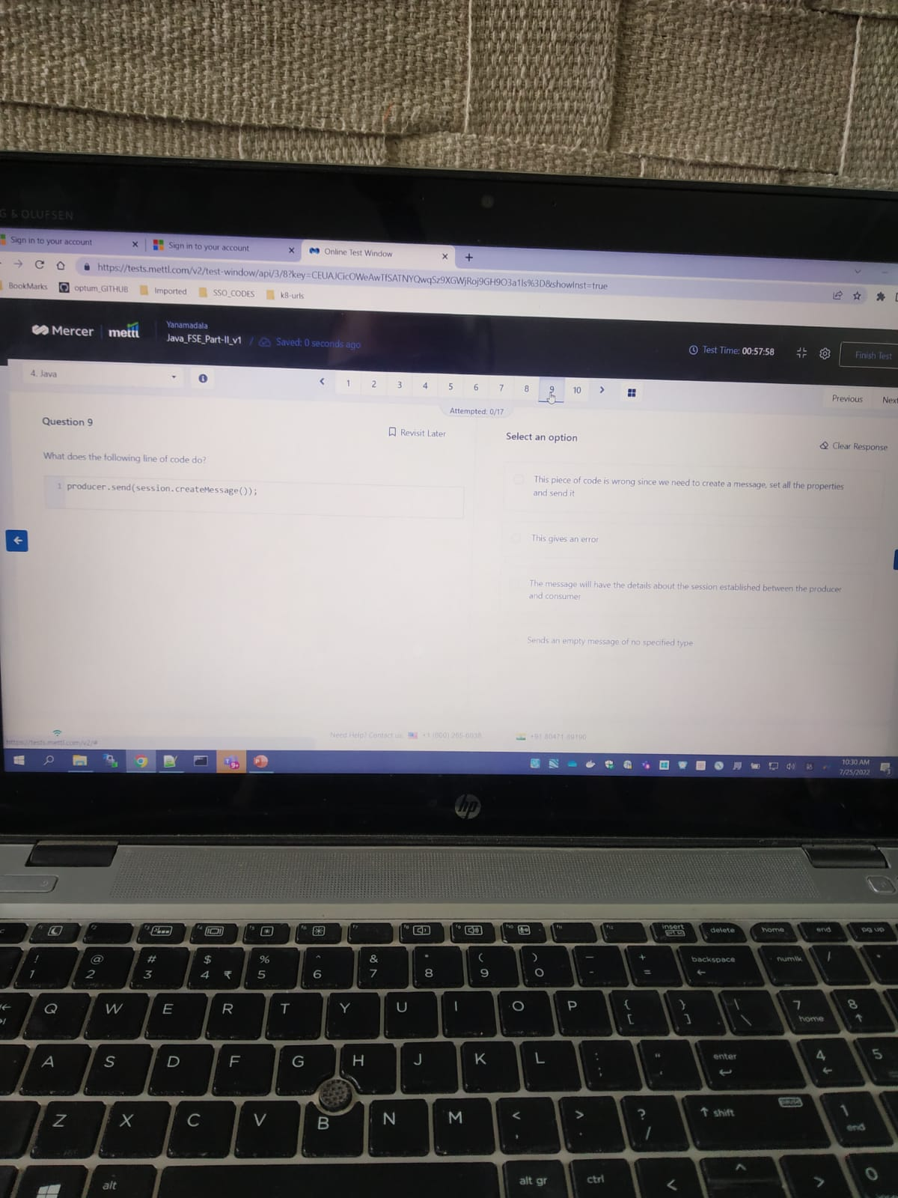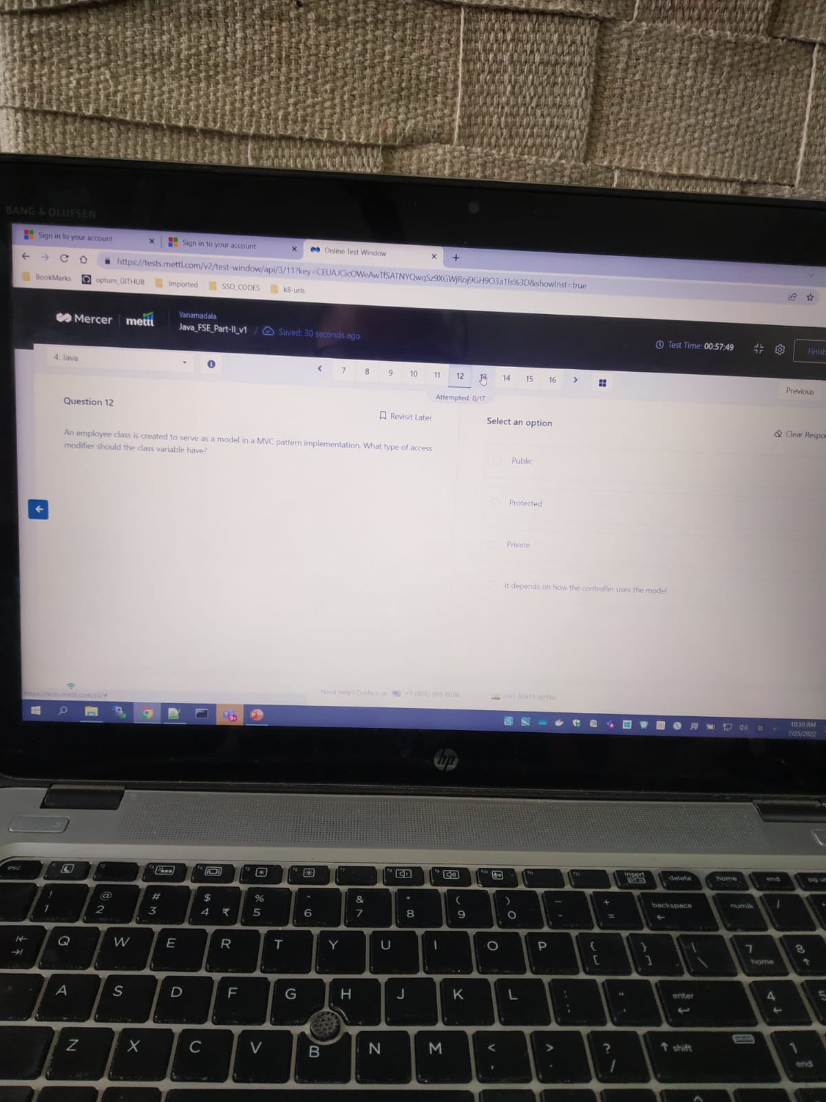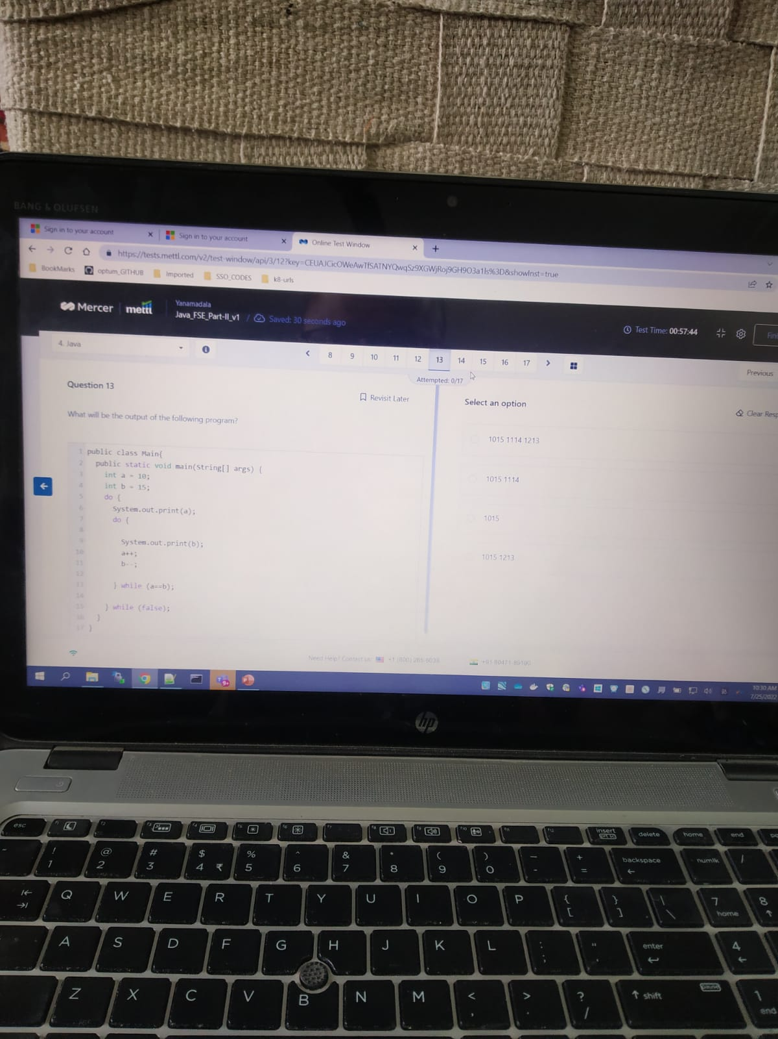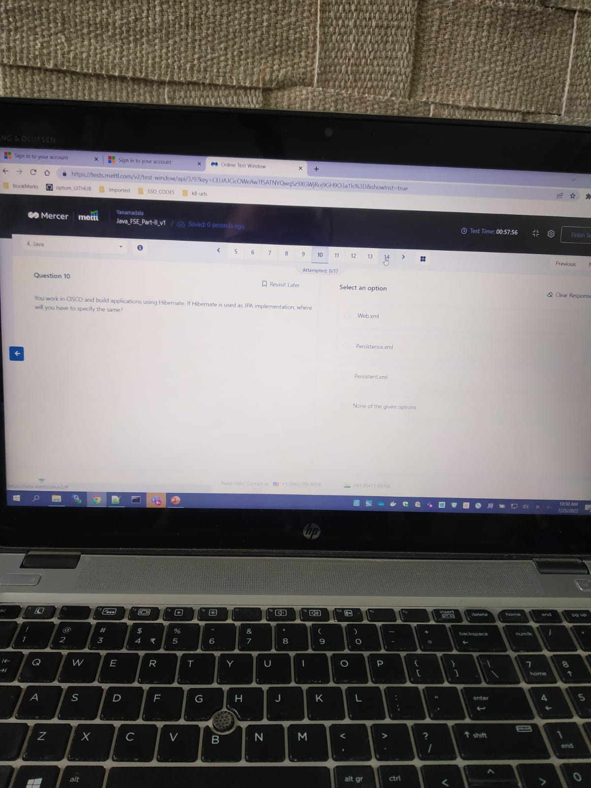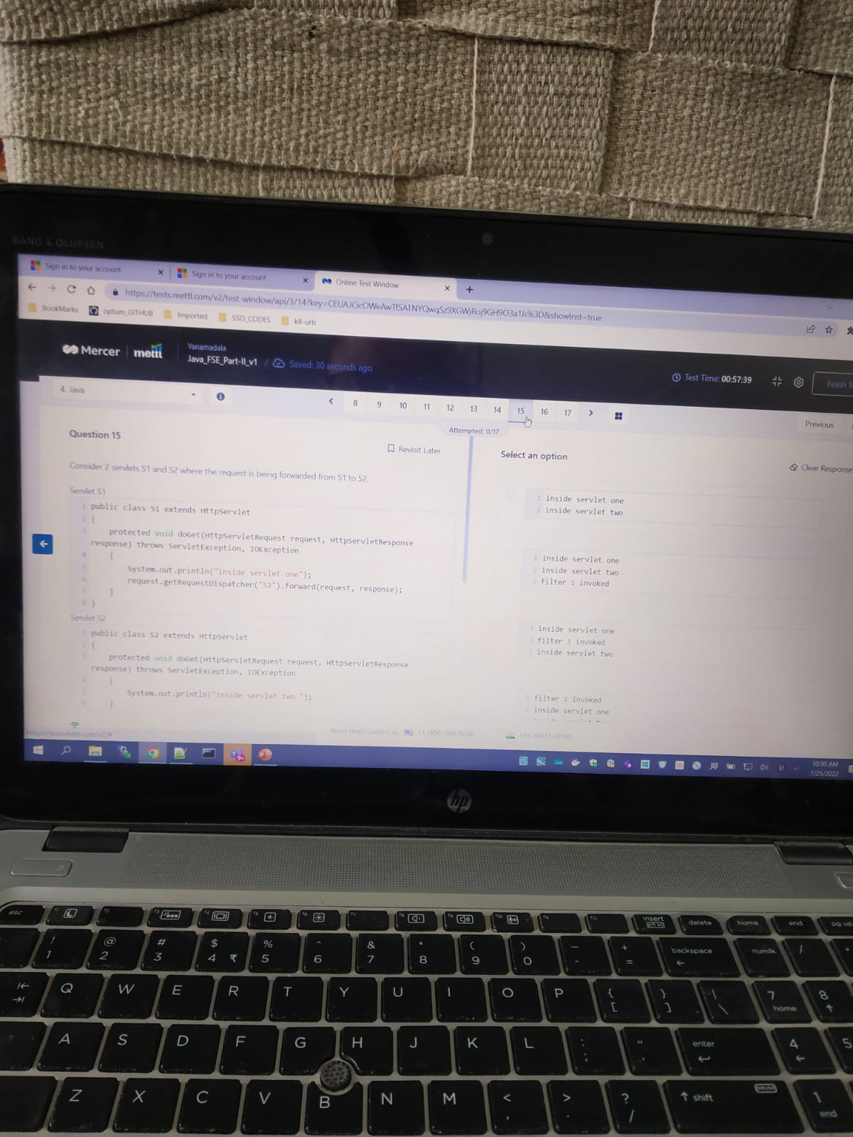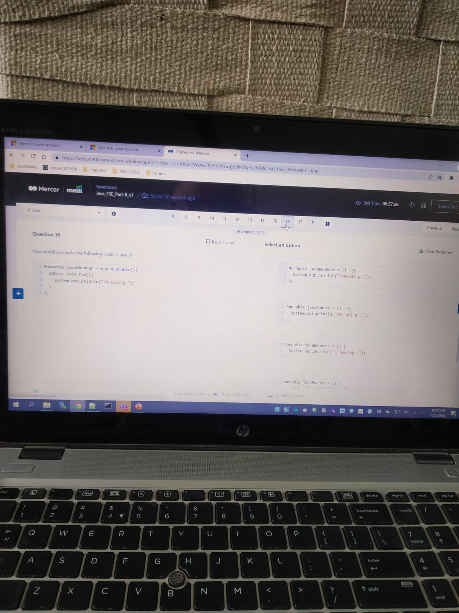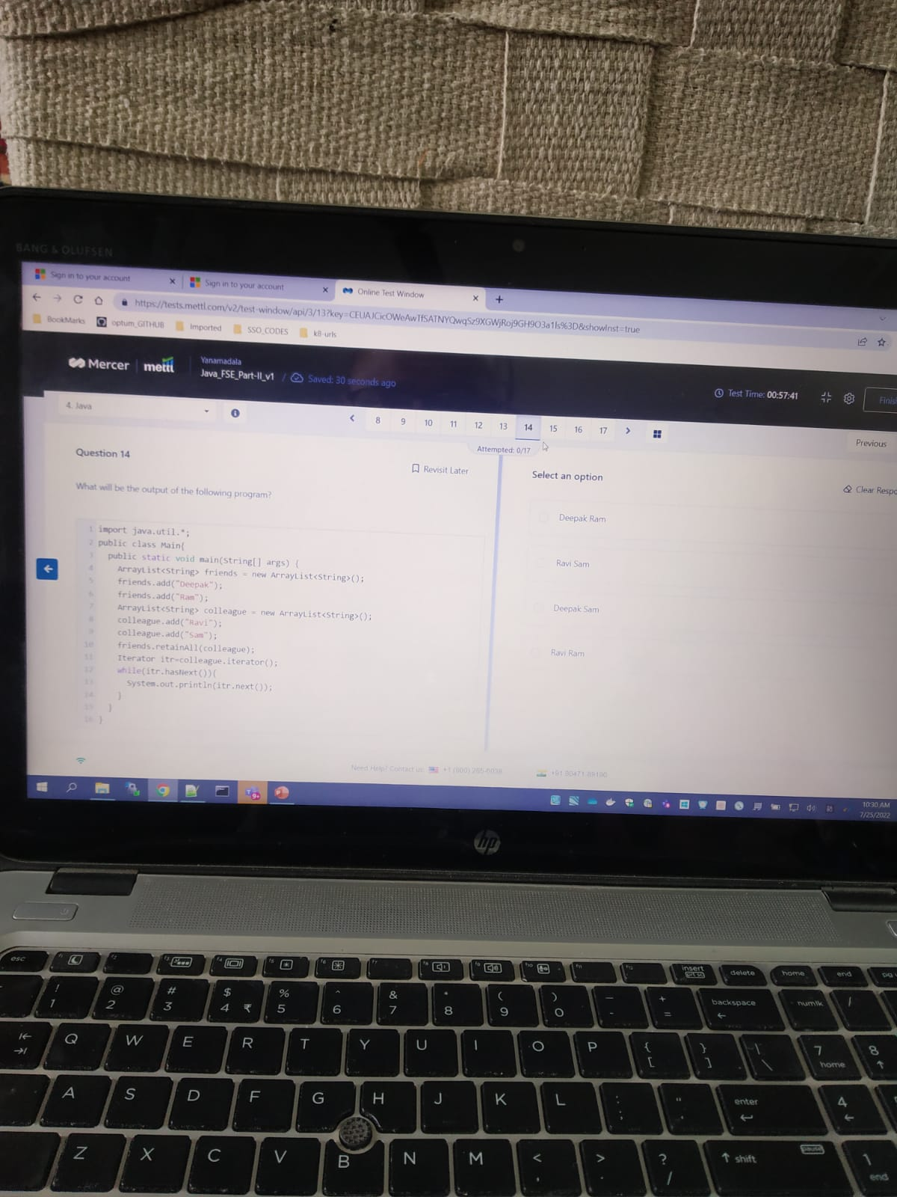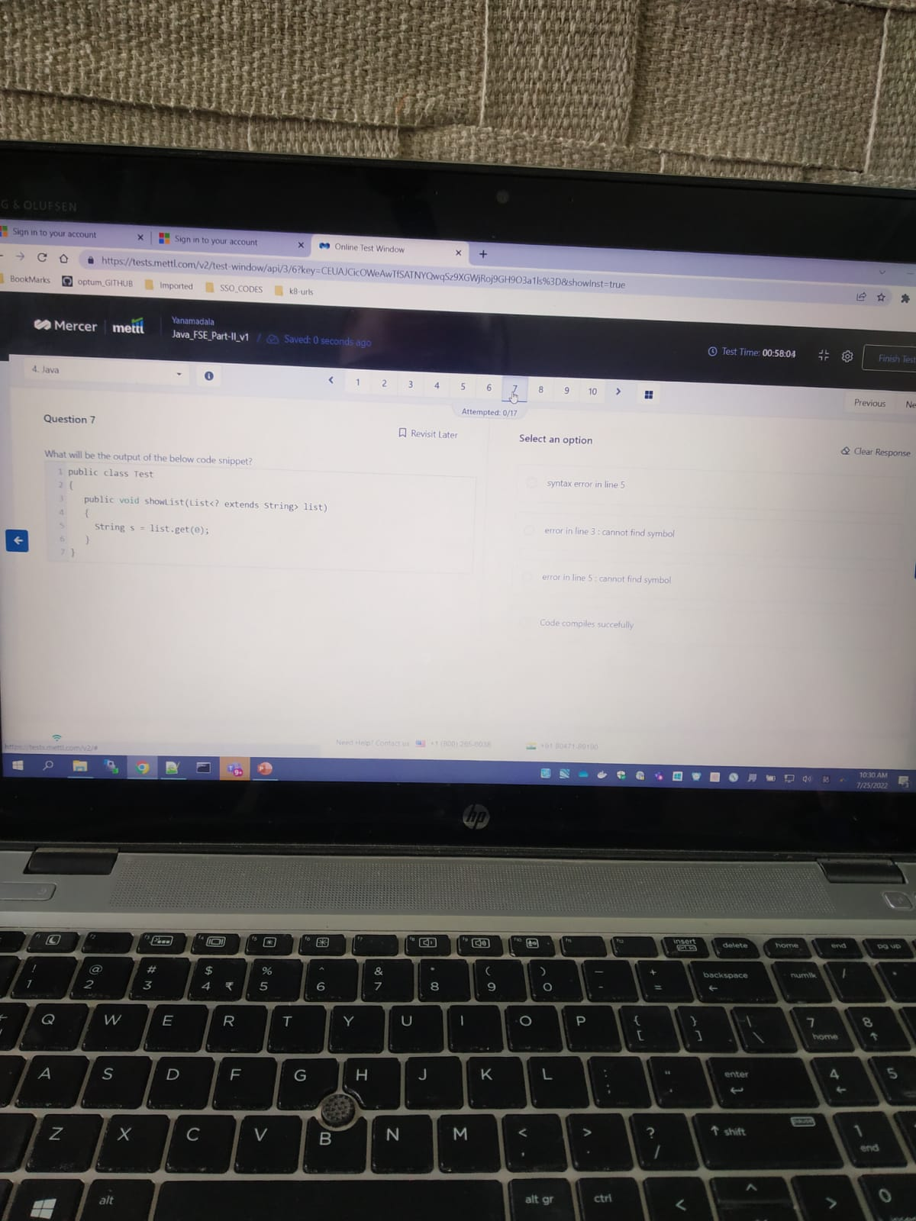

## Spring

8. in which of the following cases can the spring boot ..

A ) 4 (a b c)

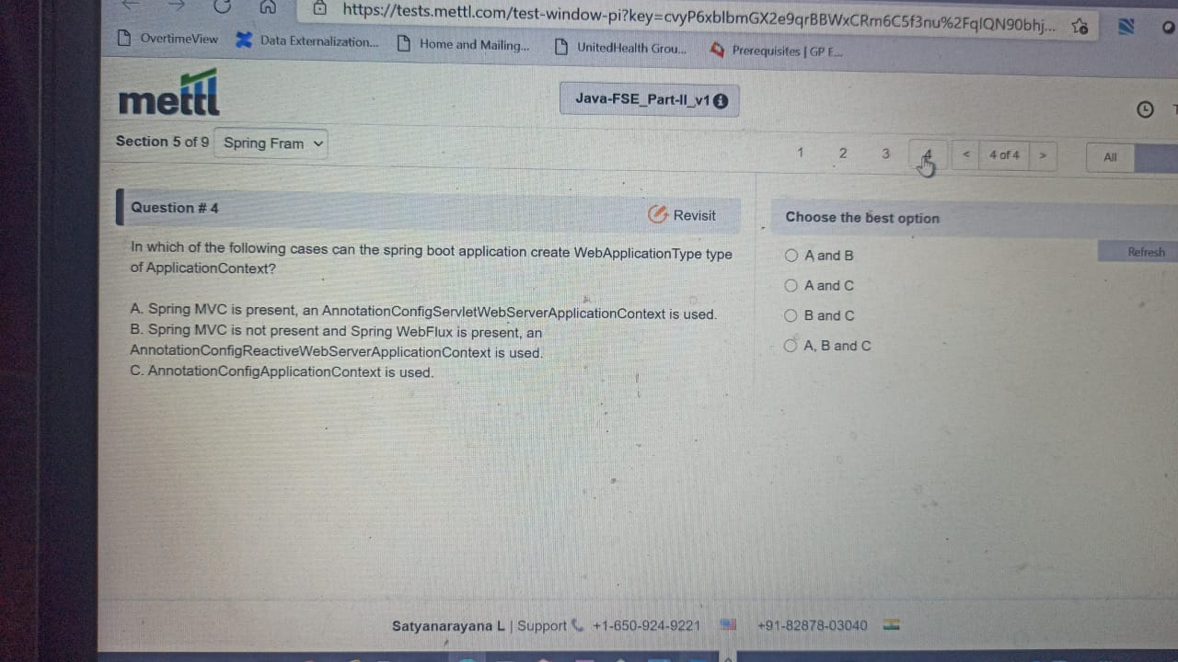

9. which of the following statements are true ?

A ) 2

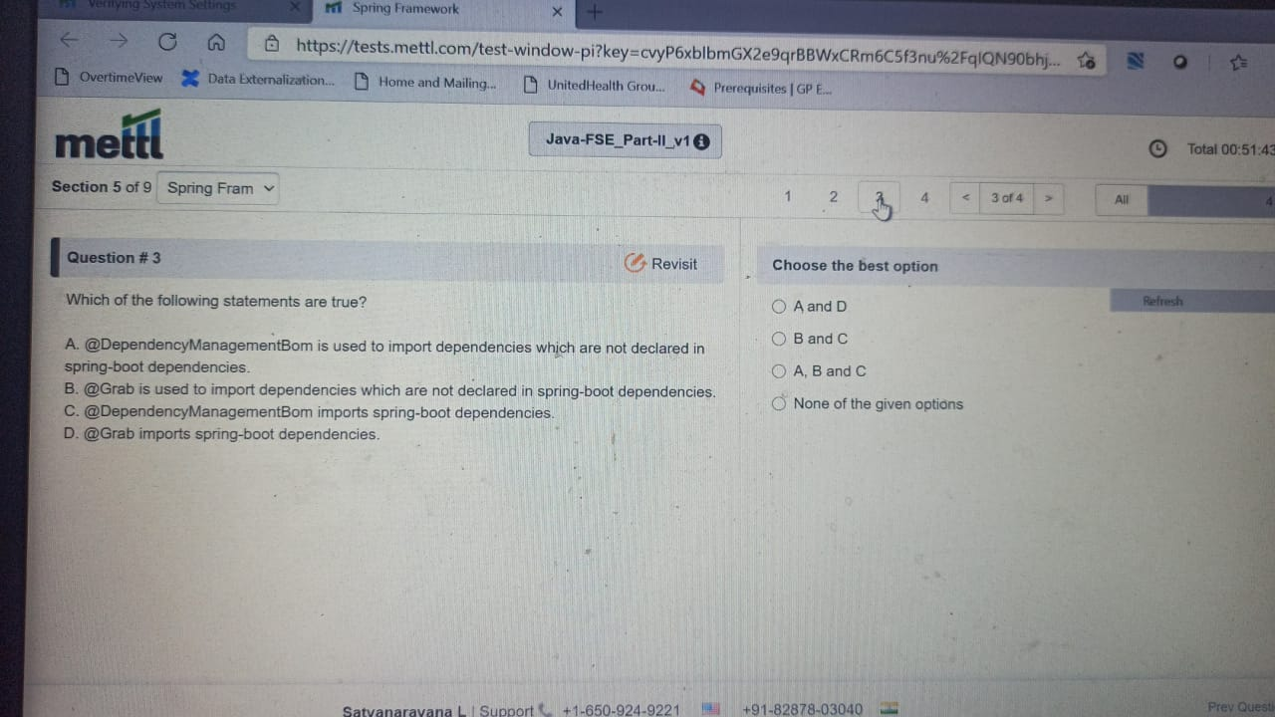

10 . while creating a spring mvc maven project in eclipse..

A ) 1 (maven archetype-webapp)

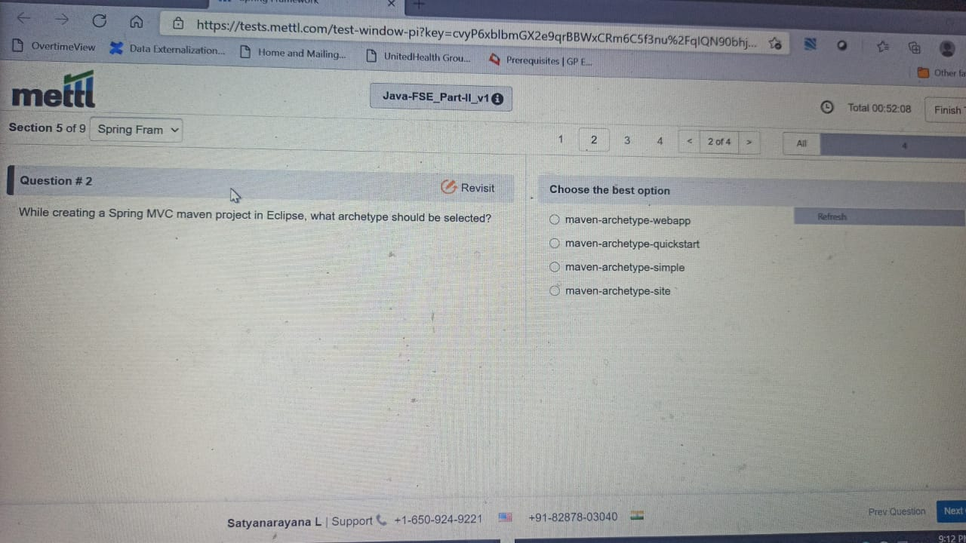

Q) how can you use the ‘p’ namespace to refer to the firstbean..

Ans: none of the above

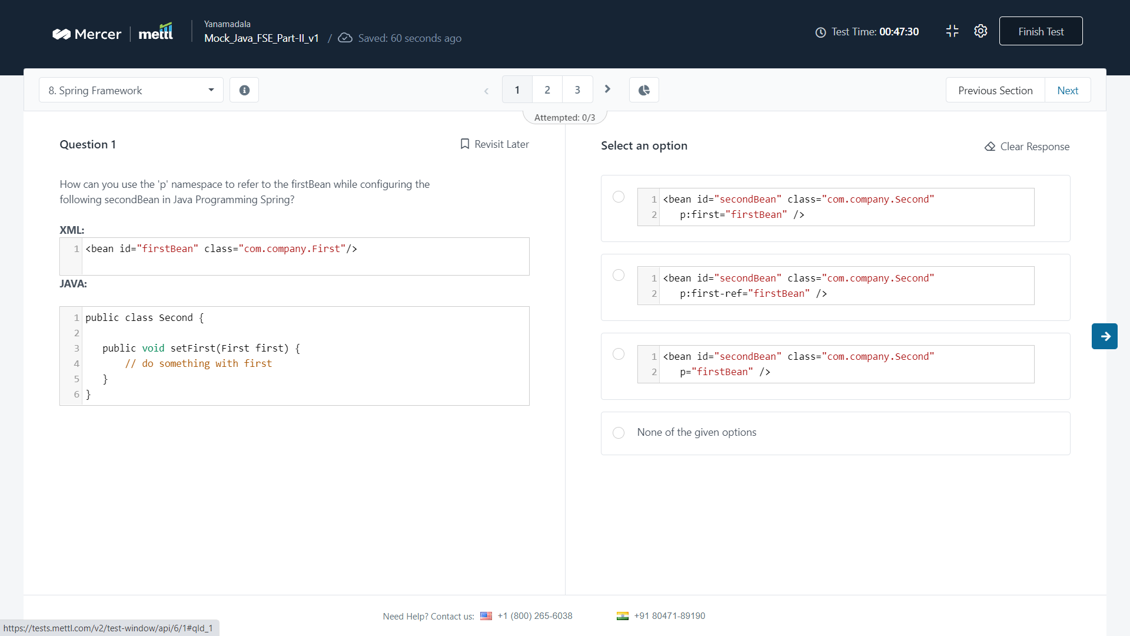

Q) which of the following configurations is appropriate to resolve the ..

Ans : 1 @Qualifier

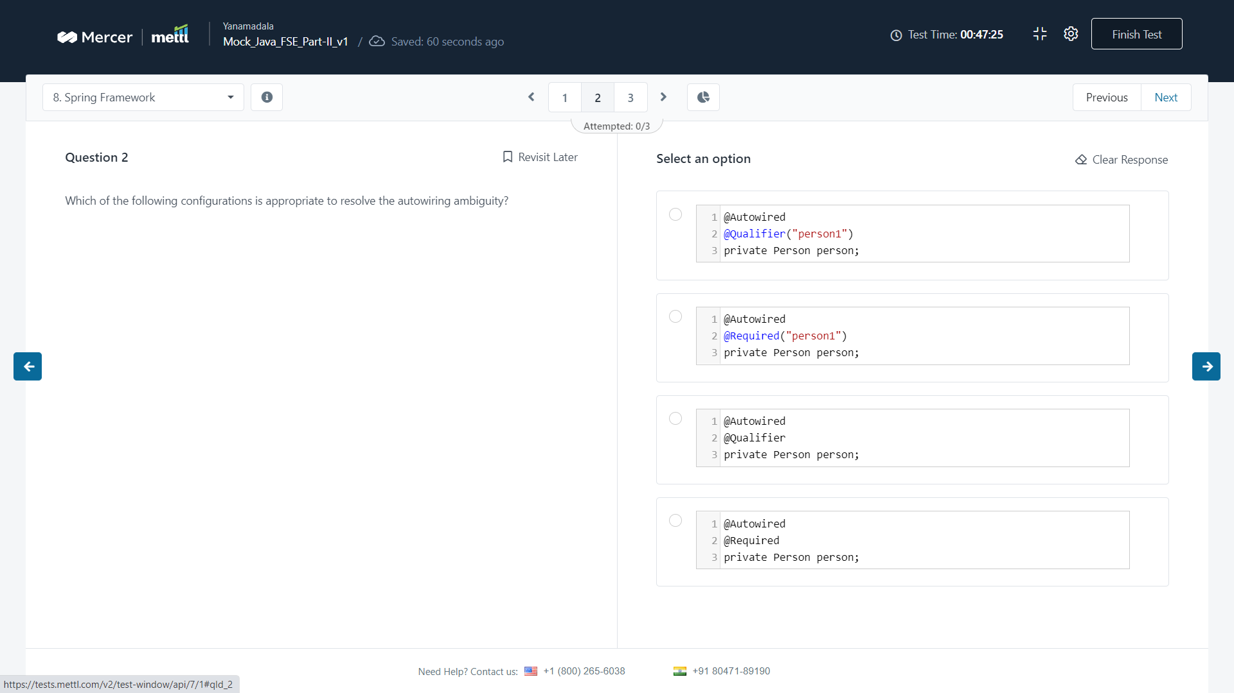

Q) which annotation(s) can be used to include the validation…

Ans : @notblank / all of the given options

Google search result below

* *@NotNull:* a constrained *CharSequence*, *Collection*, *Map,* or *Array* is valid as long as it's not null, but it can be empty.
* *@NotEmpty:* a constrained *CharSequence*, *Collection*, *Map,* or *Array* is valid as long as it's not null, and its size/length is greater than zero.
* *@NotBlank:* a constrained *String* is valid as long as it's not null, and the trimmed length is greater than zero.

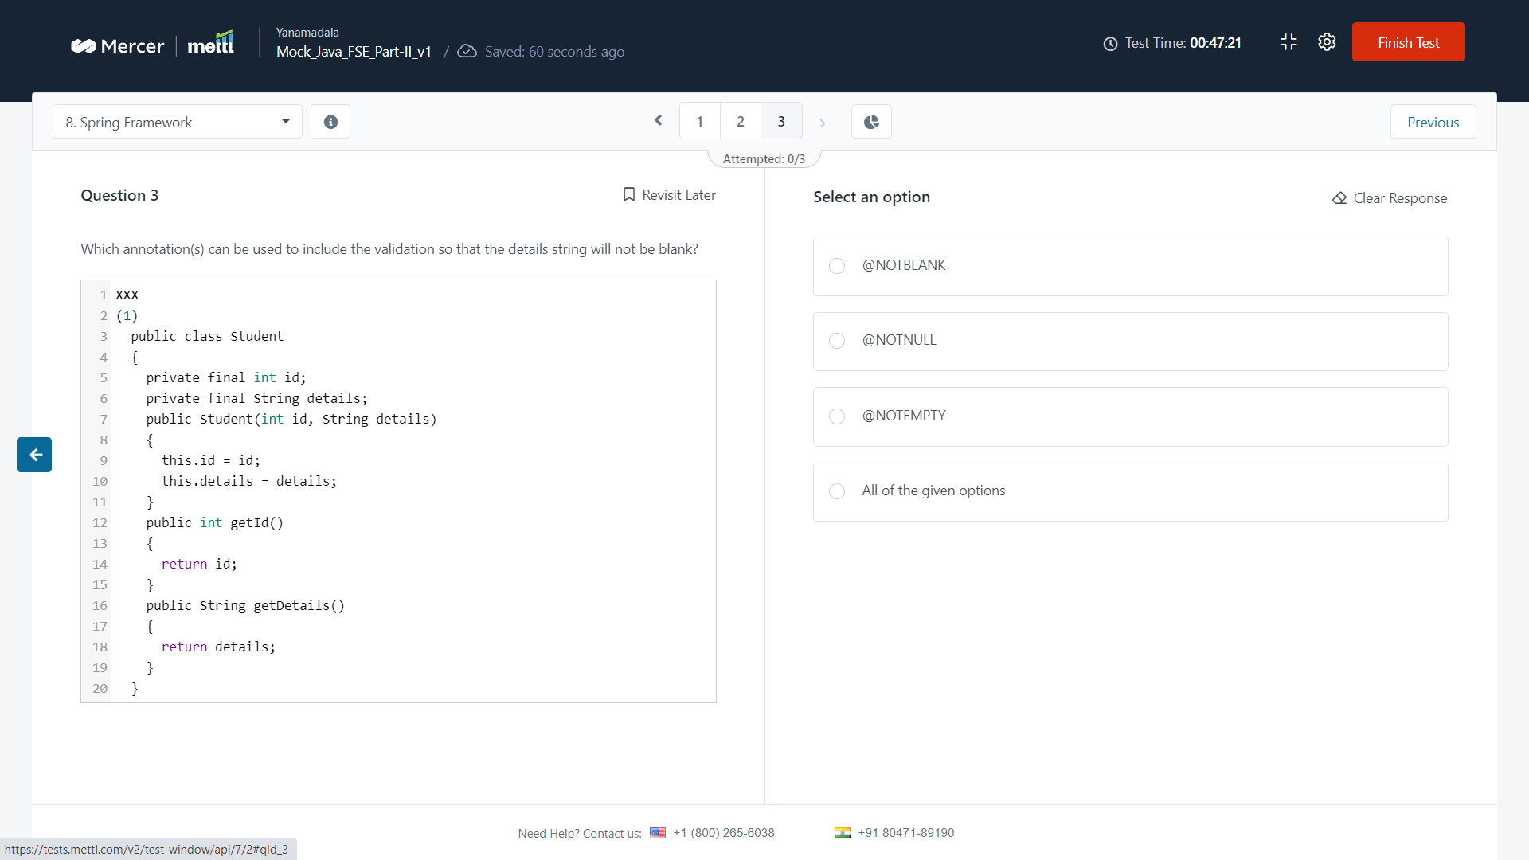

Q) which of the following steps is not a part of dispatcherServlet’s request response flow ?

Ans : 1

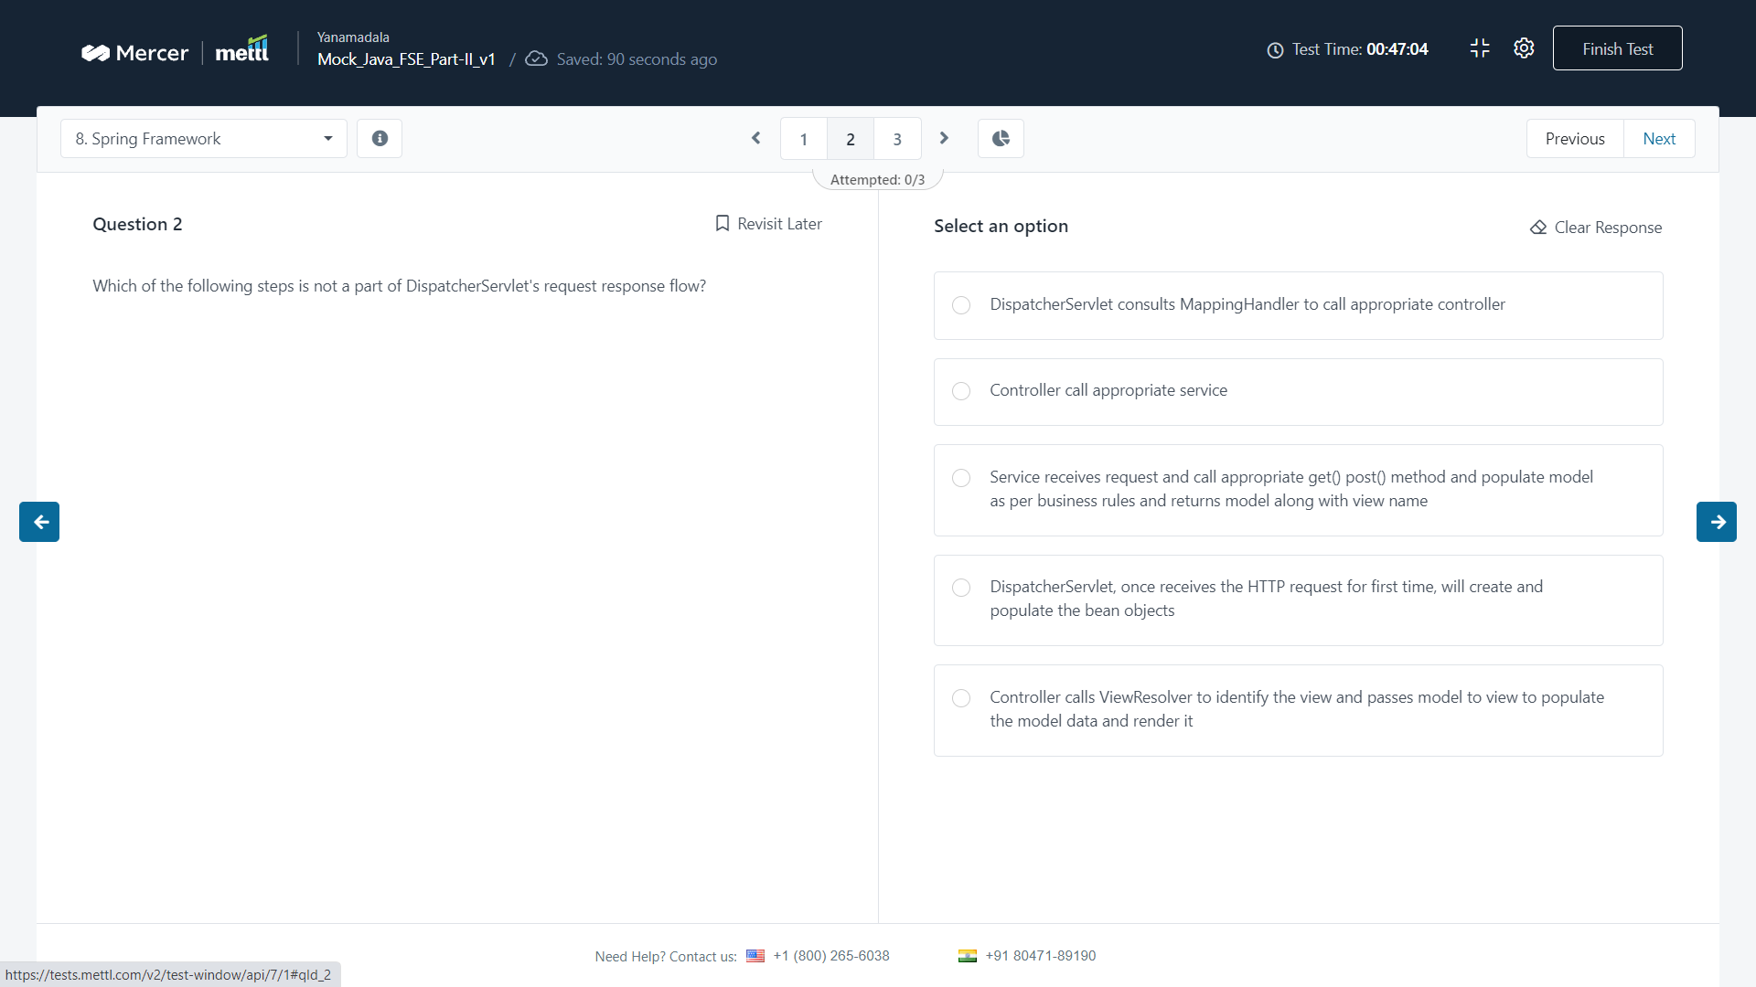

Q) you have created a spring boot application and your application.yml file code looks as

Ans : @Value

Q) when does the init() method of servlet get invoked ?

A) 1

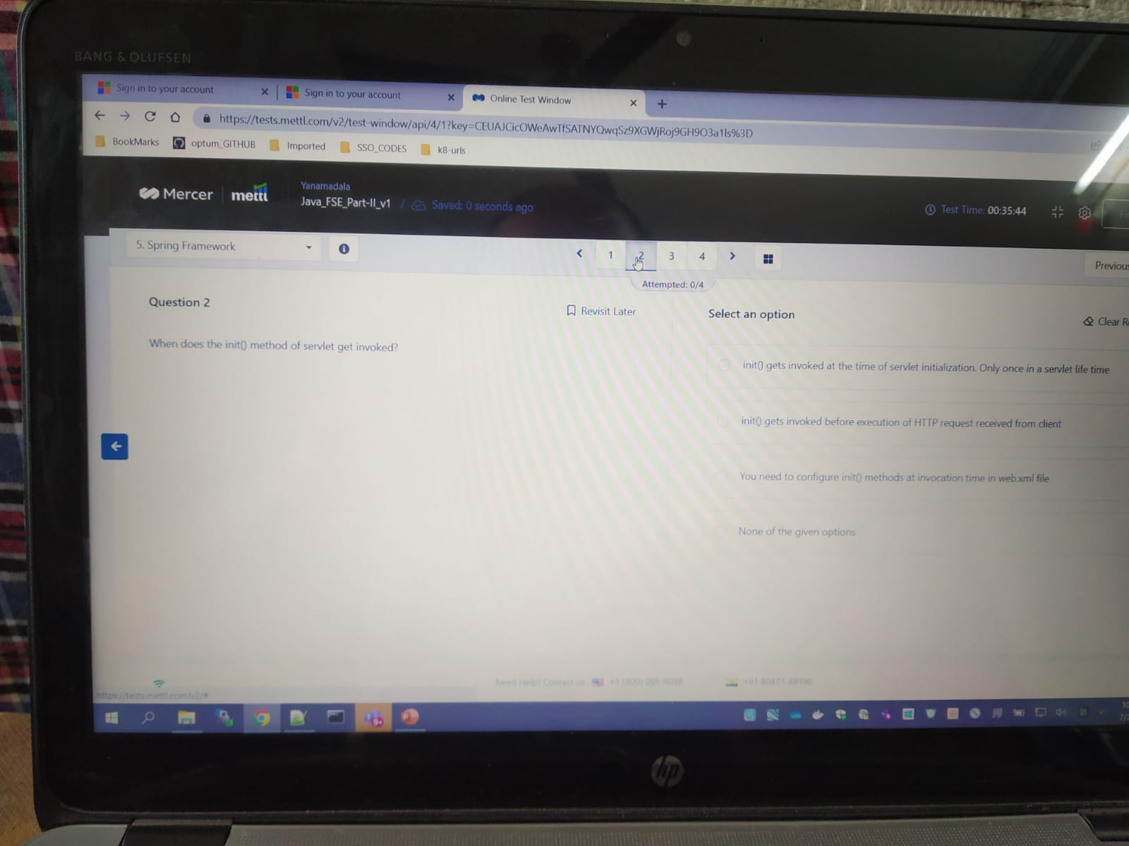

Q) the following application hosted at “http://localhost:8080..

A) 4 ?

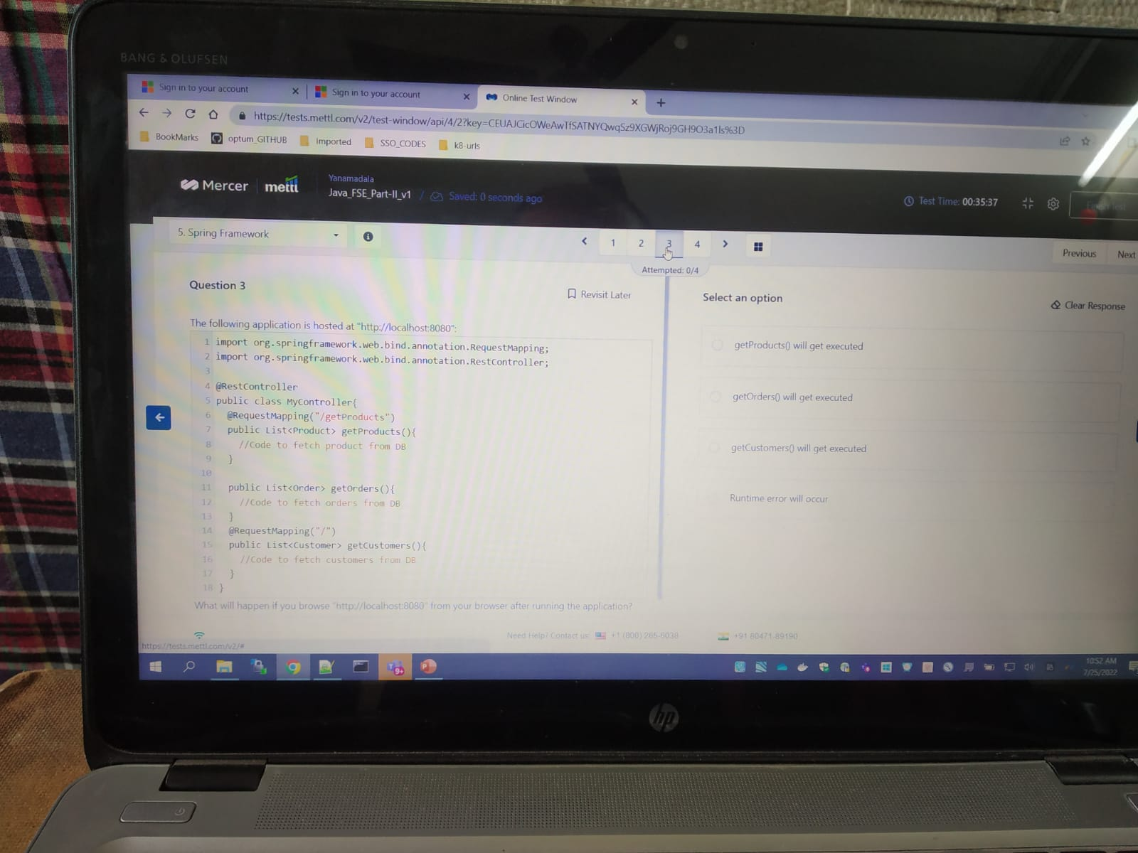

Q) in the following aspect, which method(s) will the advice run against

A) 4 ?

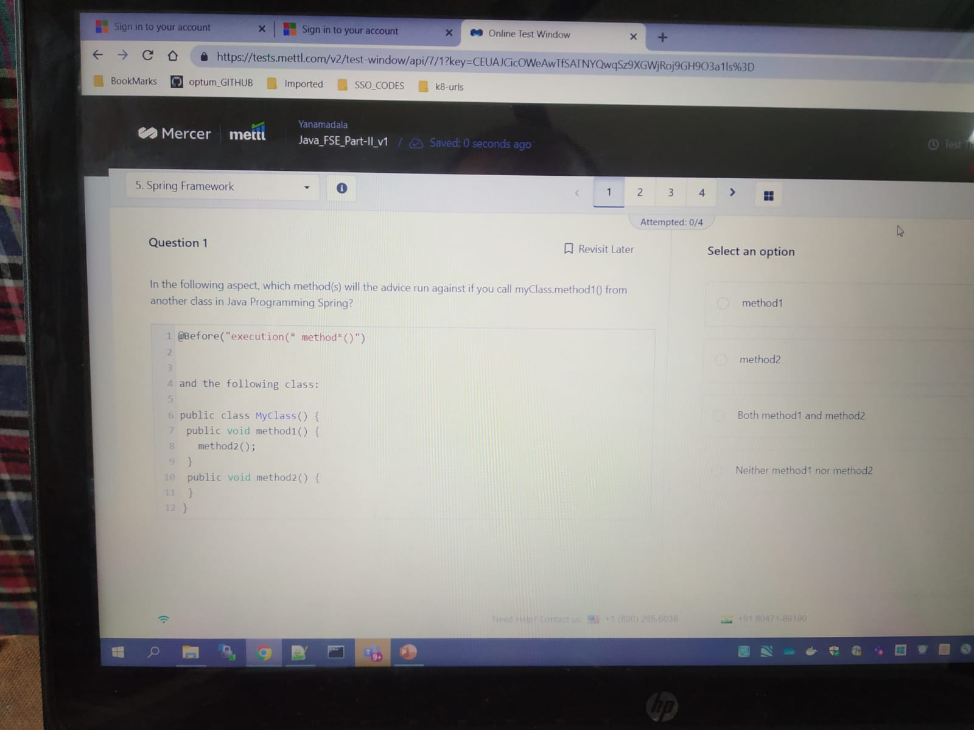

Q) you have created a spring boot application and your application.yml file code ...

A) ask satya

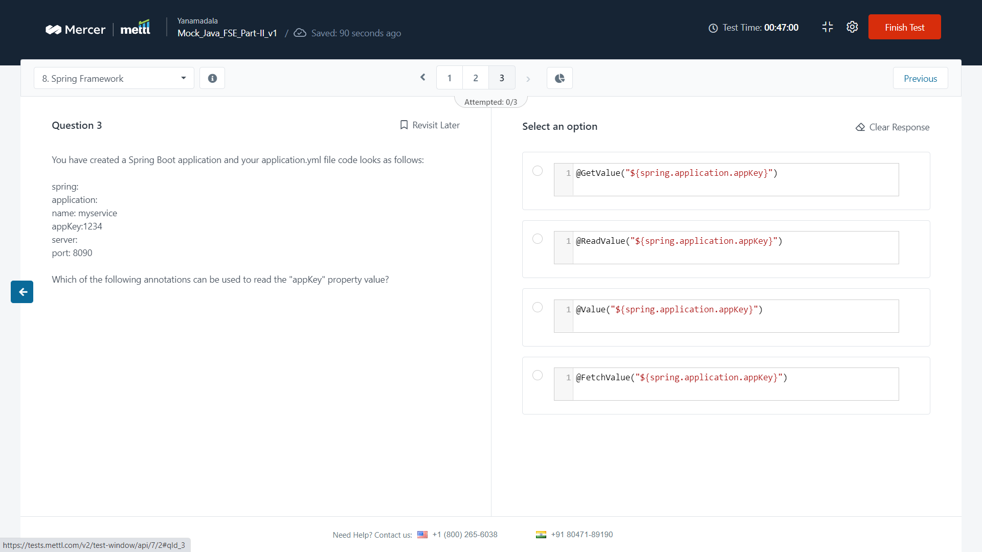

Q) in the given student controller class, which url is likely to serve

A) 4 ?

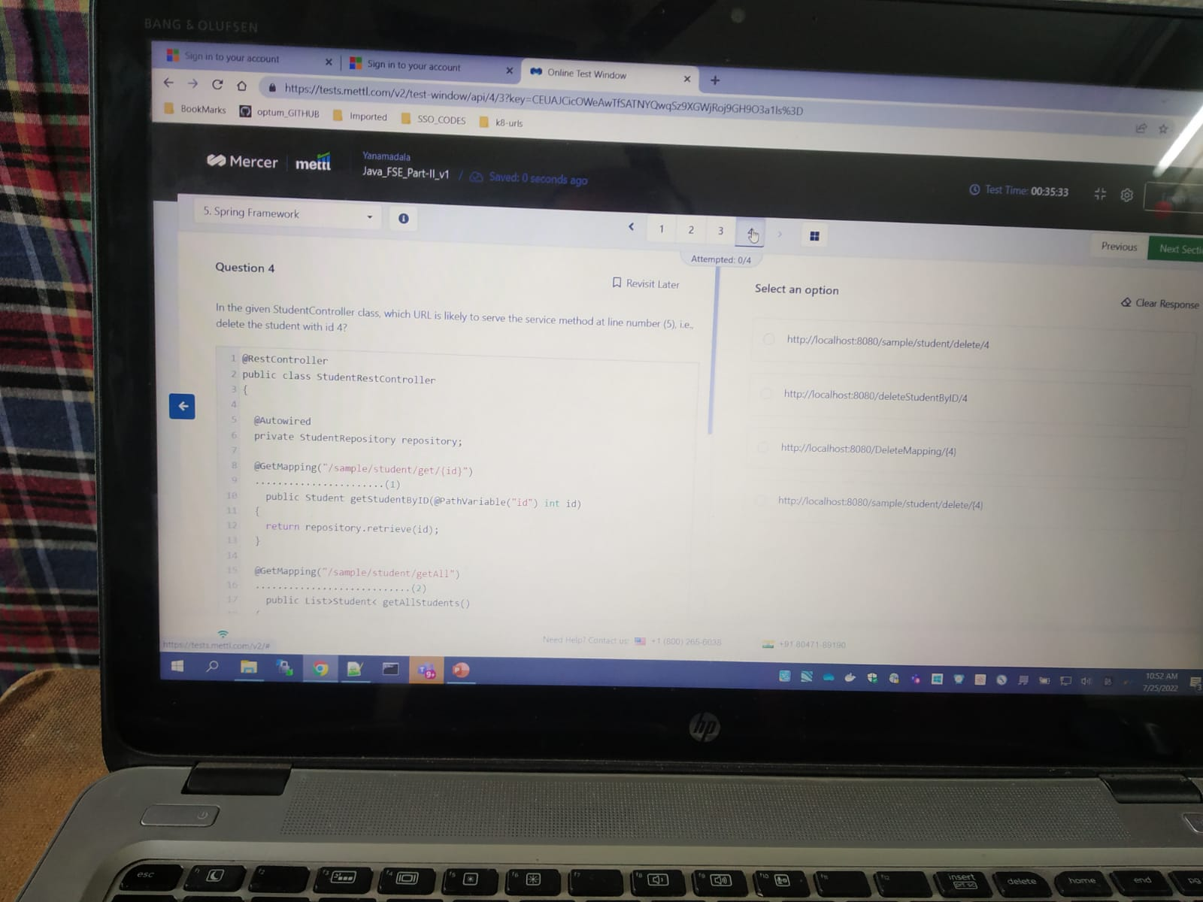

## Hands-on program

1. Sherlock received … java program

A ) Found in chegg. Program is there but answer not coming

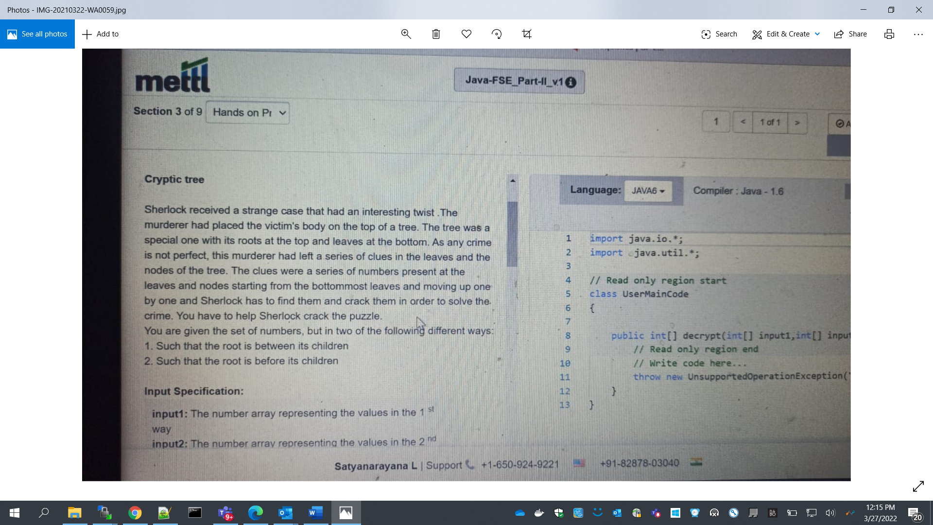

Q) You have developed an e-commerce website. Many people..

1. Ans is there in Cheg telegram

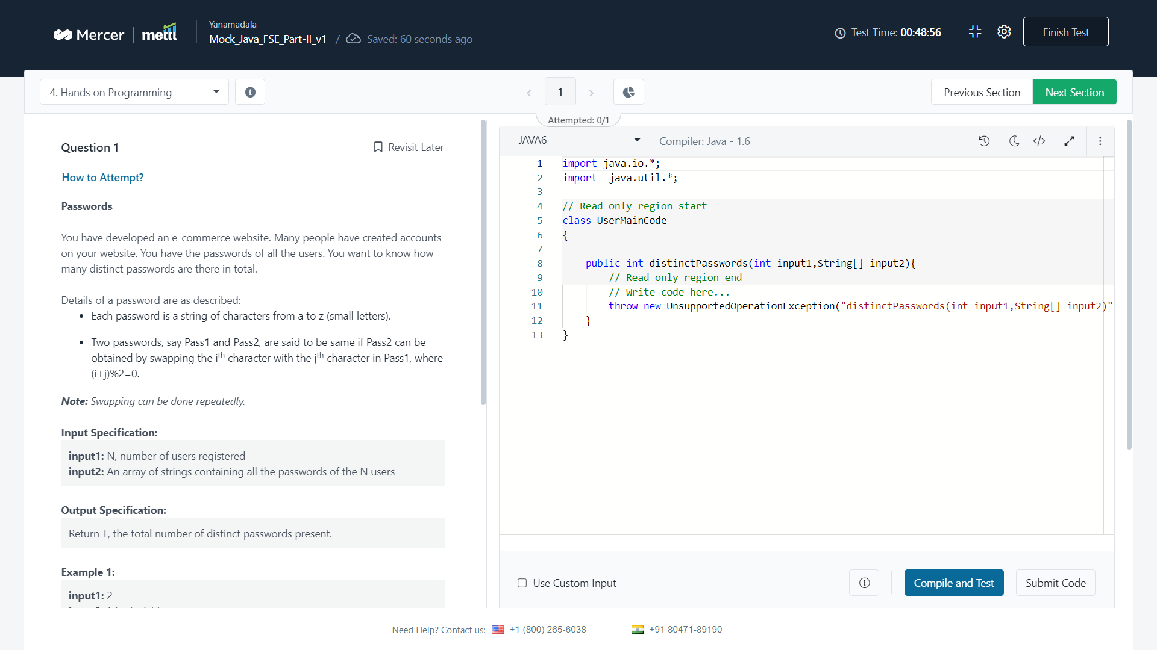



Q) A company has hired N interns, labeled from 1 to N. each intern is given a device..

A) written below after image

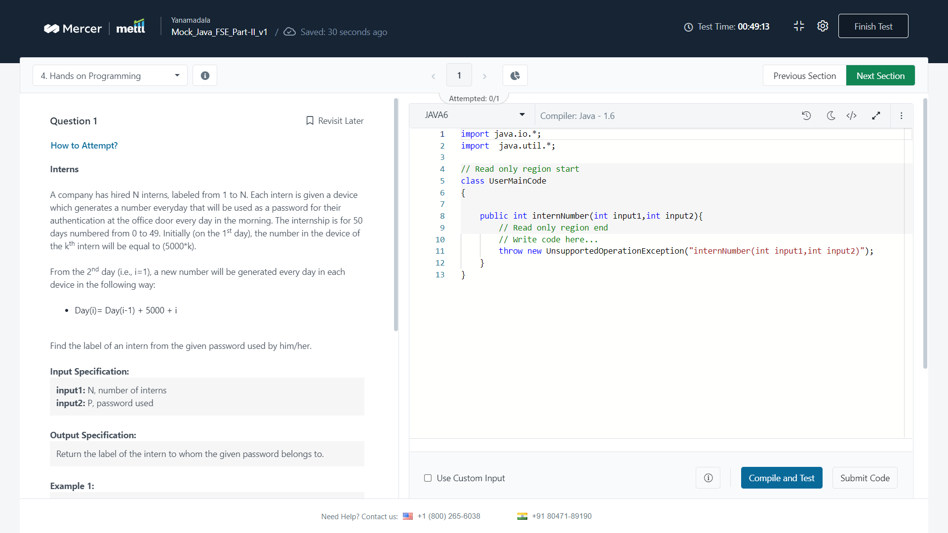

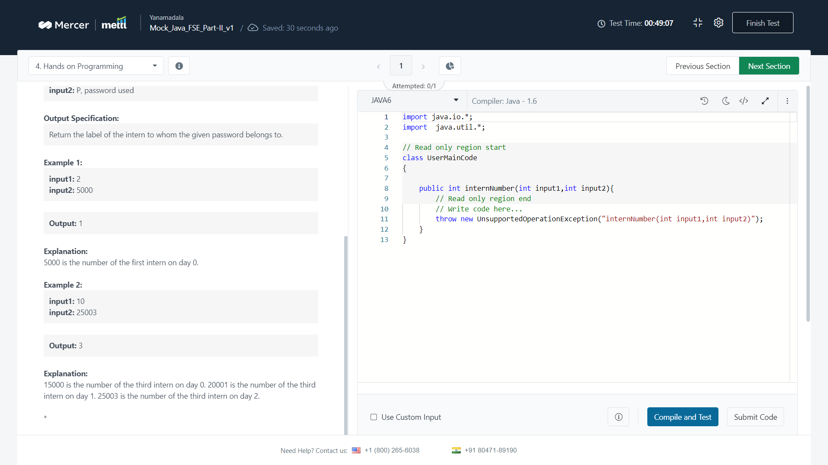

Program :

Solution :

package com.uhg.mdm;

import java.io.IOException;

import java.util.*;

import java.util.stream.Collectors;

public class Myclass{

static int interns(int n, int p){

int finalval = 0;

for(int i = 0; i < n; i++) {

int[] pass = new int[50];

pass[0] = (i*5000);

if(pass[0] == p){

//System.out.println("output... :"+ 1);

finalval = 1;

return finalval;

// break;

}

for(int j = 1; j < 49; j++) {

pass[j] = pass[j-1] +(5000)+j;

if(pass[j] == p){

// System.out.println("output :"+ (j+1));

finalval = j + 1;

return finalval;

}

}

}

return finalval;

}

public static void main(String[] args) throws Exception {

int n = Integer.parseInt(args[0]);

int p = Integer.parseInt(args[1]);

System.out.println("input n "+n);

System.out.println("input p "+p);

System.out.println( interns(n,p) );

}

}

Q) a boy is lost in an infinitely long 1 dimensional jungle.

A) ?

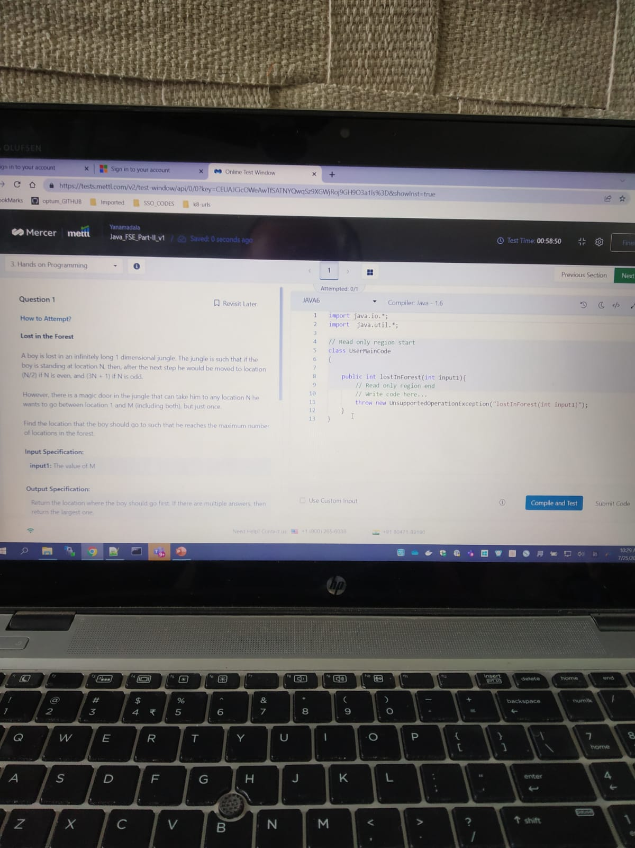

## Front End – Angular

What does the following property describe ?

Ans : 2

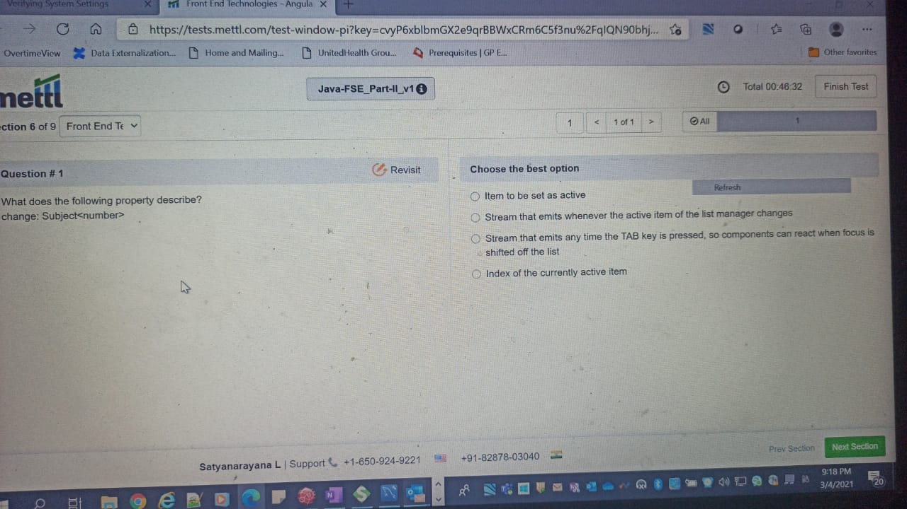

Identify the equivalent to the following

Ans : 1

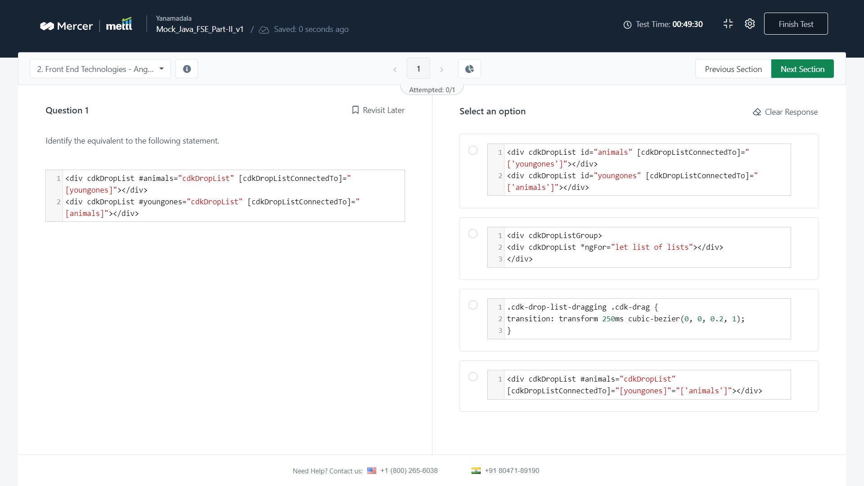

Q) which of the following is the correct import for the scrolling…

Ans : 3

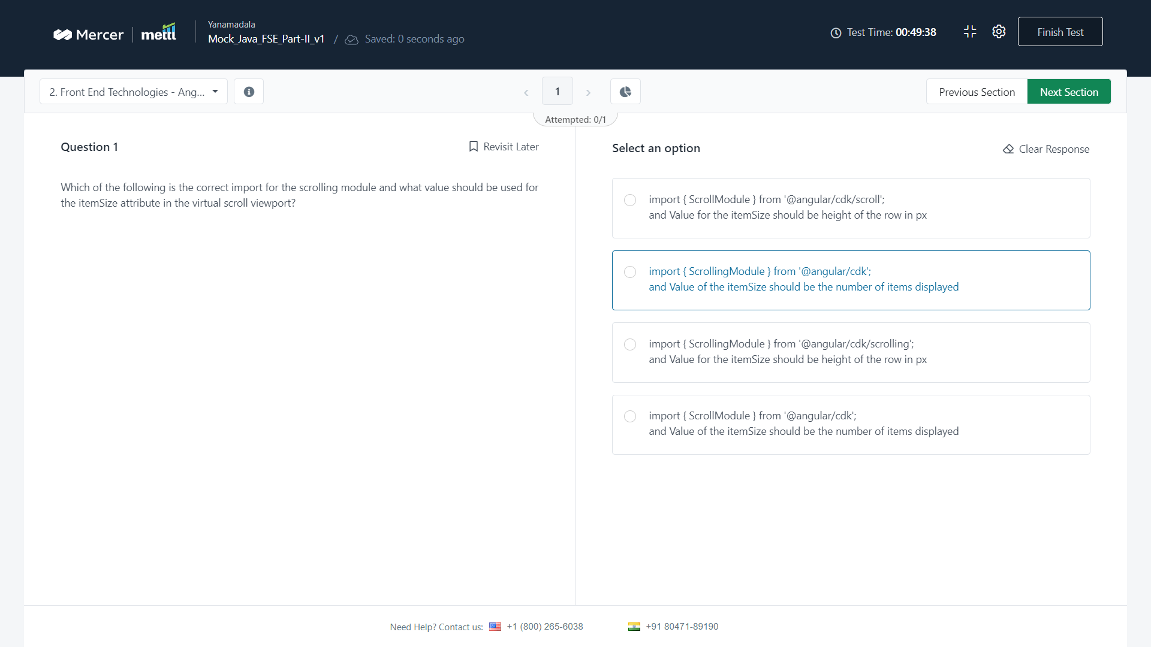

## Front End – ReactJs

In ReactJs, how will you add react dependencies

Ans : 4

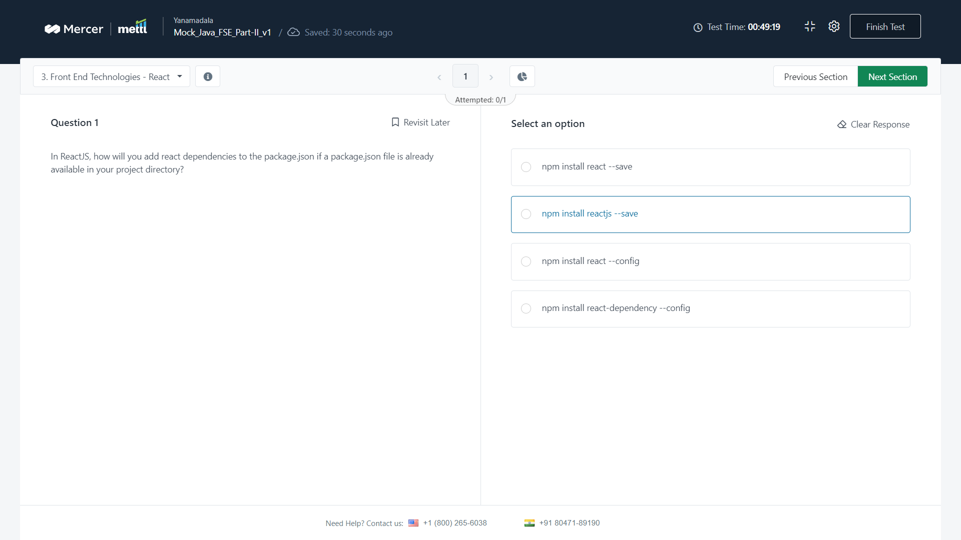

Q) In ReactJS, which of the following react components will be throw an error..

Ans : 2

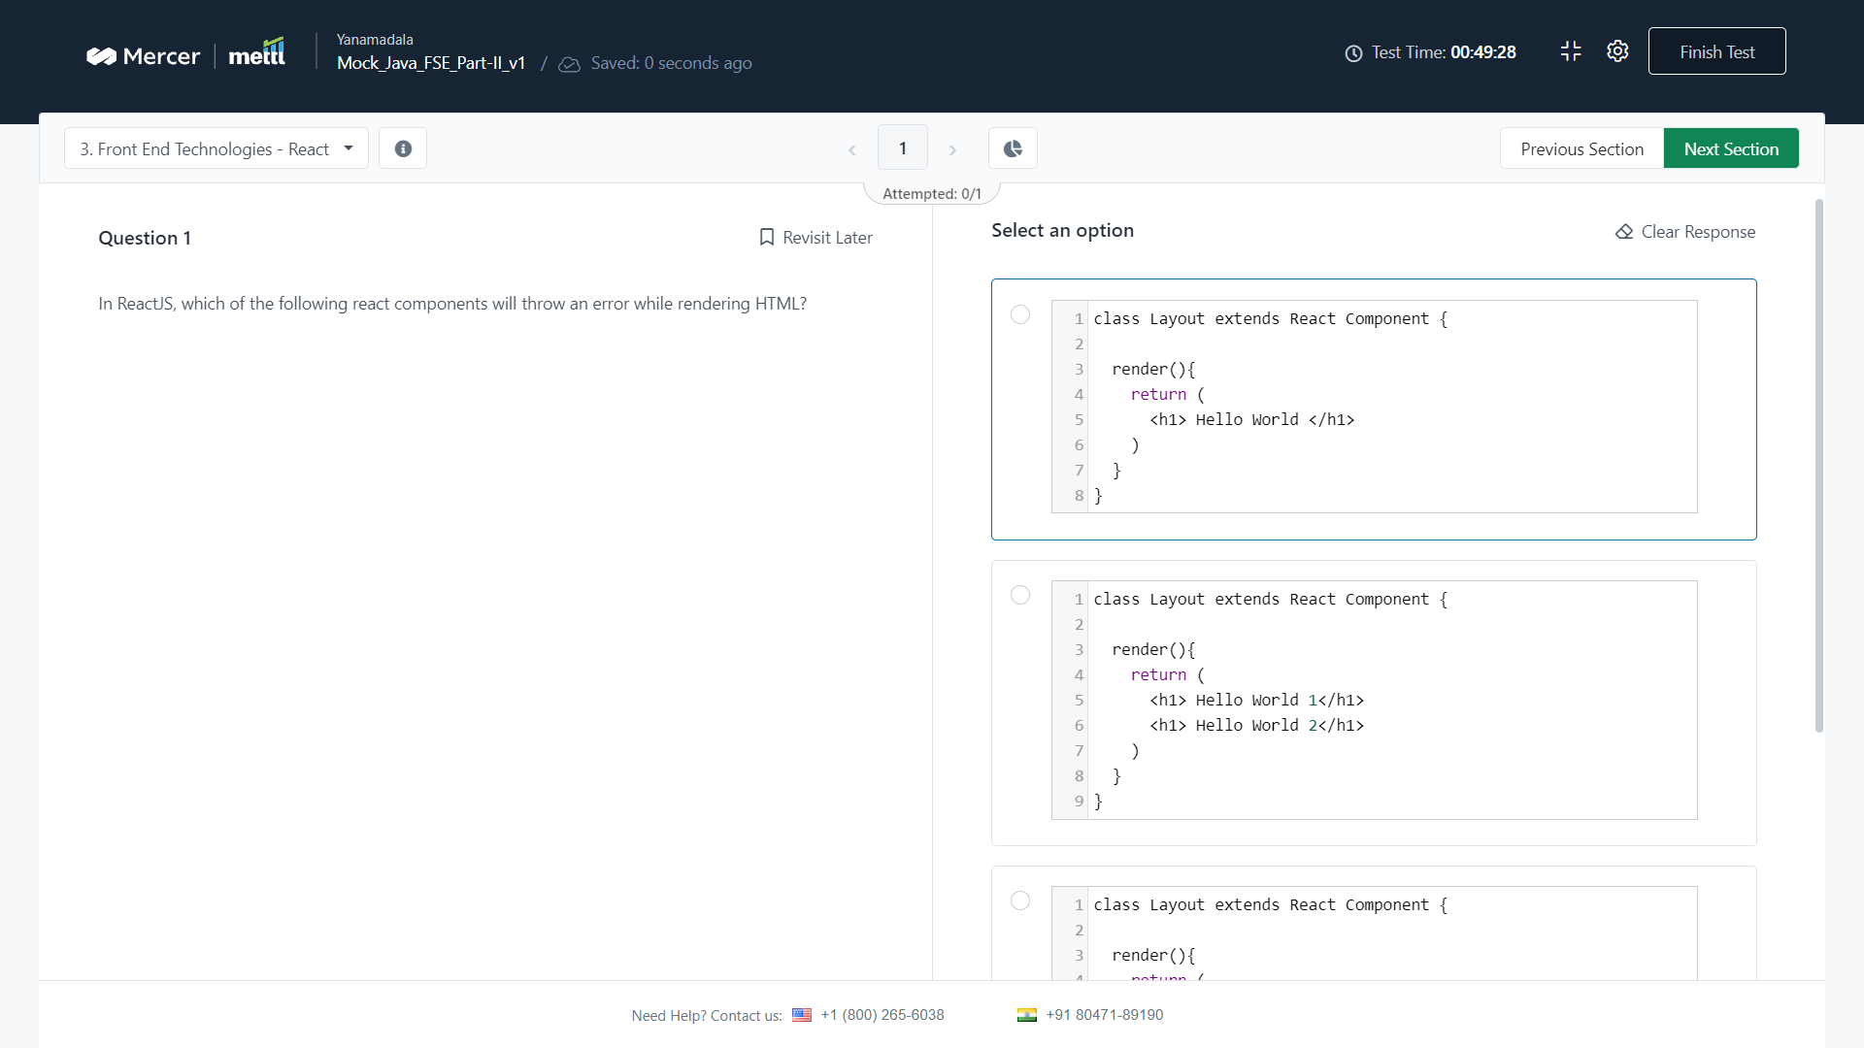

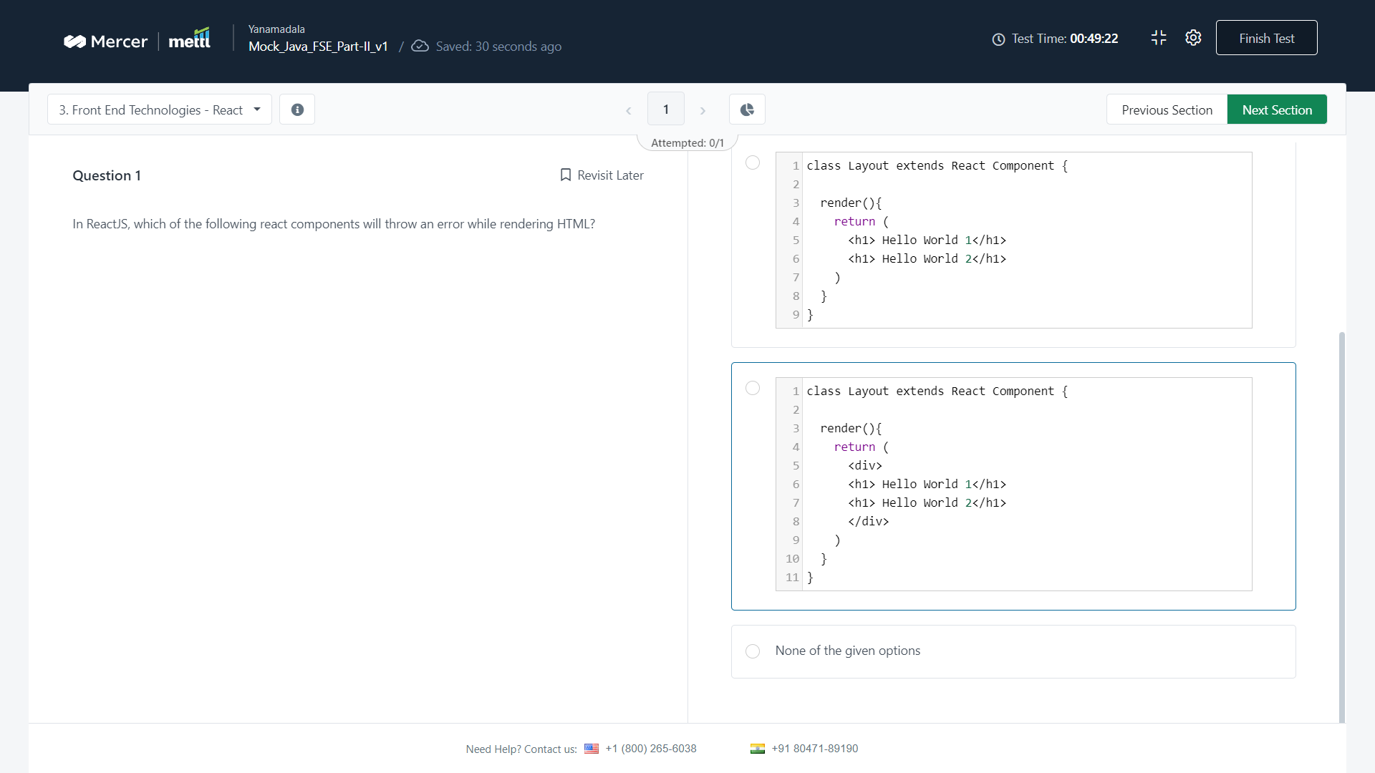

## Java WebServices

Q) which of the following classes can be used…

A ) 2 ResponseBuilder

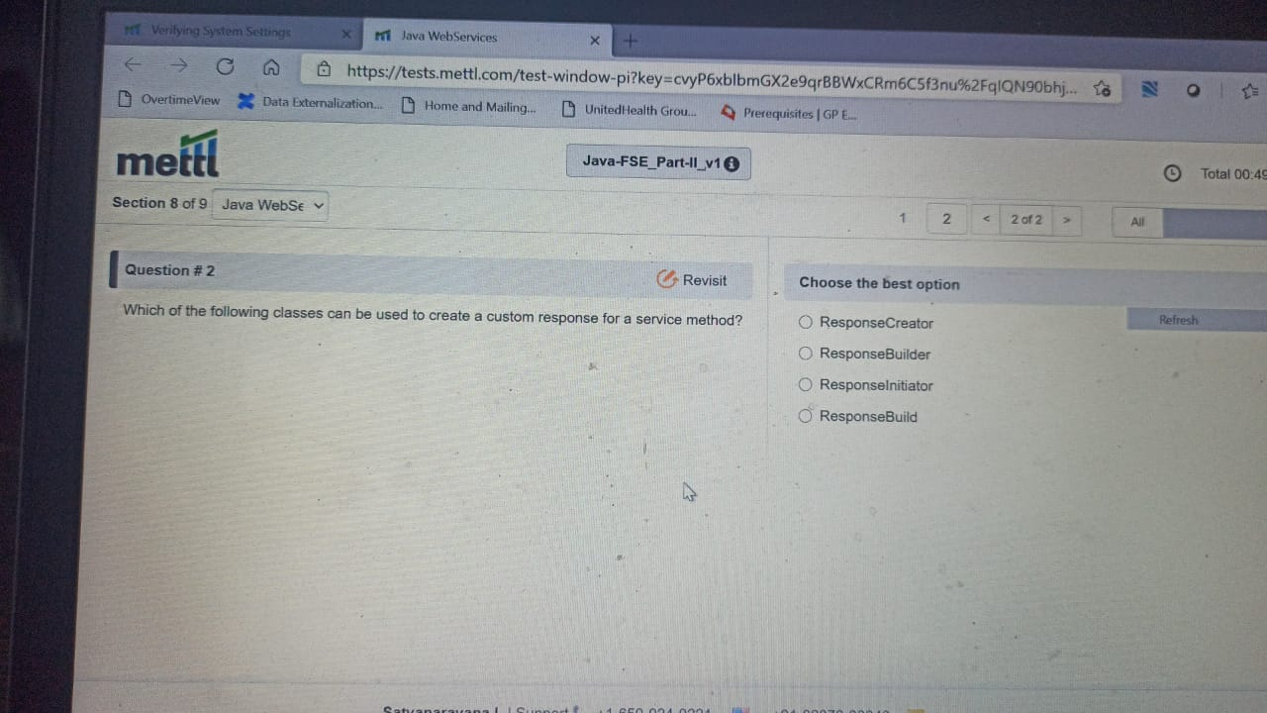

Q) as per web services concepts, web services have what type of data

A ) 2

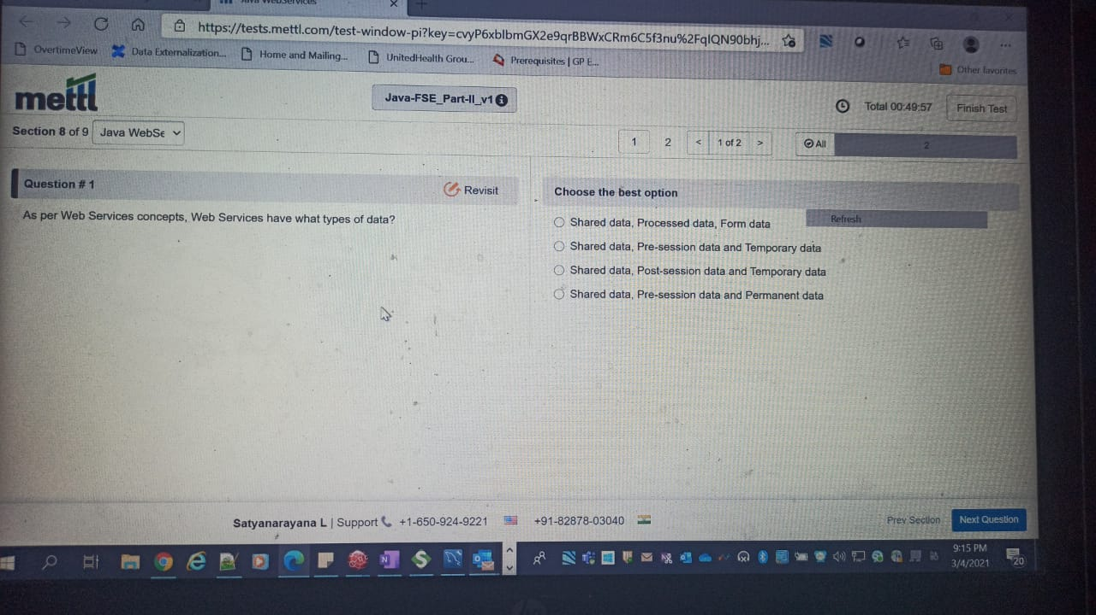

Q) As per web services concepts, web services enable ..

Ans : all of the above

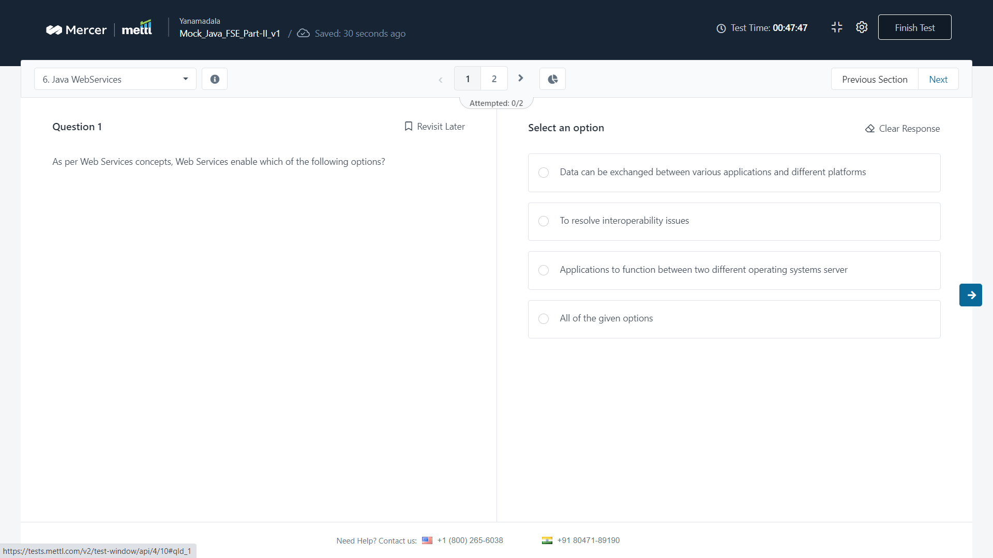

Q) which of the following methods does not belong to containerRequestContext class ?

Ans : 4 (geturlinfo () method not there)

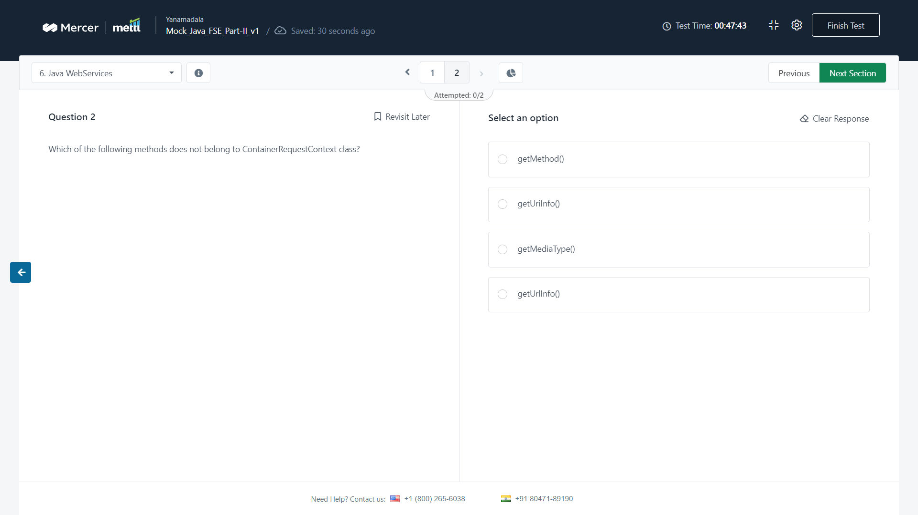

Q) As per web services concepts, which of the following options are the web service platform elements ?

Ans : 4

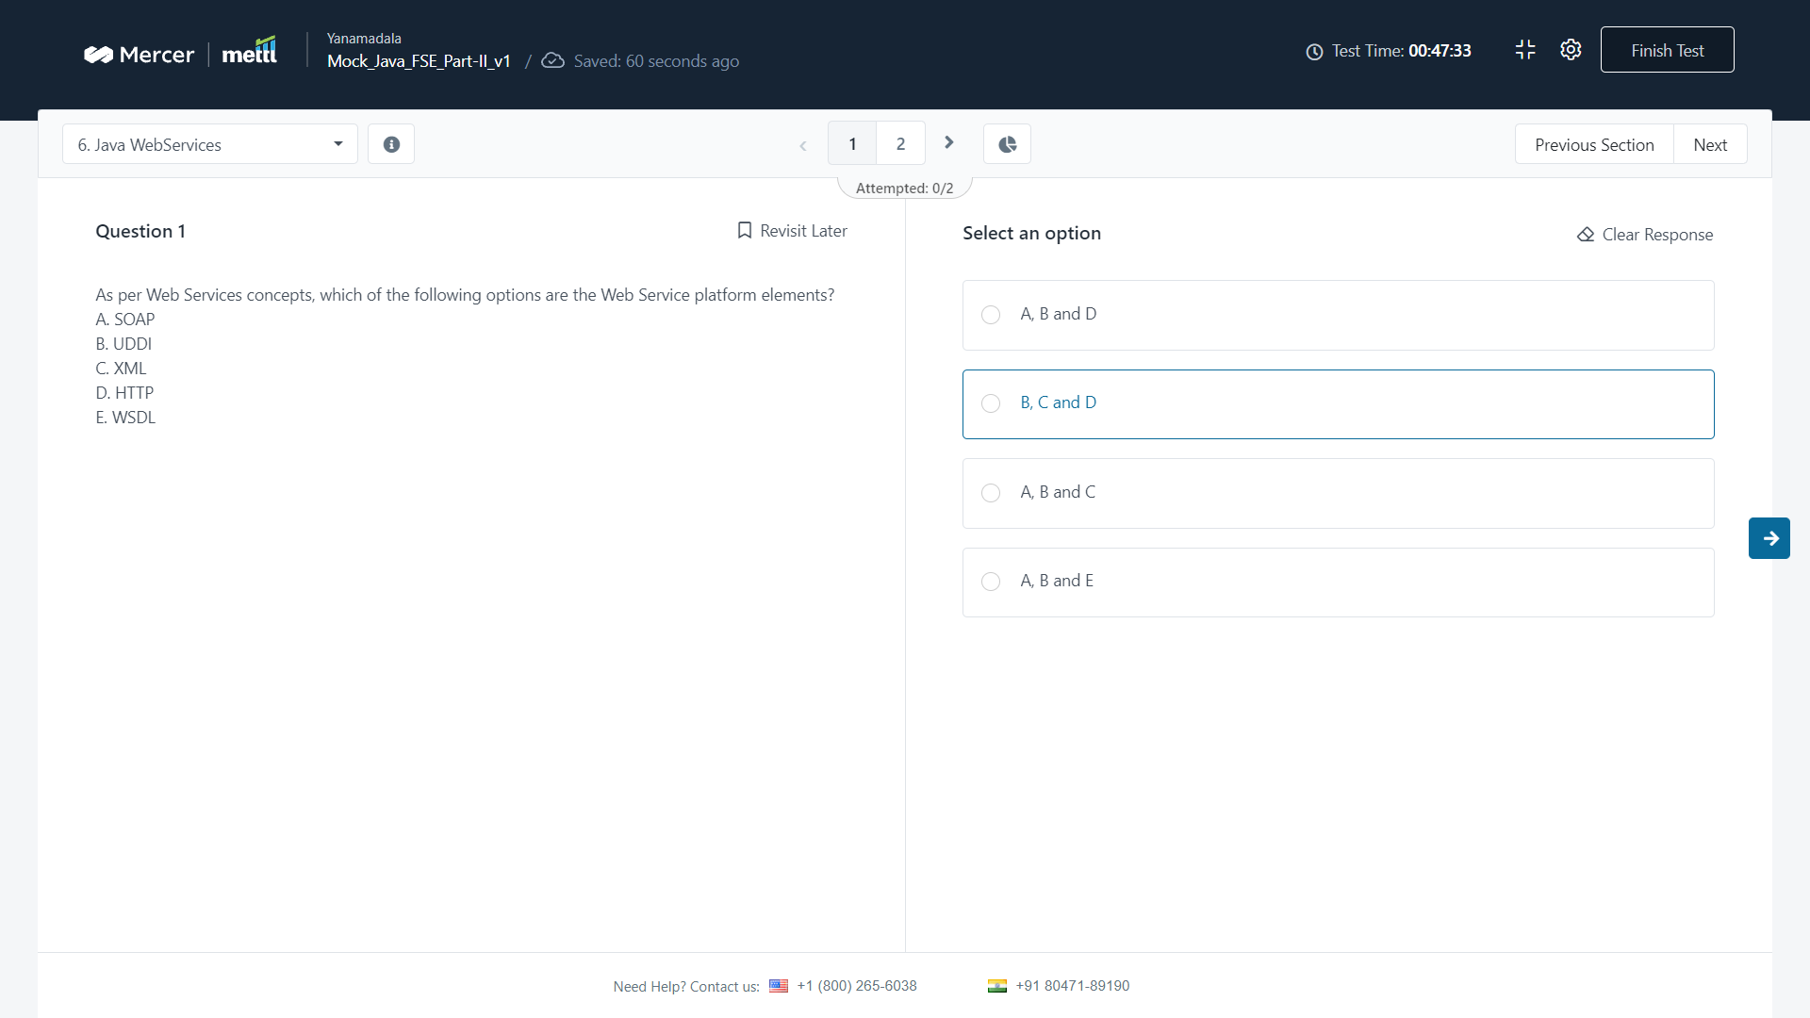

Q) which of the following methods does not belong to containerRequestContext class ?

Ans : 4

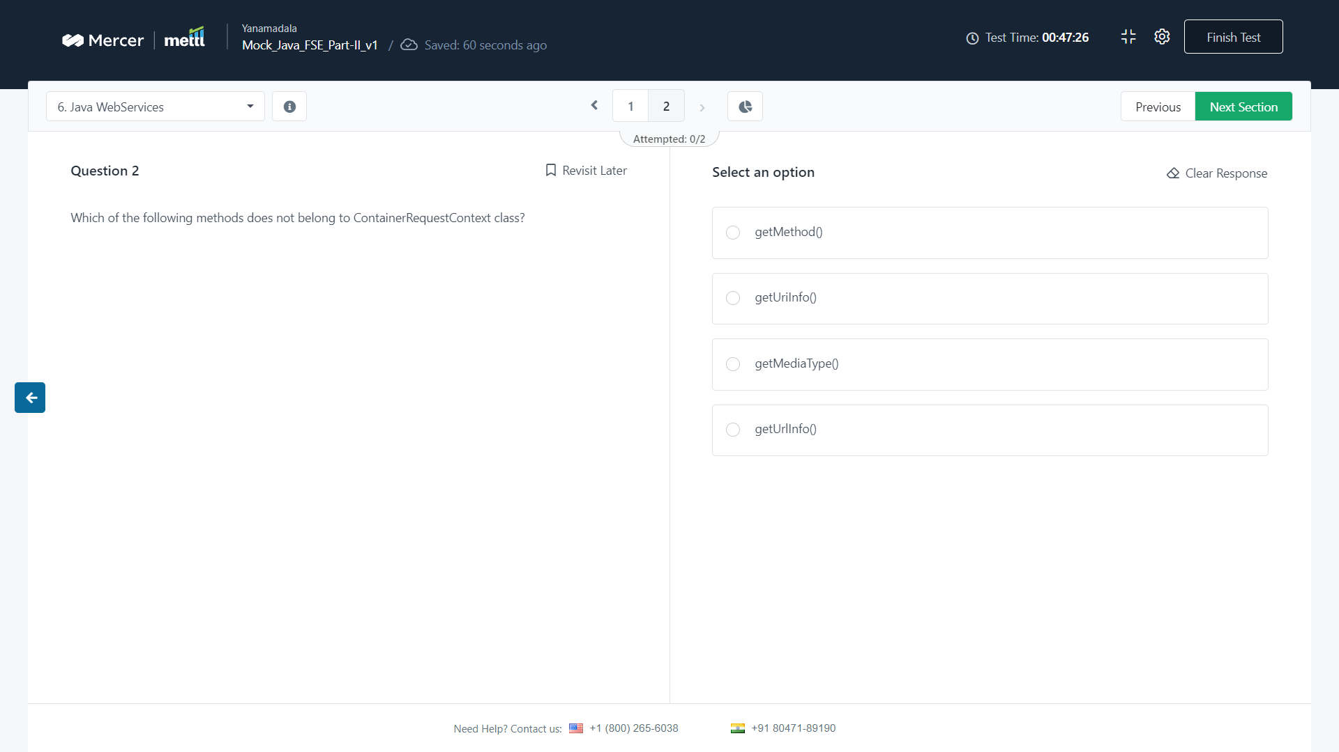

Q) AS per web services concepts, the layers, service transport, xml messaging, service

A) ?

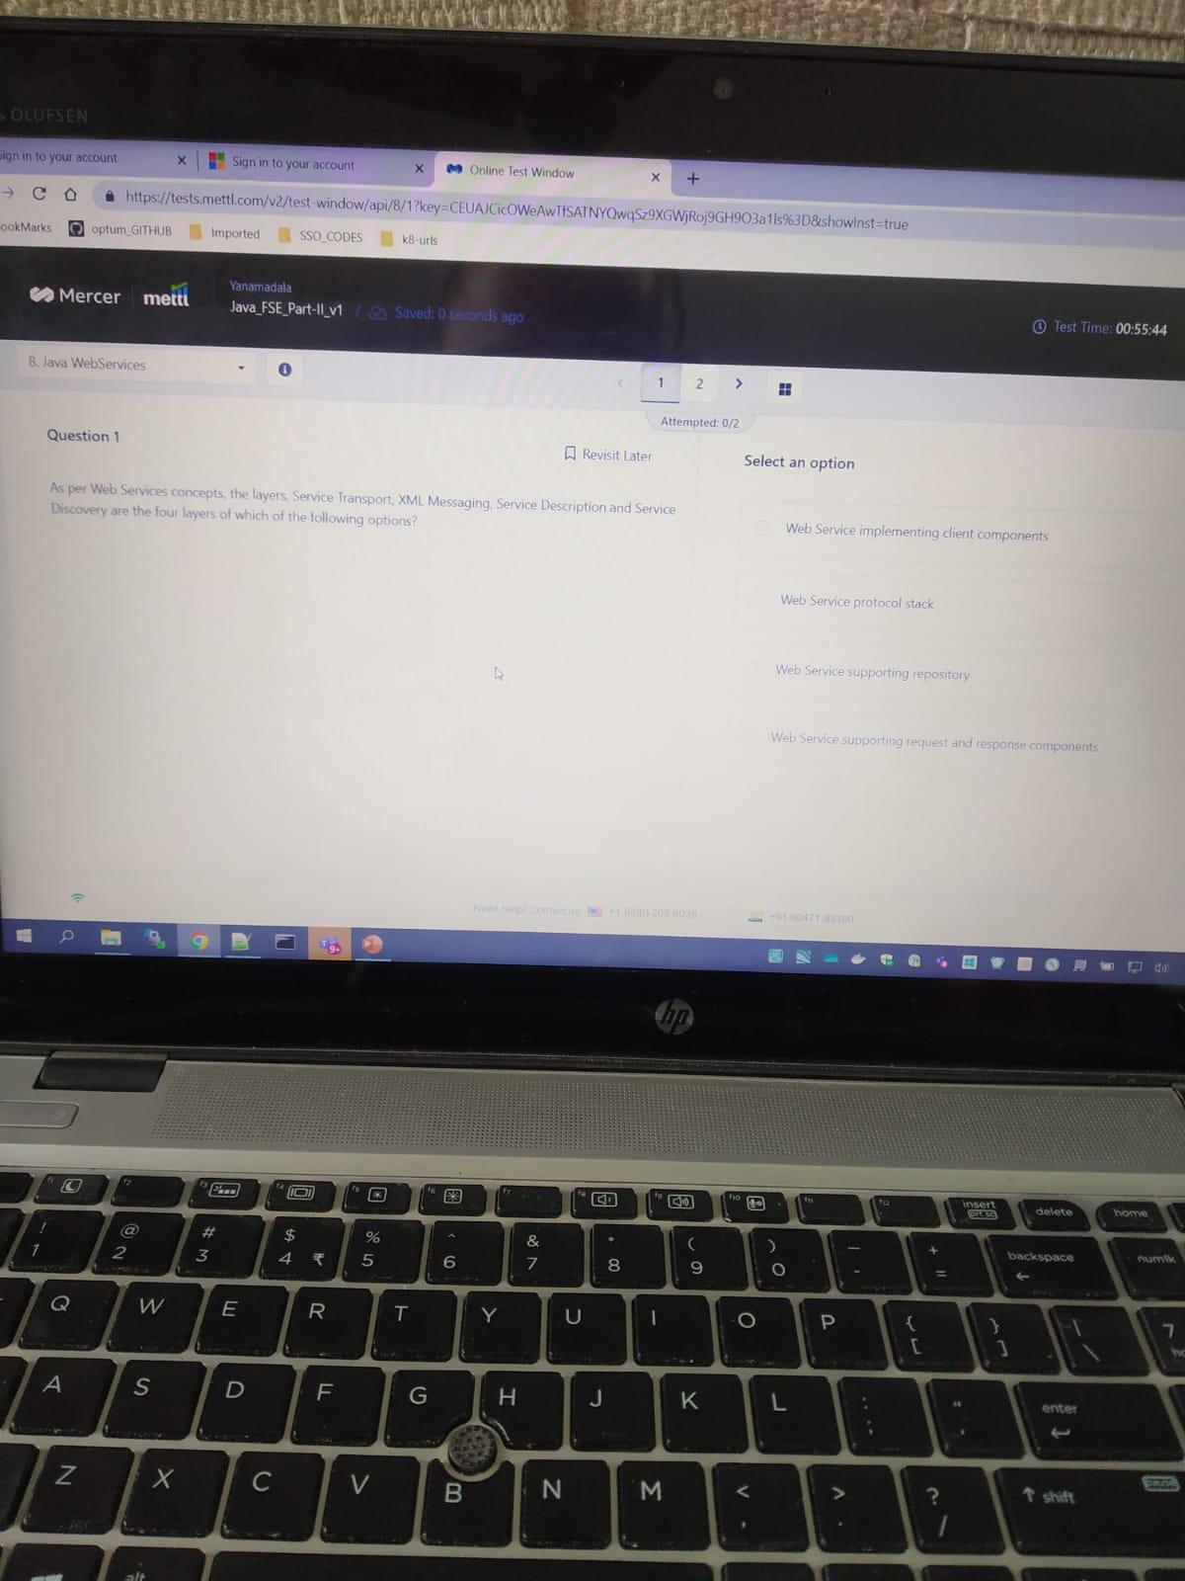

Q) which of the following pbjects will you use to fetch information...

A) ?

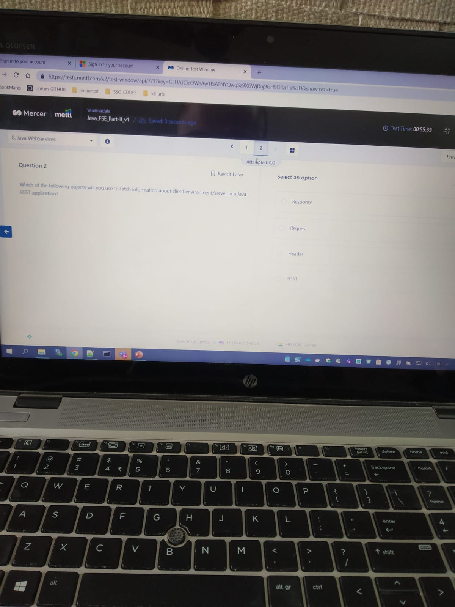

## Javascript

1. Consider the following javascript ..

Ans : 1

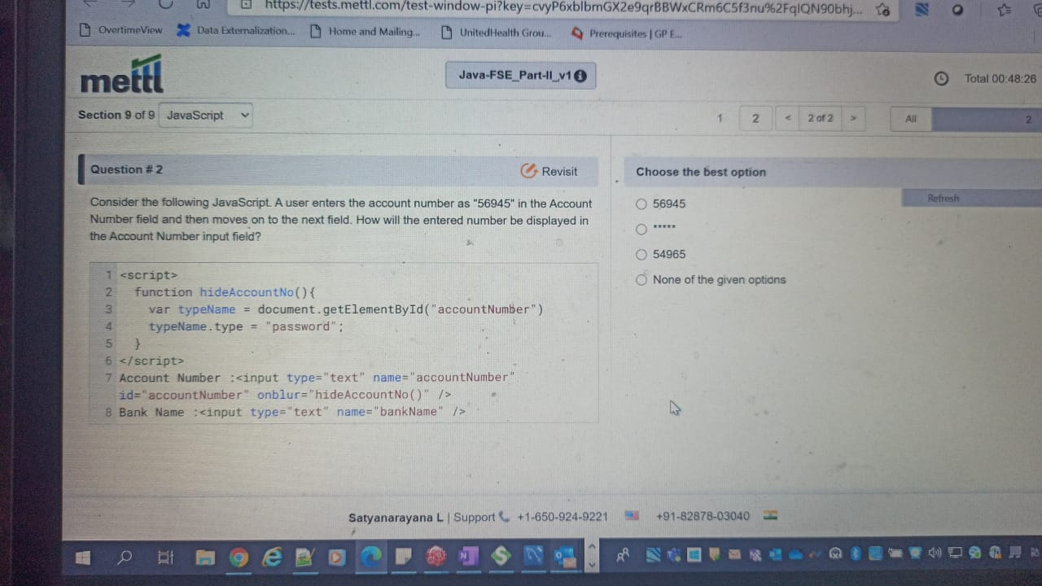

For the given regex program …

A ) 2 (regexpstr2)

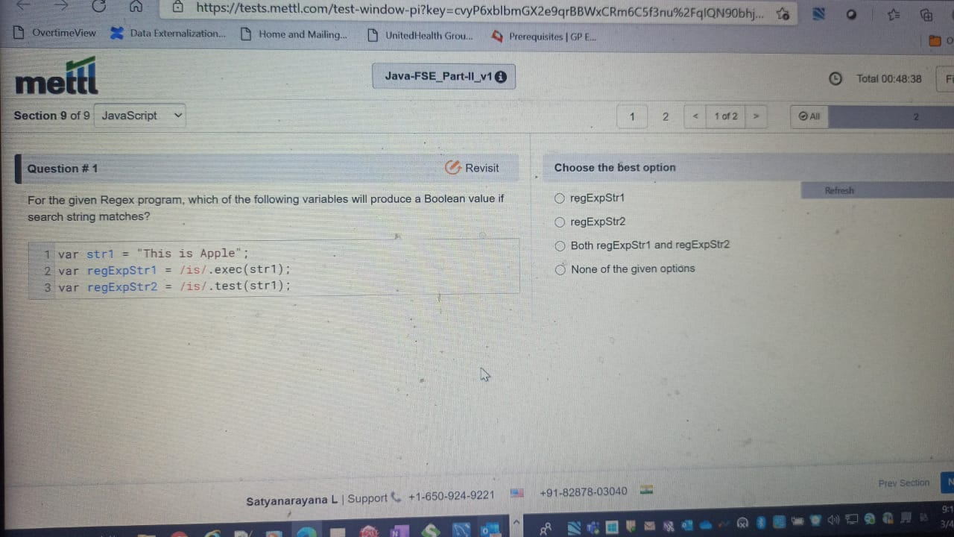

Q) which of the following modifiers is used for matching a regex ib…

Ans : g

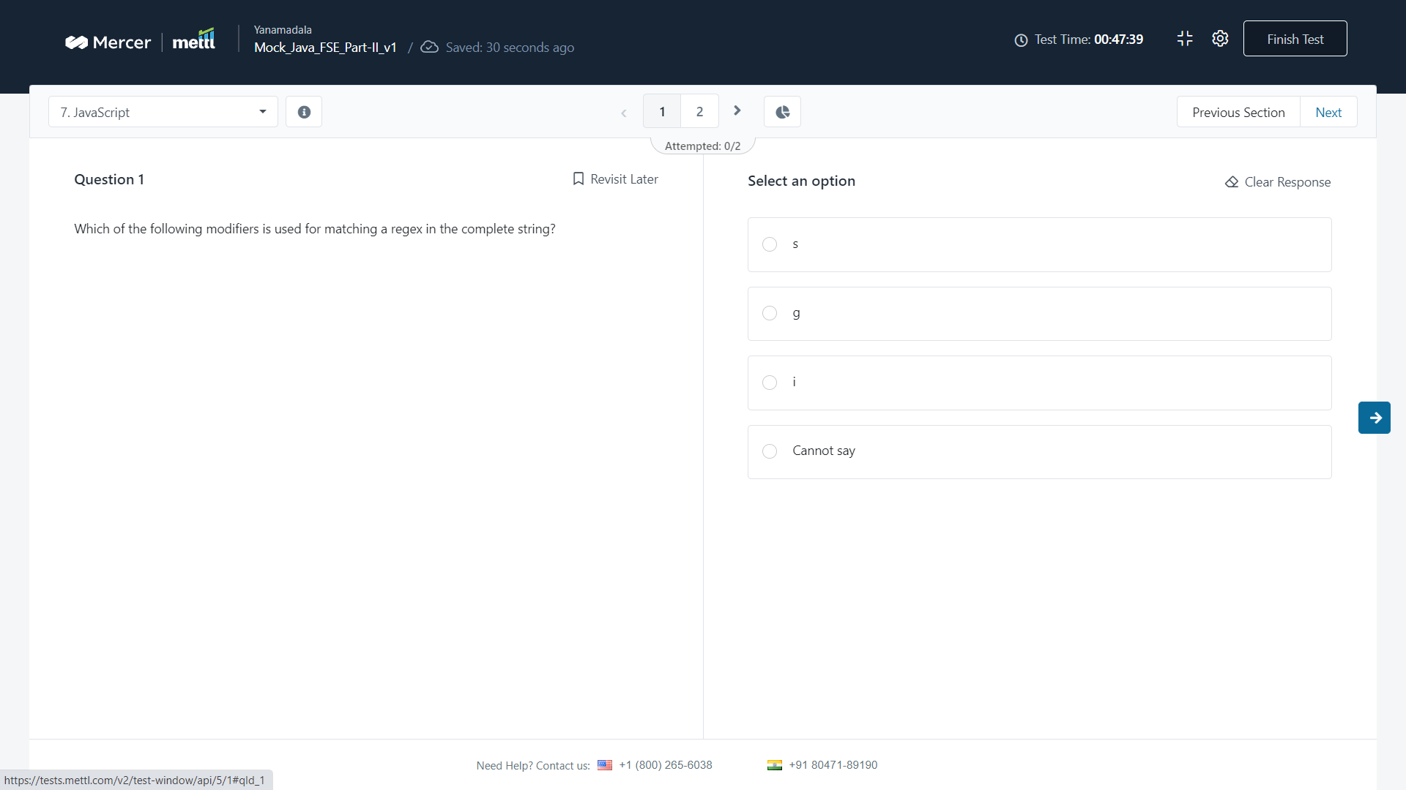

Q) what will be the output of the given code?

Ans : 3

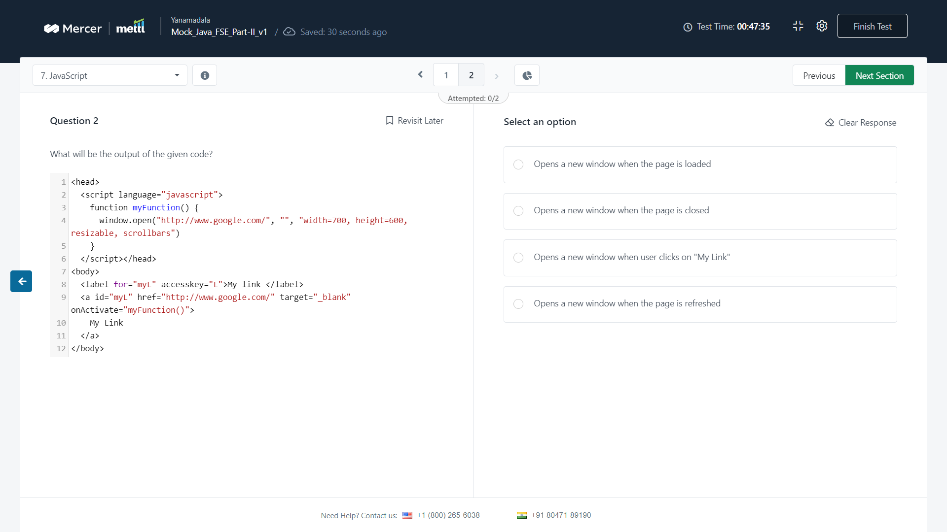

Q) Which of the following methods will return the time difference between GMT and local time…

Ans : 2

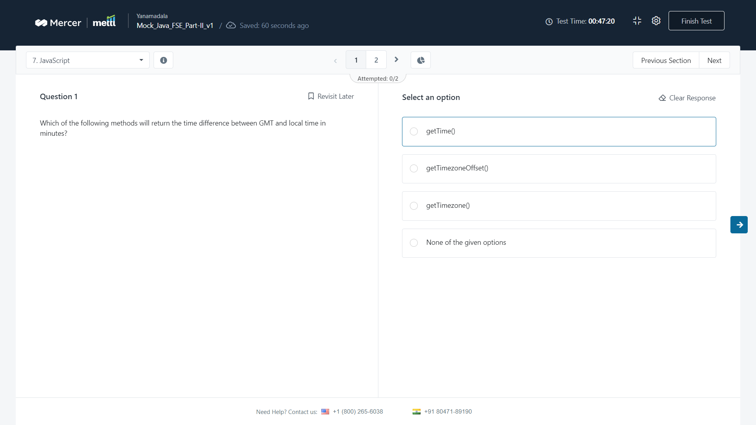

Q) For the given javascript, what will be displayed on console if a user enters “us”

Ans : 4

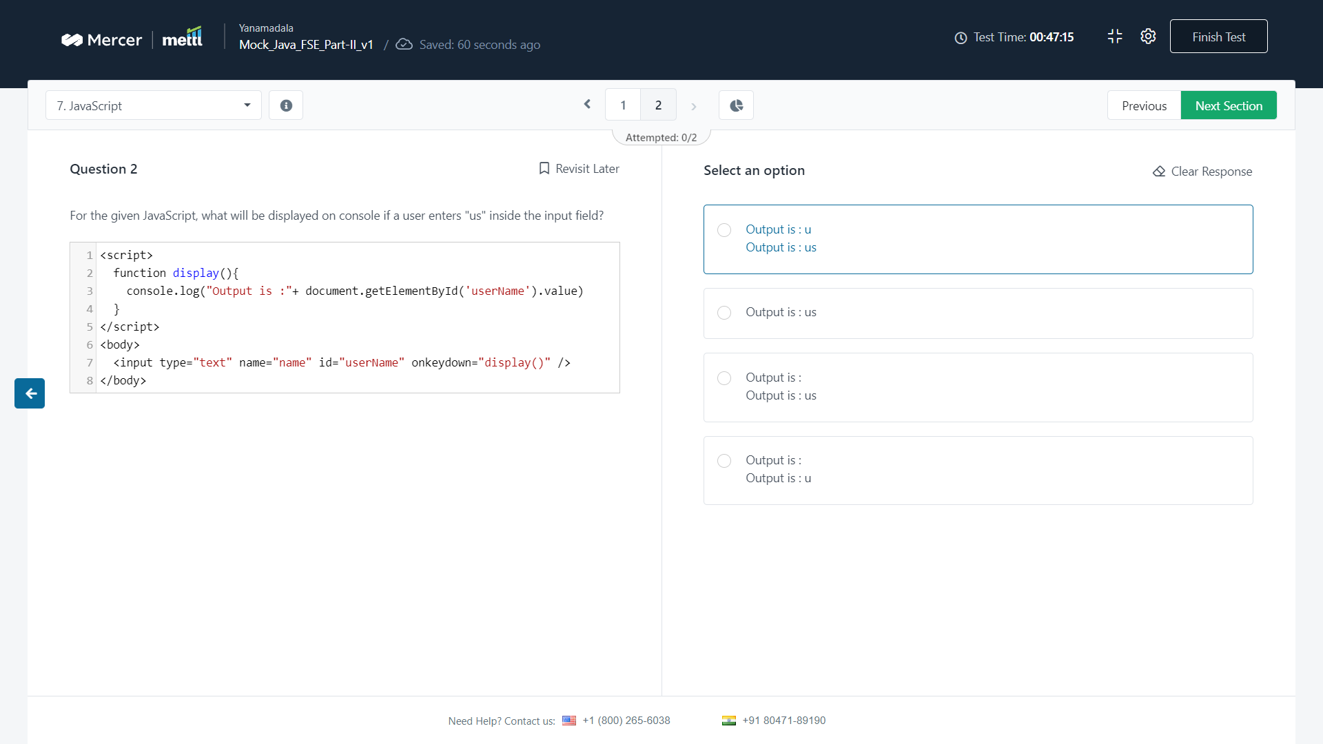

Q) what will be the output of the given code when the user clicks my button

A) ?

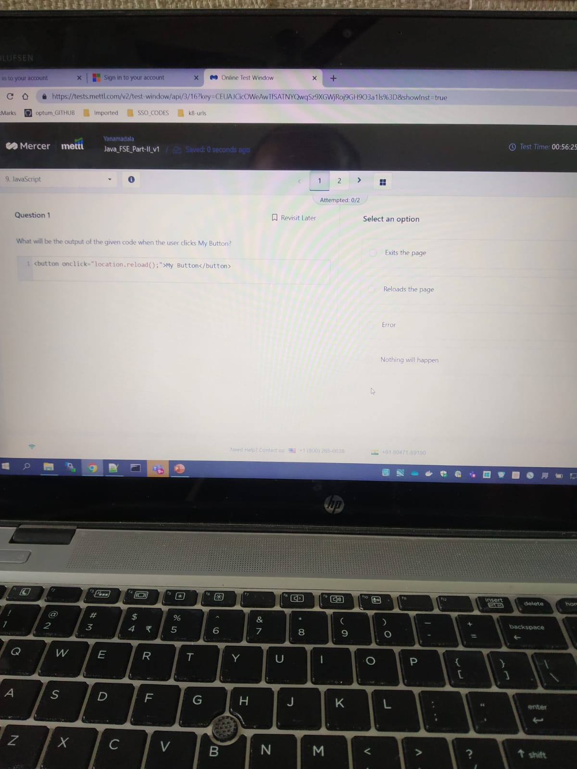

Q) <input type="text" onkeydown="fun1()" onkeyup="fun2()"?

<script>

1. ?

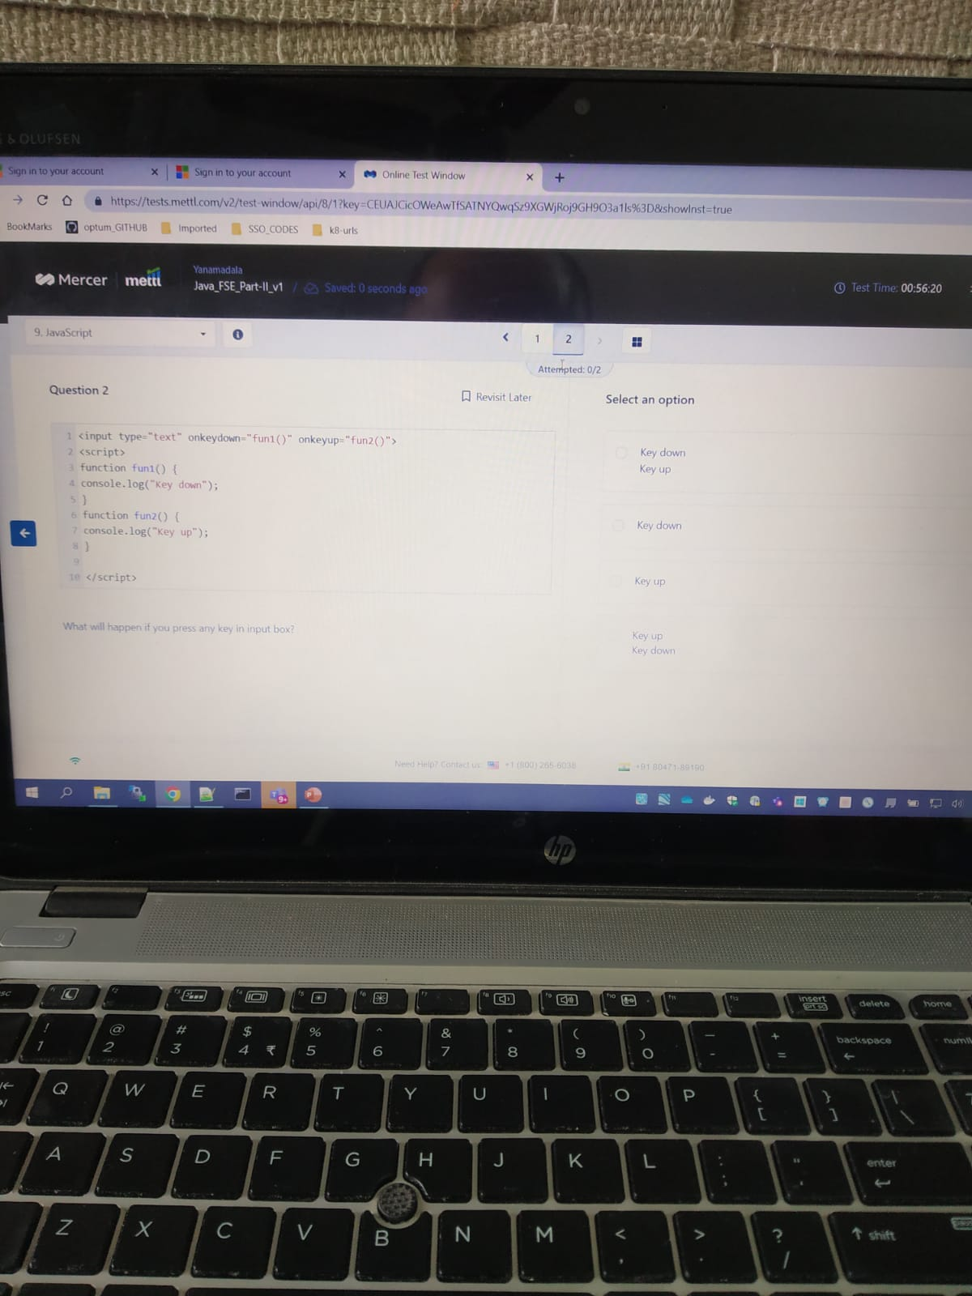

## Nothing